**Republic of Sierra Leone**

**Ministry of Water Resources**

**Water Sanitation and Hygiene (WASH) Support Programme**

**Study on Willingness and Ability to Pay in Urban Freetown – Sierra Leone**

Undertaken by PEMconsult, Colan Consult & Dalan Development Consultants on behalf of Guma Valley Water Company

Funded by the UK Government through the WASH Facility

**Draft Final Report**

January 2014



Acknowledgements

The authors of this report would like to thank all the sector professionals who have made time available to participate in meetings and workshops and for consultations with the study team during the study.

We have received valuable guidance and support from professional staff in the Ministry of Water Resources, Guma Valley Water Company, SALWACO and in particular the Focal Persons, as well as the WASH Facility. The Urban Consortium has been very helpful in providing valuable insight and documentation on the water services in Freetown.

Disclaimer:

This report has been produced by PEMconsult, Colan Consult & Dalan Development Consultants on behalf of Guma Valley Water Company (Guma). The study is funded by the UK Government through the WASH Facility. Content, wording and recommendations are those of the consultants, and do not necessarily represent the views of the Government of Sierra Leone, the Ministry of Water Resources, Guma, the UK Government or the WASH Facility/Adam Smith International.

# Synopsis

This report describes the outcome of the study on the ‘Willingness and Ability to Pay’ for water services in Freetown in 2013. The main objective of the study is to provide information on public acceptability and assess an appropriate and feasible level of service and tariffs for different types of consumer in Freetown. The results are based on household surveys, focus group discussions and key informant interviews as well as analysis of data from Guma Valley Water Company.

Chapter 1 provides an introduction to the assignment. Chapter 2 presents the description of the methodologies used in the implementation of the surveys and Chapter 3 presents the socio-economic characteristics of the respondent households and commercial enterprises. Issues of access to water services and the reliability of water service provision is described in Chapter 4.

The findings regarding willingness and ability to pay for water services is described in Chapter 5. Chapter 6 provides some recommendations concerning tariff setting. The outcome of modelling the Guma business is described in Chapter 7 and finally recommendations on cost recovery for water services are provided in Chapter 8.

The overall findings of the study can be summarised as:

1. The households and commercial enterprises in Western Area use multiple sources of water due to inadequate piped water services and are presently paying much more for water than the tariffs charged by Guma.
2. Households are presently paying more than the threshold of 3% of household resources for water services. The cost of water is generally affordable up to a level of Le 4,000 per m3. This corresponds to Le 90 per 5gal container and consumers relying on public standpipes are presently paying considerably more. Affordable access to water for the poorer households could be improved through regulated services from public standpipes and lifeline tariffs for yard taps.
3. Both households and commercial enterprises are willing to substantially pay more for Guma water services provided the reliability of water supply improves.
4. The analysis of tariffs indicate that, within the range of tariffs that the consumers are willing to pay, the average Guma tariffs could be increased to about Le 3,000 per m3 and this would enable the water utility to cover operation and maintenance costs as well as contributing to the much needed improvements in efficiency and reliability of water services from internally generated revenues.

Contents

Synopsis 3

List of Abbreviations x

Executive Summary i

The Survey methodology i

Characteristics of households and commercial enterprises i

Access to Water i

Willingness and Ability to Pay iii

Tariff Setting v

Modelling the Guma Business vi

Conclusions and recommendations vi

1 Introduction 1

1.1 The WATP Study 1

1.2 This Report 2

2 Survey Implementation and Socioeconomic Strata 3

2.1 Sampling Size and Sampling Process 3

2.2 Field Work and Data Management 4

2.3 Definition of Socio-economic Strata 9

3 Characteristics – Households and Commercial Enterprises 11

3.1 Socio-economic data - Western Urban and Rural 11

3.1.1 Gender and Age of Household Heads and Respondents 11

3.1.2 Educational Status of Respondents 11

3.1.3 Employment Status of Respondents 12

3.1.4 Household Tenure and Size 14

3.1.5 Household Incomes and Expenditures 15

3.2 Data on Commercial Enterprises 19

4 Access to Water 21

4.1 Water Sources 21

4.1.1 Water Sources for Households 21

4.1.2 Water Sources for Enterprises 25

4.2 Water Collection 26

4.2.1 Time for Collection of Water 26

**4.2.2** Who collects Water 27

4.3 Practices in relation to Water 28

4.3.1 Treatment of Drinking Water 28

4.3.2 Water Storage 28

4.4 Volume of water consumed 29

4.4.1 Volume of Water – Households 29

4.4.2 Volume of Water – Enterprises 30

4.5 Services from Water Providers 32

4.5.1 Water Service Providers 32

4.5.2 Billing and Payment for Water – Households 33

4.5.3 Satisfaction with Service Provider 36

4.5.4 Reliability of Water Service 37

5 Willingness and Ability to Pay 40

5.1 Willingness to Pay for Water Services as expressed by Consumers 40

5.1.1 Willingness to pay for Water Services by Quality of Service 40

5.1.2 Willingness to pay for Water Services by Income Groups 46

5.2 Willingness to Pay for Water Services for Commercial Enterprises 50

5.3 Ability to pay for water services 50

5.4 Conclusion on Willingness and Ability to Pay for Water Services 52

6 Tariff Setting 54

6.1 Willingness and Ability to Pay 54

6.2 General Framework for Tariff Fixing 55

6.3 Principles for Tariff Setting and Main Methodological Approaches 56

6.3.1 Principles for Tariff Making 56

6.3.2 Methodological Approaches 57

6.4 Preliminary estimate of the average tariff for Guma 58

6.5 Review of Guma Tariff Structure and Tariff Schedules 59

6.6 Tariff Adjustment formula to compensate for inflation 61

6.7 Subsidies and Affordability 61

7 Modelling the Guma Business 62

8 Cost Recovery Recommendations 66

Annex A: Terms of Reference 68

Annex B: Survey Questionnaires 69

Annex B.1: Household Questionnaire 69

Annex B.2: Commercial Questionnaire 83

**List of Figures**

Figure 2‑1: Sampled EAs in Western Urban 7

Figure 2‑2: Sampled EAs in Western Rural 8

Figure 2‑3: Scoring for Socio-economic Status [‘F-Income-Exp’ J21:O35] 9

Figure 2‑4: Grouping of Socio-economic Status [‘F-Income-Exp’ P21:X35] 10

Figure 3‑1: Gender of Respondents [‘A-Respondents’ A45:F55] 11

Figure 3‑2: Age Distribution of Household Heads and Most Informed Respondents [‘A-Respondents’ A56:F62] 11

Figure 3‑3: Education of Household Heads and ‘most informed respondent’ [A-Respondents N47:T60] 12

Figure 3‑4: Employment Status of Household Heads and Respondents [‘A-Respondents’ U47:Z60] 13

Figure 3‑5: Profession of Respondents [‘A-Respondents’ AD52:AI63] 13

Figure 3‑6: Tenancy Distribution [‘A-Respondents’ G40:K52] 14

Figure 3‑7: Number of Compounds and Household Sizes [‘A-Respondents’ BX16:CB28] 14

Figure 3‑8: Average Household Incomes per Area [‘F-Income-Exp’ AJ20:AP35] 15

Figure 3‑9: Variation in Incomes in Rural and Urban Areas [‘F-Income-Exp’ AE23:AJ37] 15

Figure 3‑10: Respondents per Income Group in Urban Areas [‘F-Income-Exp’ AF38:AN51] 16

Figure 3‑11: Respondents per Income Group in Rural Areas [‘F-Income-Exp’ AH51:AN65] 16

Figure 3‑12: Comparison between Income and Expenditure Data [‘F-Income-Exp’ CD9:CI22] 16

Figure 3‑13: Expenditures in Urban Households [‘F-Income-Exp’ CK38:CR52] 17

Figure 3‑14: Expenditures in Rural Households [‘F-Income-Exp’ DD38:DK52] 18

Figure 3‑15: Expenditures in Urban and Rural Areas [‘F-Income-Exp’ DE59:DN61] 18

Figure 3‑16: Commercial Enterprises per City Section [‘A-Respondents’ D85:K98] 19

Figure 3‑17: Type of Commercial Enterprises [‘A-Respondent’ L85:R98] 19

Figure 3‑18: Gender of the Respondents from Commercial Enterprises [‘A-Respondent’ E100:L111] 19

Figure 3‑19: Size of Enterprises [‘F-Income-Exp’ N83:S99] 20

Figure 3‑20: Average turnover of Enterprises [‘F-Income-Exp’ B85:G101] 20

Figure 4‑1: Water Sources in the Dry Season in Urban Areas [‘B-Volume of Water by Source’ AR50:AZ68] 21

Figure 4‑2: Water Sources in the Rainy Season in Urban Areas [‘B-Volume of Water by Source’ BI50:BP68] 22

Figure 4‑3: Water Sources in the Dry Season in Rural Areas [‘B-Volume of Water by Source’ AZ50:BH68] 22

Figure 4‑4: Water Sources in the Rainy Season in Rural Areas [‘B-Volume of Water by Source’ BQ50:BY68] 23

Figure 4‑5: Sources of Water in the Dry Season [‘B-Volume of Water by Source’ B4:L19] 23

Figure 4‑6: Sources of Water in the Rainy Season [‘B-Volume of Water by Source’ O4:X19] 24

Figure 4‑7: Sources of Water by Income Groups in the Dry Season [‘B-Volume of Water by Source’ AR80:AZ96] 24

Figure 4‑8: Sources of Water by Income Groups in the Rainy Season [‘B-Volume of Water by Source’ BI81:BQ96] 25

Figure 4‑9: Sources of Water in Dry Season for Commercial Enterprises [‘B-Volume of Water by Source’ B20:L36] 25

Figure 4‑10: Sources of Water in the Rainy Season – Commercial [‘B-Volume of Water by Source’ O20:X36] 26

Figure 4‑11: Time Spent Collecting Water [‘B-Water Source Dry Season’ AA78:AF94] 26

Figure 4‑12: Who Collects Water in Households [‘B-Water Source Dry S’ BU79:BY97] 27

Figure 4‑13: Who Collects Water in Commercial Enterprises [‘B-Water Source Dry S’ BL99:BQ116] 27

Figure 4‑14: Treatment of Drinking Water [‘B-Water Treatment’ B54:E69] 28

Figure 4‑15: Methods for Water Treatment [‘B-Water Treatment’ I54:O69] 28

Figure 4‑16: Type of Water Storage [‘B-Water Treatment’ W54:AB69] 29

Figure 4‑17: Average Consumption per Person in Dry and Rainy season [‘B-Volume of Water by Source’ CD5:CO17] 29

Figure 4‑18: Volume of Water Supplied by Guma ‘Guma SIM ver0’ [‘Data’ G55:J79] 30

Figure 4‑19: Average Volume of Water used by Commercial Enterprises [‘B-Volume of Water by Source’ CH20:CS31] 31

Figure 4‑20: Average Volume of Water used by Type of Enterprises [‘B-Volume of Water by Source’ DZ20:EK35] 31

Figure 4‑21: Water Service Providers [‘C-Reliability’ F36:I47] 32

Figure 4‑22: Type of Connection and Income Levels [‘C-Reliability’ C64:G77] 32

Figure 4‑23: Payment for Water Services [‘D-Billing’ B102:F116] 33

Figure 4‑24: When was Last Water Bill Received [‘D-Billing’ O49:U62] 33

Figure 4‑25: Type of Billing System [‘D-Billing’ B128:F142] 34

Figure 4‑26: Monthly Bills per Billing Method [‘D-Billing’ W70:Z84] 34

Figure 4‑27: Cost of Water from Different Types of Connections [‘D-Billing’ W92:Z106] 35

Figure 4‑28: Payment of Water Bills [‘D-Billing’ AA48:AF62] 35

Figure 4‑29: Rating of Fairness of Water Bills [‘D-Billing’ AG48:AK62] 36

Figure 4‑30: Satisfaction with Water Service Provider [‘D-Billing’ AM49:AQ62] 36

Figure 4‑31: Satisfaction with Other WSPs [‘D-Billing’ AM63:AQ76] 37

Figure 4‑32: Frequency of Guma Water Service by Seasons [‘C-Reliability’ P49:R62 & BX49:CA62] 37

Figure 4‑33: Frequency of Other WSPs Services by Seasons [‘C-Reliability’ AH49:AJ62 & CP49:CS62] 38

Figure 4‑34: Continuity of Guma Service Provision by Season [‘C-Reliability’ P78:R92 & BX78:CA92] 38

Figure 4‑35: Continuity of Other WSPs’ Services by Season [‘C-Reliability’ AH78:AJ92 & CP78:CS92] 39

Figure 4‑36: Time to Attend Request for Repairs [‘C-Reliability’ DZ47:EC61] 39

Figure 5‑1: Willingness to Pay for Standpipe Water Service [‘E-WTP’ B87:J101] 40

Figure 5‑2: Average Expressed WTP for Water from Public Standpipes [‘E-WTP’ C107:G125] 41

Figure 5‑3: Willingness to Pay for Yard Tap Water Service [‘E-WTP’ Y103:AG117] 42

Figure 5‑4: Average Expressed WTP for water from Yard Taps 42

Figure 5‑5: Willingness to Pay per m3 for Water from Yard Taps [‘E-WTP’ AL134:AP149] 43

Figure 5‑6: Willingness to Pay for House Connection Water Service [‘E-WTP’ AH103:AP117] 44

Figure 5‑7: Average Expressed WTP for Water from House Connections [‘E-WTP’ AF134:AJ151] 45

Figure 5‑8: Comparison of Responses for Households with Existing Reliable Service [‘E-WTP’ R112:X126] 45

Figure 5‑9: Willingness to pay per m3 for water from House Connections [‘E-WTP’ AQ134:AV151] 46

Figure 5‑10: WTP for Public Standpipe Service per Income Category [‘E-WTP’ C199:G216] 46

Figure 5‑11: WTP for Yard Tap Service per Income Category [‘E-Average WTP’ A39:D56] 47

Figure 5‑12: Average Consumption per Household in Rainy Season [‘B-Water Quantity’ B171:F185] 47

Figure 5‑13: Average WTP per m3 for Yard Taps per Income Category [‘E-Average WTP’ E39:H56] 48

Figure 5‑14: WTP for House Connection Service per Income Category [‘E-Average WTP’ I39:L56] 48

Figure 5‑15: Average WTP per m3 for House Connections per Income Category [‘E-Average WTP’ M39:R56] 49

Figure 5‑16: Average WTP per month for Commercial Enterprises [‘E-WTP’ AM30:AS43] 50

Figure 5‑17: Average WTP per M3 for Commercial Enterprises[‘E-WTP’ AT30:AY43] 50

Figure 5‑18: Water expenditures in Urban Areas [‘F-Income-Exp’ BQ43:BW56] 51

Figure 5‑19: Water expenditures in Rural Areas [‘F-Income-Exp’ BY43:CF56] 52

Figure 6‑1: Willingness to Pay for Household Piped Connections 54

Figure 6‑2: Willingness to Pay for Yard Tap Piped Connections 55

Figure 6‑3: Willingness to Pay and Guma Efficient Unit Costs 55

Figure 7‑1: Forecast of Guma Revenue and Costs [‘Guma SIM ver0 Jan2014’ sheet ’Graphs WATP Report’ C9:P35] 63

Figure 7‑2: Demand and Capacity forecast [‘Guma SIM ver0 Jan2014’ sheet ’Guma’ H17:O40] 64

Figure 7‑3: Investment Requirements [‘Guma SIM ver0 Jan2014’ sheet ’Guma’ P17:AD40] 65

Table 2‑1: Coverage of Household and Commercial Surveys 4

Table 2‑2: Coverage of Semi-Structured Interviews and Focus Groups 5

Table 3‑1: Household Members 14

Table 5‑1: Average Consumption for HHs Opting for Yard Taps [‘E-WTP’ AN188:AQ191] 43

Table 5‑2: WTP for Water from Yard Taps per m3 [‘E-WTP’ AG119:AT124] 44

Table 5‑3: Average Consumption for HHs opting for House Connections [‘E-WTP’ AN193:AQ196] 45

Table 5‑4: WTP for water from house connections per m3 46

Table 5‑5: Affordability of water services 52

Table 5‑6: Average household WATP for 24 hour water services 53

Table 6‑1: Unit Costs, System Losses, and Tariff needed to Break-even 56

Table 6‑2: Current Estimated Tariff Structure 59

Table 6‑3: Proposed Tariff Structure 60

Table 6‑4: Proposed Tariff Structure and tariff schedules 60

### List of Abbreviations

|  |  |
| --- | --- |
| ASI | Adam Smith International |
| CAPMANEX | Capital Maintenance Expenditure |
| DFID | Department For International Development, UK |
| EA | Enumeration Area |
| GoSL | Government of Sierra Leone |
| GVWC | Guma Valley Water Company also referred to as ‘Guma’ |
| Le | Leons (exchange rate 4,300 Le per US$) |
| LRMC | Long Run Marginal Cost |
| M&E | Monitoring and Evaluation |
| MWR | Ministry of Water Resources (new) |
| NGO | Non-Governmental Organisation |
| O&M | Operation and Maintenance |
| SPSS | Computer Software: ‘Statistical Package for the Social Sciences’, later modified to read ‘Statistical Product and Service Solutions’ |
| WASH | Water, Sanitation & Hygiene |
| WATP | Willingness and Ability To Pay |

# Executive Summary

This report describes the outcome of the study on the Willingness and Ability to Pay (WATP) for water services in Freetown in 2013. The main objective of the study is to provide information on public acceptability and assess appropriate and feasible levels of service and tariffs for different types of consumer in Freetown.

#### The Survey methodology

Two surveys were undertaken covering Western Area. Western Rural was included to provide information to the discussions on a possible extension of the service area of Guma Valley Water Company (Guma) to Western Rural. The surveys covered:

* Households: with a sample size of 2,500, divided between Freetown (2,000 households) and Western Rural (500 households). The sample was drawn from 250 enumeration areas, with a fixed sample size of 10 households to be sampled per enumeration area.
* Commercial enterprises: with a sample size of 250, distributed between Freetown (200 users) and Western Rural (50 users).

The survey specifically targeted low income consumers. The data has been analysed according to the socio-economic strata of the participating households, classified as ‘very poor’; ‘poor’; ‘middle income’ and ‘high income’ using a number of indicators on household amenities, type of fuel, standard of housing etc. The survey methodology and the socioeconomic strata are described in detail in Chapter 2.

#### Characteristics of households and commercial enterprises

Detailed data was collected the gender and age of the respondents, the educational and employment status and details of household tenure and the average size of the households and compounds. Data was also collected on the household incomes and expenditures. The data on household expenditure are considered more reliable and are used in the analysis for affordability of water presented in the report.

Data was collected on the characteristics and water use from the commercial enterprises covering construction, water purification, catering, accommodation, drink and food processing, manufacturing, shops and cleaning services, the majority being catering business. The characteristics of households and the commercial enterprises are described in detail in Chapter 3.

#### Access to Water

The information collected on access to water includes sources of water used by season and by income group, perceived quality of water source, the volume of water used from each source per day and corresponding cost and who is collecting the water as well as information about the time spent fetching water. The main observations are:

**Sources of water**

* Conventional water services: Piped water is the main source of water – 55% of the water consumed in urban areas comes from piped systems, either through pipe connections to houses or yards or from public stand-pipes. The second most important source of water is groundwater from point sources. 27% of water used in urban areas is from either boreholes, protected or un-protected dug wells
* Unconventional water services: Packet water in terms of volume of water is a minor source – although very important as source of safe drinking water. In terms of volume, tankers and pushcart vendors supply only a minor part of the water used in town. Untreated surface water is used in some areas – 2% of the water used in Freetown is from un-treated surface water sources. Rainwater plays a major role in the rainy season and supplies 33% of the water consumed in urban areas.
* Distribution of water source types: The availability of piped water vary considerably between the different locations within Western Area with some areas such as Central 2 having almost 90% of the water use from piped water sources while other urban areas such as East 3 has less than 40%. In rural areas, Koya Rural is exceptional with no piped systems and almost 30% of the water being drawn from surface water sources and the remaining 70% from groundwater sources. Piped systems in the form of yard or house connections provide almost 90% of the water use in commercial enterprises in the urban areas and 80% in rural areas. Groundwater is a main source of water in areas without reliable piped systems such as East 2, Waterloo Rural and York Rural. Tanker services also play a major role in some areas e.g. in East 1 30% of the consumption in commercial enterprises is from tankers.

**Collection, treatment and storage of water**

* Time taken to fetch water: During dry season 21% of the population in Western Area spend more than 1 hour fetching water, compared with about 11% in the rainy season. The results show that providing water is a heavy burden for the households and commercial enterprises in terms of the time it takes
* Collection burden: The main burden for collection of water is on children – both boys and girls. 70% of the water is collected by children and this is likely to have an adverse impact children schooling and lead to other social problems
* Household water treatment: 32% of urban households and 34% of rural households treat water for drinking. Treatment of water is mainly done on water from un-protected sources, but it does include some piped water also. 38% of the commercial enterprises are treating the water used for drinking purposes.
* Water storage: Most households and enterprises cope with the irregular supply of water by storing the water. 99% of the households in urban areas and 97% of households in rural areas reportedly store water as well as 96% of the commercial enterprises. The water for domestic consumption is mostly stored in drums or smaller containers and only the commercial enterprises use reservoirs and tanks to a larger degree.

**Volume of water consumed**

* Per capita consumption: The data on per capita consumption reveals that the water consumption is restricted during the dry season since the rainy season consumption rates are about 30% higher. The figures also indicate considerable variations across the different areas with urban areas generally having higher consumption rates. The average consumption in the rainy season is 48 litres per capita per day. This corresponds roughly to the volume of water supplied for domestic purposes by Guma when adjusting for the proportions supplied by piped systems and by other service providers.

**Water Service Providers**

* Service Provider: The main water service provider in the area covered by the survey is Guma serving more than 90% of the households in urban areas and 50% of the households in rural areas that have access to piped water services. The yard connection is the dominating type in all income categories.
* Payment for water: 42% of the customers in Western Urban and 58% of the customers in Western Rural do not pay for water. Only 8% of the Commercial customers do not pay for water services. The households that do not pay for water seem to do so because of inefficient billing and not due to un-willingness to pay the water bills.
* Tariff and billing: The majority of the domestic customers in both rural and urban areas are billed according to a flat rate, while most of the commercial customers are metered with only 23% being billed a flat rate. The majority (60%) of the consumers in urban areas rate their bills as fair or very fair, while around 40% rate the bills as not fair or very un-fair. The households in rural areas are more satisfied with almost 80% rating their bills as fair or very fair. Amongst the commercial consumers, only 50% regard their water bills as fair.
* Service satisfaction: About half of the respondents expressed either satisfied or very satisfied with the service provider in contradiction to the statements from the focus group discussions which indicated a high level of dissatisfaction with the water services. The consumers in rural areas seem to be more satisfied with the Guma services than in urban areas. Amongst the commercial customers, 50% expressed that they are not satisfied with the services from Guma.
* Frequency of Service: During dry season only about 15% of the household and commercial customers supplied by Guma have service daily, compared with about 20% during the rainy season. The commercial customers have better service than households with 22% in the dry season and 29% in the rainy season having daily services.
* Length of continuous water supply: About 10% of Guma customers in the dry season and 15% in the rainy season report that they normally receive the service for 24 hours. About 40% report that the water flows for at least 12 hours on the days where there is service and 50% in the dry season and 40% in the rainy season have water service for less than 12 hours.
* Time it takes Guma to repair reported problems: the data indicate that Guma never attends to requested repairs in 50% of the reported cases. In 24% of the cases it repairs within one week the problem has been reported, and in 9% of the cases it repairs within one month. In about 6% of the cases repairs are done during the same day.

All the detailed information on access to water in Western Area is provided in Chapter 4.

#### Willingness and Ability to Pay

**Willingness to pay** is assessed for three types of water services: (i) public standpipes; (ii) yard tap connections; and (iii) household connections for different levels of reliability and time for fetching water from public standpipes. The detailed assessment of willingness to pay for water services can be summarised as:

**Public Standpipes**

Households relying on water from public standpipes express that they are willing to pay in average about Le 400 per 5gal container of water. This is less than the present average cost of about Le 500 per 5gal container and still much more than the cost of Le 90 per 5gal container that can be considered affordable for the poorer households using the water expenditure threshold of 3% of total household expenditures.

**Yard Taps and House Connections**

The willingness to pay for water from yard taps and house connections depends on the reliability of the water service. In average households are willing to pay Le 28,000 per month for yard taps equivalent to about Le 3,000 per m3 for 24 hour water services. This reduces to less than Le 1,000 per m3 for water services only available once per week.

Households are willing to pay Le 52,000 for house connections with 24 hour service corresponding to Le 6,400 per m3. This reduces to less than Le 2,000 per m3 for water services only available once per week. The per m3 amounts are calculated based on the data on the total household water consumption in the rainy season, however with improved reliability of water service the water consumption is likely to increase and therefore the expressed willingness to pay per month could result in a lower rate per m3. The willingness to pay for commercial enterprises for reliable services is above Le 8,000/m3 for 24 hour service from house connections.

According to the assessment of household expenditures on water compared to total expenditures using a threshold of 3% for affordable water services, a cost of Le 4,000 per m3 could be considered affordable for most households.

| **Service Level (24h)** | **WTP/month** | **WTP/ volume** | **Affordable threshold** |
| --- | --- | --- | --- |
| Public Stand Posts |  | Le 400 per 5gal container | Le 90 per 5 gal container |
| Yard taps | Le 28,000 per month | Le 3,000 per m3 | Le 4,000 per m3 |
| House Connections | Le 52,000 per month | Le 6,400 per m3 | Le 4,000 per m3 |

**Ability to Pay** for water services is assessed by comparing the household expenditures on water to the total household expenditures. A 3% threshold for expenditure on water out of the total household expenditures is used to assess the affordability of water services. Households in Western Area spend a considerable proportion of their financial resources on water.

In urban areas, the monthly expenditures on water increases from about Le 70,000 per month or 5.2% of total household expenditures for the very poor households to about Le 150,000 per month for the high income households representing about 5% of total household expenditures.

The expenditures for rural households show a similar trend to the urban households, however the expenditures on water are significantly less in rural areas, in particular for the poorer households – this is likely to be due to easier access to natural water sources. The middle and high income households in rural areas pay considerably more for water and this is likely to be due to the absence of reliable piped systems and therefore the households are using more expensive sources such as water vendors.

The affordability of water services for the average households in Western Area and for the households categorised as ‘very poor’ is presented below using the threshold of 3% of total household expenditures as the limit for affordable water services.

|  |  |  |  |
| --- | --- | --- | --- |
| **Affordability of water services** | **All** | **Very Poor** | **units** |
| Threshold for water | 3% | | |
| Monthly expenditures | 1 782 930 | 1 149 079 | Le/ month |
| Threshold amount per month | 53 488 | 34 472 | Le/ month |
| Average consumption | 12 | 9 | m3/ month |
| Threshold affordability | 4 553 | 3 983 | Le/ m3 |

With this assessment, a cost of Le 4,000 per m3 could be considered affordable for most households. It should be noted that a cost of Le 4,000 per m3 is equivalent to a cost of only Le 90 per 5gal container, considerably less than the cost of Le 200 – 300 presently paid for water from standpipes.

#### Tariff Setting

Chapter 5 provides information on the principles for tariff setting. Given that official tariffs for Guma have not changed since 2006 it seems to be time to adjust them. When adjusting the tariffs it is important to understand the WATP of the served population, but at the same time to also consider the financial implications of the steps that are needed to improve reliability and accessibility of the water service provided by Guma.

An estimate of average tariff to make Guma financially viable should include provisions to cover: the full efficient O&M costs; investments on reduction of systems losses; and investments on expansion of the system. As a principle all O&M will be recovered through tariffs. Regarding investment two approaches can be considered: full cost recovery where all investments will be paid out of tariff revenues; partial cost recovery where not all investments costs are financed out of tariff revenue.

Two main methodological approaches which are used in tariff studies to estimate average tariffs are presented: i) Revenue requirement methodology; and ii) Long run Marginal Cost methodology – estimating the incremental operating costs plus investment programs for undertaking the water services to enable full coverage. The long-run marginal cost methodology requires accurate data and well founded investment programmes. At this stage examples are provided on how to calculate tariffs using the revenue requirement methodology.

The preliminary estimates indicate that the general average tariff that will give Guma financial viability for operations and maintenance and improvements in the distribution system will be Le 2,864/m3. Fairness in the application of the tariffs can be achieved through the implementation of universal metering. Simplicity can be achieved by having as much as possible uniform tariff for each customer class. It is proposed here that all customer classes except residential are at uniform tariff. In the case of residential tariffs, it is proposed a low cost lifeline segment is adopted for customers that consume less than 5 m3 per month. When operationalising this, special attention will needs to be given to yard taps serving several low income households.

It is recommended that tariff adjustment formulas should include adjustment factors that allow Guma to be compensated for inflation. The suggested tariff does not include use of subsidies, except for the customer class “standpipes” where Guma receives a transfer from the government equal to the amount of water billed for the consumption at the standpipe.

Investments are assumed to be funded by donors and the government of Sierra Leone. A depreciation allowance should enable Guma to pay for it based on instalments properly calculated. If applied properly the above tariff schedule, and specially, if system losses are reduced accordingly, Guma should be able to generate revenue to contribute to investments for reduction of system losses and expansion of service.

#### Modelling the Guma Business

A basic strategic financial planning model has been established for Guma. The model estimates the investment needs to reach certain coverage targets, the operations and maintenance costs and the revenues. The calculations are based on a number of assumptions on growth in population, commercial and institutional demand, adjustment of tariffs and improvements in operating efficiencies etc. Based on the present weak data foundation, the results of the calculations should not be regarded as accurate; however the model can be used to illustrate the relation between the service level and coverage targets, the investment needs and level of tariffs to sustain the water services.

From the modelling, one can conclude that considerable investments are needed in water services in Freetown and if Guma is to finance these capacity expansion and replacement investments from tariffs, then considerable tariff increases will be required over the next 20 years to reach a level where the revenues can cover the investment costs. It is recommended that Guma, based on and making use of the current study, continue to work on collecting data and further develop planning tools that can assist in documenting and justifying tariff levels and overall planning of investments.

#### Conclusions and recommendations

The following conclusions regarding payment for water services and the viability of the Guma Valley Water Company are emerging from the WATP study and the tariff considerations and modelling of the Guma services:

1. Households in Freetown get water from various sources and are generally paying for water depending on the time of the year and the quality required e.g. many households use packet water for purely drinking purposes. Although Government pays Guma for public standpipe services, many households are also paying for this water to standpipe attendants and water vendors.
2. People and commercial enterprises are generally willing to pay for water services at levels even above the present tariff rates provided the reliability of the services improve.
3. The approximately 16,500 residential connections are serving about 350,000 persons; how-ever 40% of the households reported that they are not paying for water, mainly because they are not billed. Most residential connections are not metered.
4. The technical non-revenue water (leaks) are wasting water while the administrative non-revenue water (illegal connections and billing inefficiencies) is actually providing people with water – only that Guma is not collecting revenue. The 75,000 m3/day (2.25 million m3/month) capacity of the Guma system can provide a large proportion of Freetown’s water needs – provided technical losses are brought to a minimum. Actually the estimated 1.3 million people presently residing in Freetown can all be supplied with an average of 40l/person/day allowing for 25% of the water for commercial and institutional use.
5. Commercial customers are generally paying for water and are the most important revenue source for Guma providing 50% of the revenue. Most commercial and institutional connections are metered. There are still arrears in Government payment of water bills.
6. The efforts over the last 9 months (100 days programme etc.) has proven that it is possible to improve the viability of the water company.

To improve the water services in Freetown and improve the financial viability of Guma, the following 10-points road map is recommended:

1. To improve the short-term financial viability of the water company, Guma continue to focus on the improvements in billing and revenue collection, especially targeting the residential customers
2. To improve the reliability of water services, Guma implements a programme to reduce water losses by carrying out network and customer mapping in connection with i) metering of all connections; ii) renovating the distribution system; and iii) zoning and installation of area meters
3. To ensure long term water services to the greater Freetown area, Guma prepares an investment programme focussing as a first priority on investments in the transmission and distribution network, and secondly on longer term plans for capacity expansion and new water sources.
4. To improve the longer financial viability of the water company, Guma prepares a proposal for tariff increases to Government using the guidelines and methodologies outlined in Chapter 5. This should include seeking approval of the mechanism for automatic tariff increases to compensate for inflation as outlined in Chapter 6.
5. To ensure immediate improvements in access to water services for poorer households, Guma expands the network of public standpipes and implements a programme of water kiosks with metered supply, local water storage and priority supply from the network. To supplement this action it is noted that the WATP survey revealed that the majority of households are interested in and willing to pay for yard connections and therefore a programme of making metered yard connections available should be implemented.
6. To achieve economic efficiency, Guma improves the data management and develop planning tools to provide the baseline and planning data needed to base longer term tariff increases on the long run marginal cost methodology.
7. To ensure an integrated programme and culture of performance improvement, Guma improves the response to complaints, communications and public relations. This will in particular be needed if substantial tariff increases are to be accepted to finance the replacement and expansion programmes.

To improve governance in the sector and improved performance management in the sector institutions, the Ministry of Water could consider the following steps:

1. Arrange for performance contract to be signed between Guma and the Ministry of Water with clear milestones. Such performance contract can include:

* Commitment to timely payment of water bills from Government departments
* Schedule of payment of subsidies for investments in network improvements based on achievement of billing and revenue collection targets
* Schedule of tariff increases based on documented, metered reduction of systems losses and milestones for improvements in reliability of supply.

1. Arrange for update of investment plans and planning studies to ensure long term sustainability of water services to Western Area as an integrated part of the municipal and physical development plans. Assist Guma in seeking financing for the implementation of the longer term plans
2. Consider the subsidies paid for water from public standpipes in Freetown in the national context and prepare a national pro-poor subsidy strategy for water and sanitation services.

# Introduction

## The WATP Study

The main objective of the study is to provide information on public acceptability and assess an appropriate and feasible level of service and tariffs for different types of consumer in Freetown. Specifically the study determines:

* the affordability and willingness to pay amongst households, industrial and commercial consumers for specified service changes or for maintaining the present service to avoid deterioration in service;
* the political acceptability of tariff increases;
* the demand impact of changed service levels and tariffs;
* the future tariffs that balance the need to recover costs and the preferences of customers for service, taking into account the specific needs of the poor and vulnerable groups.

The study provides recommendations on the structure and levels of tariffs and connection charges and cost recovery mechanisms in order to meet objectives of economic efficiency, equity and financial viability. The following issues are covered:

* Accessibility: who gets what type of service now and how; what will it take to increase accessibility to the unserved and sustain services to the served
* Reliability: how reliable is the service being given and what are customer perceptions of the service being delivered by providers
* Affordability: how much do customers/ consumers pay for the service now and what they are willing to pay for improved service
* Duty of care: how to ensure that utilities have systems and procedures to provide appropriate and timely response to customer’s concern and to promote community participation.

The Study Outputs include:

* The Inception Report describing the detailed work plan and methodology and provide draft questionnaires and field-guides for qualitative data collection – submitted in final version mid-May 2013
* Progress Report presenting progress against the detailed work plan - submitted in mid-June 2013
* Interim Report providing a further progress report and present preliminary statistics and analysis from the study components, in particular the preliminary findings of the survey – submitted in September 2013.
* Final Report that will provide results from all the study components. Draft Final Report submitted in September 2013 and presented at a workshop on the 19th of September 2013.
* Public awareness and National Workshop to facilitate national ownership of the study, dissemination of its findings and promotion of acceptance of decisions emanating from it.

## This Report

This report is the Final WATP Report and it presents the results of the analysis of the key data sets produced by the surveys and data obtained from Guma Valley Water Company (Guma).

Chapter 1 of this report provides an introduction to the assignment. Chapter 2 presents the description of the methodologies used in the implementation of the surveys and the socio-economic strata used in the sampling

Chapter 3 presents the socio-economic characteristics of the respondents in terms of the gender and age, the educational and employment status of the respondents and household size and tenure as well as data on household expenditure and incomes. Chapter 3 also include the information collected on the characteristics of the commercial enterprises that are included in the study.

Chapter 4 presents the findings on access to water. The different types of sources used by households and commercial enterprises are quantified and data is presented on the time used for collection of water, who collects water and other practices related to water such as treatment and storage. The volume of water used for domestic and productive uses is quantified. Chapter 4 also presents the findings on water service providers and billing and payment for water services as well as the satisfaction with the service providers expressed by the respondents and data on the reliability of the water services.

The willingness and ability to pay for water is presented in Chapter 5 using information collected in the surveys and information provided by Guma.

Chapter 6 presents tariff procedures taking into account the result of the WATP study and the key objectives to improve accessibility and reliability of water service provision in Freetown and chapter 7 presents a summary of the findings from modelling the Guma business.

Finally Chapter 8 presents the conclusions and recommendations in relation to cost recovery.

The Terms of Reference for the study is provided in Annex A and the Survey Questionnaires are presented in Annex B.

Additional detailed information on the data collection and analysis of the household and commercial survey data is found in the ‘Interim Report’, September 2013. All the data tables and graphs, the SPSS and excel data files and the transcripts of the focus group discussions and key informants interviews are available on a CD.

The data presented in this report is derived from analysis of the household survey results and Guma data. The household survey data is available in SPSS as well as in MS Excel in the file: ‘*Final WATP Freetown Data Jan2014*’.

For ease of detailed assessment of the information, the titles to the respective graphs and tables in the report are referenced to the location of the source data in the Excel file e.g.: ‘sheet name’ B1:D23 indicating that the figures in the graph are from that particular sheet in range B1 to D23. The excel file is structured according to the sections of the questionnaire and contains data imported from the SPSS analysis as well as analysis of the household and commercial survey data directly. The imported SPSS data is marked with a bright blue colour.

The Guma data are found on the MS Excel model analysing the Guma production and sales: ‘*Guma SIM Ver0 Jan2014*’.

# Survey Implementation and Socioeconomic Strata

## Sampling Size and Sampling Process

Sampling decisions were guided by the general requirements in the tender dossier, more specifically in the sub-section on “*scope of consulting services*”. The following elements were of particular relevance to guiding the sampling process:

* *Investigating access to water supply in served and unserved locations in Freetown*.
* *Demand for water and willingness to pay for this service, between consumption for domestic and productive (economic) purposes*.
* *Investigating access to water, including consumption and pricing, among low-income households.*

Two separate surveys were scheduled, one for household and the second for commercial and formal sector users. Both surveys were intended to cover the Western Urban, which is principally Freetown and where Guma has official mandate to serve. Western Rural was included in the survey in order to assist in the discussions on the possibility that Guma service area being extended to Western Rural at a later stage.

A sample size of 2,500 was used for the household survey, divided between Freetown (2,000 households) and Western Rural (500 households). Sample was drawn from 250 enumeration areas (EAs), with a fixed sample size of 10 households to be sampled per EA. The sample size for commercial and formal sector users was 250, distributed between Freetown (200 users) and Western Rural (50 users).

In Freetown, two important criteria were employed to distributing the 200 EAs for the household survey. First, samples were distributed to EAs classified as served[1] and unserved. Because of the focus on understanding the water supply situation for poor households, a wealth hierarchy was constructed, using selected housing characteristics from the 2004 population census data. EAs were then categorised into poor, middle income and rich as the second selection criterion. The consultants initially wanted to use household income data for this criterion but this data was not available in the census data. Hence, housing characteristics other than income were classified into wealth categories, as a proxy for household income. Sample size was for the household survey was distributed as follows: 75% to EAs in the poor income class; 20% to EAs in the middle income class; and 5% to EAs in the rich or high income category.

A different sampling approach was used for the commercial survey. Sampling units were not selected by EAs. Rather, the list of commercial customers was obtained from Guma to serve as the main sampling frame for Freetown. The list, which included customer names and addresses, was divided into two – i.e. water intensive/ dependent businesses and others less dependent on water for their functioning. For Western Rural, enumerators selected commercial enterprises for the study through personal visits to the respective localities, since it was not feasible to lay hands on a reliable sampling frame for this respondent group ahead of data collection.

The steps taken for the sampling were as follows:

1. Population and housing data were obtained for Western Urban from the 2004 census.
2. Selected housing variables were used to construct the quintile- i.e. type of sanitation facility, drinking source, cooking, roofing material floor type and number of persons per room.
3. Composite score was computed for the selected variables (*above*) for every household listed in the census, across the 1,375 EAs in Western Urban. This analysis generated a percentage distribution in the three income category for households in every EA.
4. The dominating income category in the specific EA was then used to define the income category for that EA.
5. EAs were then sorted by chiefdoms, which in the case of Freetown is divided into East, Central and West.
6. The proposed EA sample of 200 was distributed across chiefdoms, using a probability proportional to size. This implied, chiefdoms with higher number of EAs were more represented in the sample compared to chiefdoms with fewer EAs.
7. EAs in the respective chiefdoms and income categories were further categorised into served and unserved, based on data obtained from Guma Valley.
8. Using the service status and income category for each chiefdom, the determined sample of EAs was randomly selected using random table in excel spread sheet.

## Field Work and Data Management

The survey collected data from two categories of water users- i) domestic/household and ii) commerce, industry and administrative entities, in Freetown and Western Rural. Qualitative data was also collected from diverse stakeholders through semi-structured interviews (SSIs) and focus group discussions (FGDs). The actual coverage for the household and commercial surveys is reported in Table 2‑1, while Table 2‑2 gives an overview of qualitative data sources.

Table 2‑1: Coverage of Household and Commercial Surveys

| **City Section / Chiefdom** | **EAs for Household Survey Distributed according to City Sections and Income Groups** | | | | |  | **Respondents for Commercial Survey** | |
| --- | --- | --- | --- | --- | --- | --- | --- | --- |
| **Low Income** | **Middle Income** | **High Income** | **Total** | **Per cent** |  | **Number of Respondents** | **Percentage Respondents** |
| **Western Urban** |  |  |  |  |  |  |  |  |
| Central 1 | 7 | 4 | 1 | 12 | 6% |  | 39 | 18% |
| Central 2 | 1 | 3 | 0 | 4 | 2% |  | 17 | 8% |
| East 1 | 7 | 5 | 0 | 12 | 6% |  | 21 | 10% |
| East 2 | 12 | 5 | 0 | 17 | 9% |  | 21 | 10% |
| East 3 | 85 | 7 | 0 | 92 | 46% |  | 18 | 9% |
| West 1 | 7 | 4 | 1 | 12 | 6% |  | 14 | 7% |
| West 2 | 19 | 5 | 2 | 26 | 13% |  | 10 | 5% |
| West 3 | 12 | 7 | 5 | 24 | 12% |  | 71 | 34% |
| Total | 150 | 40 | 9 | 199 | 100% |  | 211 | 100% |
| Percentage | 75% | 20% | 5% | 100% |  |  |  |  |
| **Western Rural** |  |  |  |  |  |  |  |  |
| Koya |  |  |  | 7 | 14% |  | 1 | 3% |
| Mountain |  |  |  | 5 | 10% |  | 2 | 6% |
| Waterloo |  |  |  | 20 | 40% |  | 30 | 91% |
| York |  |  |  | 18 | 36% |  | 0 | 0% |
| Total |  |  |  | 50 | 100% |  | 33 | 100% |

Table 2‑2: Coverage of Semi-Structured Interviews and Focus Groups

|  |  |  |
| --- | --- | --- |
| **Stakeholder** | **No. of SSIs** | **No. FGDs** |
| Ministry of Water Resources | 2 |  |
| Ministry of Finance and Economic Development | 1 |  |
| Guma Valley Water Company | 2 |  |
| Urban WASH Consortium | 1 |  |
| Local Council - Freetown City Council | 1 |  |
| Community Representatives |  | 9 |
| Water Vendors |  | 2 |
| Community Representatives | 1 |  |
| **Total** | 8 | 11 |

Thirty (30) enumerators were hired for the quantitative data collection in the field under the supervision of a technical team. The technical team trained the enumerators prior to the field work. Training included detailed briefing of the assignment, explanation of the data collection tools, field testing of the tools and review of the tools.

The enumerators collected data from two categories of water users- i) domestic/household and ii) commerce, industry and administrative entities, in Freetown and Western Rural.

Quality assurance was provided by the technical team, which carried out the qualitative data collection from a wide range of stakeholders, including community representatives, senior officials in Guma Valley and the Ministry of Water Resources, Urban WASH Consortium, water vendors, etc.

The database was designed in CSPro4.1 for capturing the household survey while data from the commercial survey was captured in SPSS. A statistician took responsibility for storing data and backing up files on a daily basis.

After input, the data was cleaned and preliminary analysis was run, by generating basic frequencies for the various variables. This measure was necessary for checking the consistency of the data. SPSS was used for analysis. An analysis plan was developed based on the terms of reference and the suggested contents for final report and hence structured as the data collection tools:

* Section A provides general information concerning the respondent and the household, including the “most informed” members of the household – in relation to water – when this was not the household head.
* Section B concerns information on water source, consumption, cost and quality. This information is sought for both the dry and the rainy season. The consumption and use is sought for each source of water as well as the time used for collecting the water. Information regarding treatment of drinking water and water related diseases are also collected.
* The third, section C looks at the data collected concerning reliability and responsiveness of the service provider. Both the number of days as well as the hours that water is running is recorded, again for both rainy as dry season. In the same section, the responsiveness of the service provider is examined.
* Section D looks at billing experiences and perception of the present rate charged.
* Section E looks at the willingness to pay for water. The willingness to pay starts with establishing which type of service level the respondent is interested in. Then various scenarios are presented and costed. The result is information on how much different groups are willing to pay for which level of service.
* Finally section F provides information on the ability to pay. This is assessed indirectly, by proxy-indicators concerning income, expenses, household amenities, housing materials, fuel used for cooking and type of latrine used. These indicators are scored in order to determine the socio-economic status of the household and thereby indirectly the ability to pay. It was necessary to have a number of indicators, since the reported income and expenses are not necessarily accurate.

The Survey Questionnaires are provided in Annex B.

The sampled EAs are shown on the map in Figure 2‑1 showing the EAs in Western Urban and Figure 2‑2 showing the EAs in Western Rural.

Figure 2‑1: Sampled EAs in Western Urban



Figure 2‑2: Sampled EAs in Western Rural



## Definition of Socio-economic Strata

The socio-economic strata of the respondents are informed by the requirements in the tender dossier. The tender dossier specifically referenced the potential (demand) impact of changing tariff on low income consumers. In order to satisfy this, low income EAs were identified and purposefully targeted in the sample. A higher proportion of the overall sample size was allocated to EAs classified as poor neighbourhood, based on the construction of wealth quintiles from the 2004 Census data for the purpose of the study.

The analysis of the data presented below is based on the geographical location of the respondents according to the 8 wards in Western Urban and the 4 Districts in Western Rural. The analysis is also carried out according to the socio-economic strata of the participating households, classified as ‘very poor’; ‘poor’; ‘middle income’ and ‘high income’. A number of indicators were considered for the stratification and as it is difficult to assess the income of the household, either because respondents are reluctant to disclose their income or because it is not readily known as may be the case where the income is from self-employment or from a number of minor jobs, other assets were considered.

Household amenities, the type of fuel used for cooking, the materials used for the dwelling unit and the type of toilet used by the household was recorded and later scored in order to have a more valid picture of the socio-economic strata of the responding households.

The questions used for scoring the ‘socio-economic status’ are in section F of the questionnaires. The resulting scoring is shown in Figure 2‑3.

Figure 2‑3: Scoring for Socio-economic Status [‘F-Income-Exp’ J21:O35]

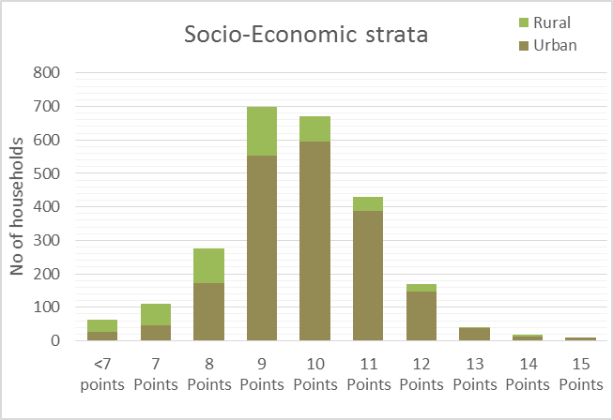From the scoring, four groups have been identified representing the very poor households (0-8 points), the poor (9-10 points), the middle income group (11 points) and the high income group (12 or more points).

The results correspond with the intended poverty focus and the distribution of the EAs.

The distribution in the four groups is shown in Figure 2‑4. 70% of the respondents in Western Urban are in the socio-economic groups of ‘very poor’ and ‘poor’ while in Western Rural this proportion is 85%. In particular the group ‘very poor’ is more represented in rural areas with 41% versus 12% in urban areas.

Figure 2‑4: Grouping of Socio-economic Status [‘F-Income-Exp’ P21:X35]

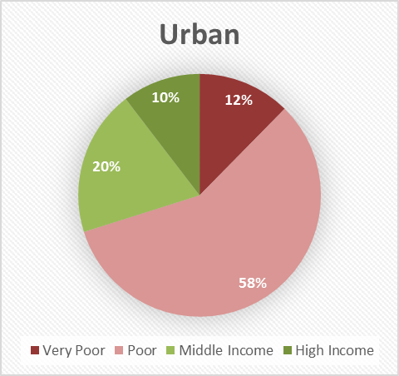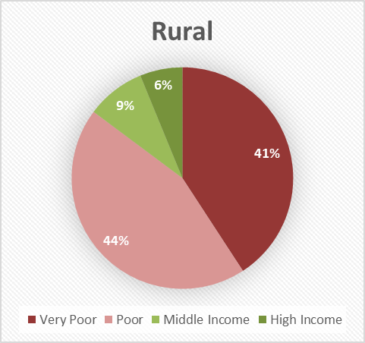

# Characteristics – Households and Commercial Enterprises

## Socio-economic data - Western Urban and Rural

### Gender and Age of Household Heads and Respondents

Target respondents for the household survey were household heads, but where the household head was not informed about water consumption in the home, a second respondent that was more informed was added.

Figure 3‑1: Gender of Respondents [‘A-Respondents’ A45:F55]

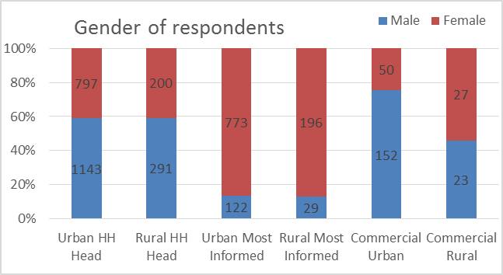Figure 3‑1 shows the distribution of men and women among the household heads and most informed household members interviewed as well as the gender of the heads of the commercial enterprises that were interviewed.

The analysis of the data shows that about 60% of the household heads are men and 40% women in both rural and urban areas, while about 90% of the ‘most informed respondents’ are women, indicating that women are the ones that are more informed about water consumption in the home.

The majority of the heads of commercial enterprises that were interviewed in urban areas were men (75%), however the heads of the rural commercial enterprises were mainly women (55%).

Figure 3‑2: Age Distribution of Household Heads and Most Informed Respondents [‘A-Respondents’ A56:F62]

Figure 3‑2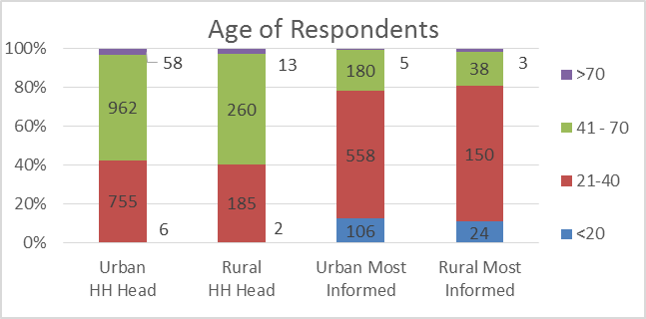 illustrates the age distribution amongst the household heads and the most informed respondents in urban and rural areas.

The majority, about 60% of the household heads are between 41 and 70 years old in both rural and urban areas. The most informed respondents are typically younger with 10% less than 20 years’ old, 70% between 21 and 40 and only 20% above 41 years.

### Educational Status of Respondents

About 20% of the household heads in Western Urban, comprising 15% of men and 25% of women, have no formal education, about 30% have some level of primary and secondary education, while 50% have completed secondary school and have had some tertiary education.

About 30% of the household heads in Western Rural, comprising 35% of men and 23% of women, have no formal education, about 35% have some level of primary and secondary education, while 35% have completed secondary school and have had some tertiary education.

Figure 3‑3: Education of Household Heads and ‘most informed respondent’ [A-Respondents N47:T60]

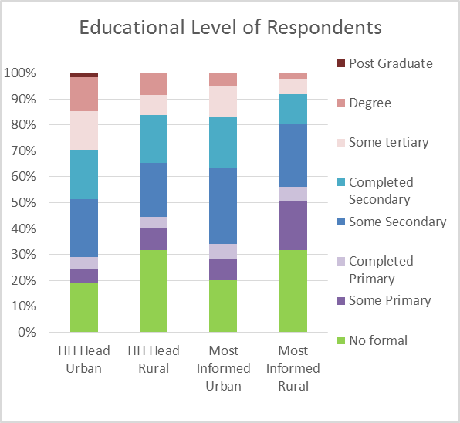The trend in educational status amongst the ‘most informed respondents’ is similar however the segment with some level of primary and secondary education is larger, 45% in urban and 50% in rural areas with a corresponding lower level of persons who have completed secondary education and has tertiary education with about 35% in urban areas and 20% in rural areas.

The data also indicate that the education level for men is significantly higher than for women and that poor households have a much higher percentage of members with no formal education.

The educational level in urban areas is higher than in rural areas and this would indicate a higher level of ability and willingness to pay for water services in urban areas.

### Employment Status of Respondents

Figure 3‑4 illustrates the employment status of the household heads and the ‘most informed respondents’ in urban and rural areas respectively.

25% of the respondent household heads in urban areas are in ‘paid employment’ and the majority, about 55% are reporting that they are self-employed.

The trend is similar in rural areas where 20% of the household heads are in paid employment and about 60% are self-employed.

Figure 3‑4: Employment Status of Household Heads and Respondents [‘A-Respondents’ U47:Z60]

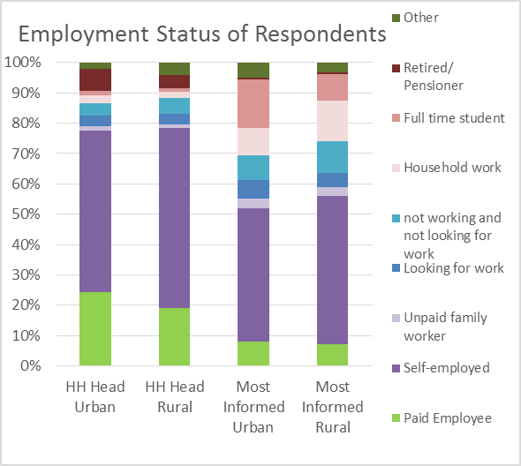The rate of paid employment for the ‘most informed respondents’ is lower than the household heads with less than 10% in both rural and urban areas and with the proportion of self-employed being about 45% in urban and 50% in rural areas; leaving higher proportions for the other categories such as not working, household work and full time students. The fairly high proportion of full time students corresponds well with the lower age of the ‘most informed respondents’ compared to the household heads as presented in Figure 3‑2 above.

Generally there is a slightly higher proportion of households with income from paid employment in urban areas compared to rural areas and this could indicate a higher level of ability to pay for water services in urban areas.

Figure 3‑5: Profession of Respondents [‘A-Respondents’ AD52:AI63]

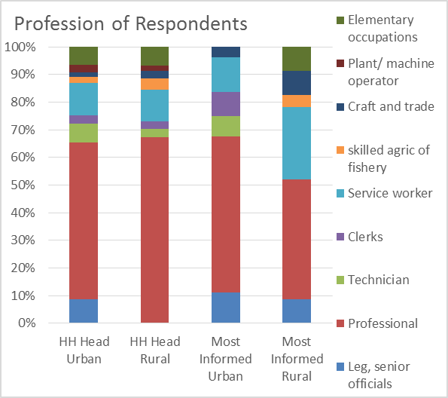The profession of the respondents that are in paid employment (or looking for work) is illustrated in Figure 3‑5. The highest proportion is classified as ‘Professional’ – this includes all skilled workers, mostly not holding a managerial post. It includes teachers, health workers, security (police and military) and those in civil/ public service.

The distribution of the type of professions are similar for the urban and rural areas with the exception that there are no household head respondents in rural areas in the ‘legal, senior officials’ category.

Amongst the ‘most informed respondents’ there are less ‘professionals’, ‘technicians’ and ‘clerks’ and more ‘service workers’ in rural areas. Generally the respondents in urban areas that have paid employment are in more senior positions than the respondents in rural areas.

### Household Tenure and Size

Figure 3‑6: Tenancy Distribution [‘A-Respondents’ G40:K52]

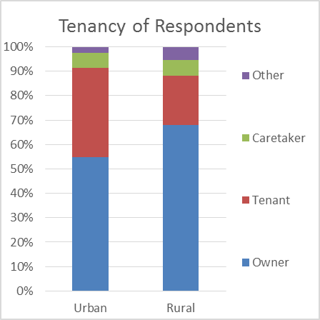**Tenure**: Analysis of the household tenure data shows quite a high number of house owners in the sample, with 55% of respondents in urban areas and close to 70% in rural areas being owners of the premises where they reside.

The detailed data shows quite some variation across town with almost 50% being tenants in in typical urban areas such as ‘Central’ and as much as 90% being house owners in typical rural areas such as ‘Koya Rural’. The majority of the tenure arrangements classified as other covered two types: where the occupants were relations of the owner and various kinds of government quarters.

The tenure is important for the payment of water from water service providers such as Guma since it is typically the owner of the compound that would be responsible for the account with the water company and the tenants would pay their part of the water bill when paying for rent. The almost 40% of the respondents in urban areas that are tenants would therefore report on the rate for water they would pay to the owner rather than the rate paid directly to Guma.

Figure 3‑7: Number of Compounds and Household Sizes [‘A-Respondents’ BX16:CB28]

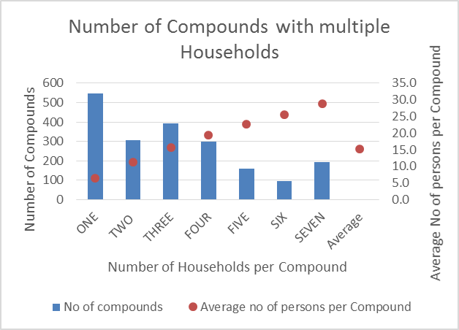**Household Size**: The size of the households of the respondents vary between 6 and 7 members in the different areas of town. The households in a compound in addition to the respondents are typically smaller as shown in Table 3‑1.

Table 3‑1: Household Members

Figure 3‑7 illustrates the number of compounds with different number of households per compound in urban areas. About 28% of the respondents in urban areas live in single household compounds while the rest live in compounds with up to seven households. The detailed data also show that the single household dwellings rise with the income level – poorer people tend to live in bigger compounds.

In average there are 15.3 persons per compound. This is an important figure when assessing the average consumption of water since typically a piped connection will serve this number of persons and not only the persons in the respondents own household.

In rural areas, at least half of the households interviewed own their house, while between 25% and 45% are renting.

### Household Incomes and Expenditures

**Household Incomes**

Figure 3‑8: Average Household Incomes per Area [‘F-Income-Exp’ AJ20:AP35]

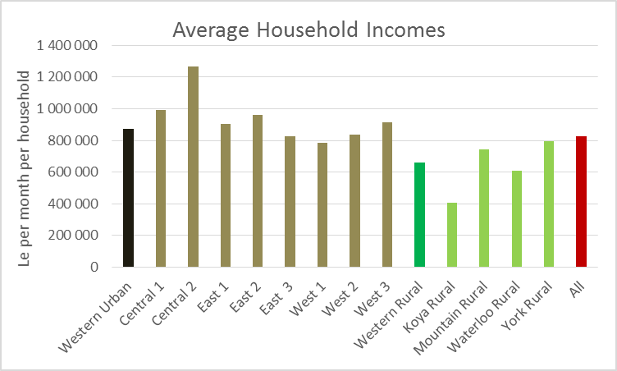The data collected on household income indicate and average income of just above Le 800,000 per household per month in the group of respondents.

As described in Chapter 2.1 above, the sampling specifically targets the poorer households and the average income in the group of respondents would therefore be lower than the general level of household incomes in Western Area.

The average incomes vary between urban and rural areas and between the different locations as shown on Figure 3‑8. Generally the salary/ cash incomes are higher in urban areas compared to rural consistent with a higher degree of subsistence farming in rural areas. The highest incomes are in Central 2 and the lowest in Koya Rural.

Figure 3‑9: Variation in Incomes in Rural and Urban Areas [‘F-Income-Exp’ AE23:AJ37]

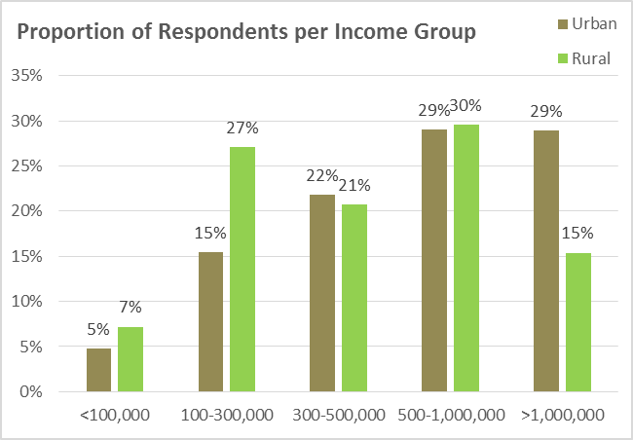The variation in incomes in urban and rural areas is illustrated on Figure 3‑9. Generally there is a lower proportion of households in the lower income brackets in rural areas compared to urban. 60% of households in urban areas have incomes above Le 500,000 per month while in rural area this proportion is 45%.

The proportions of the respondents in the different income groups per area is illustrated on Figure 3‑10 and Figure 3‑11.

Figure 3‑10: Respondents per Income Group in Urban Areas [‘F-Income-Exp’ AF38:AN51]

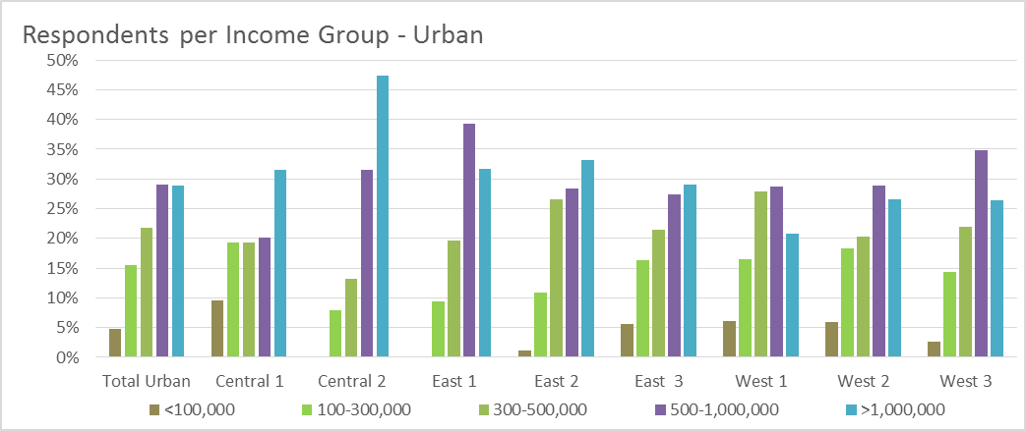

Figure 3‑11: Respondents per Income Group in Rural Areas [‘F-Income-Exp’ AH51:AN65]

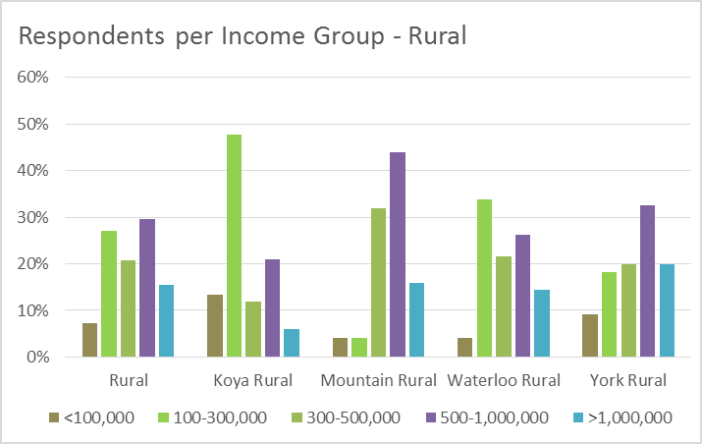There are very few or no household with incomes less than Le 100,000 per month in Central 2 and East 1 and 2 and almost 50% of the households in Central 2 have incomes above Le 1,000,000 per month.

In rural areas the proportion of households with lower incomes is highest in Koya Rural.

**Household Expenditures**

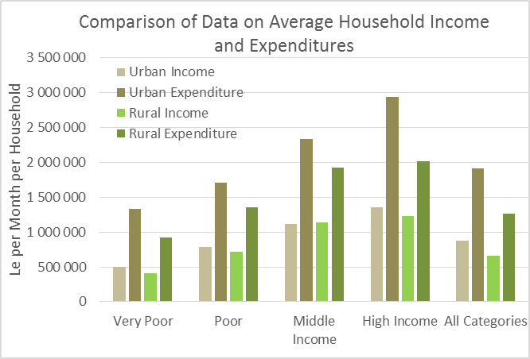Figure 3‑12: Comparison between Income and Expenditure Data [‘F-Income-Exp’ CD9:CI22]

It is generally considered more difficult to collect reliable data on household incomes as compared to data on expenditures, either because of reluctance to reveal incomes or because the incomes are not known because of informal employment etc. This is illustrated on Figure 3‑12 showing the data collected on income and expenditures in the different income groups. The data on expenditures are considerable higher than incomes in both rural and urban areas for all the income groups.

A list of expenditure items was used in the interview and the figures, which were recorded as per day (ex. food expense), per week (ex. transport), per month (ex. rent) or per quarter (ex. education). The figures were recalculated as expenses per month. The accuracy of the figures for expenditure could be limited, as it was not always easy for respondents to reveal what is paid for what. While the income data could be under-reported by the respondents, there could also be a tendency to report higher household expenditures by the respondents to underscore affordability problems. However generally the expenditure data are considered more reliable and will be used in the analysis below on affordability of water.

Data on household expenditures were collected on a variety of items such as water (in general and drinking water specifically); food; transport (in general and fuel for vehicles); rent and other HH costs (including electricity, fuel for generator and cooking, communication, health and clothing); and other that include entertainment, education, contributions to family and religious institutions etc.)

The total level of household expenditures is indicated on Figure 3‑12 above for the different income groups and the distribution on the different types of expenditures is illustrated on Figure 3‑13 for urban households and on Figure 3‑14 for rural households.

Figure 3‑13: Expenditures in Urban Households [‘F-Income-Exp’ CK38:CR52]

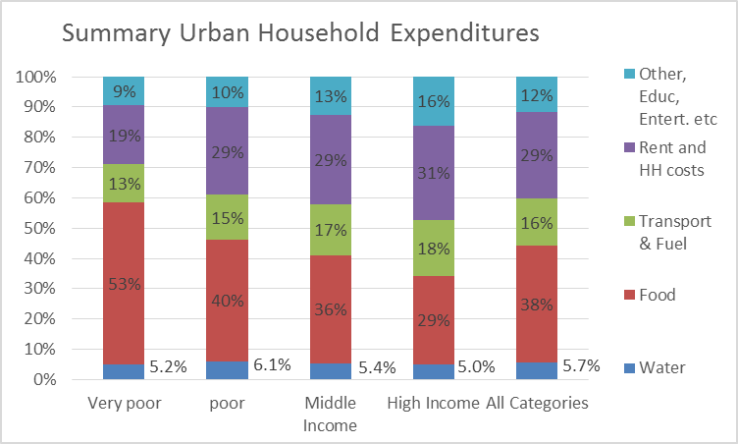Food is the major expenditure item for the very poor and poor households in urban areas. The poorest households spend more than half of available resources on food while this for other income groups reduces to about one third. At the same time the very poor use a smaller proportion on rent and other household costs of about 20%.

The higher income groups spend a larger proportion on housing and other items such as education, entertainment etc. Transport is a major expenditure item for all households and in particular for the high income groups with ownership of vehicles. These figures are in line with what could be expected with the very poor using a high part of available resources for food and are living in very poor standard accommodation. The proportion used on water will be described further below.

Figure 3‑14: Expenditures in Rural Households [‘F-Income-Exp’ DD38:DK52]

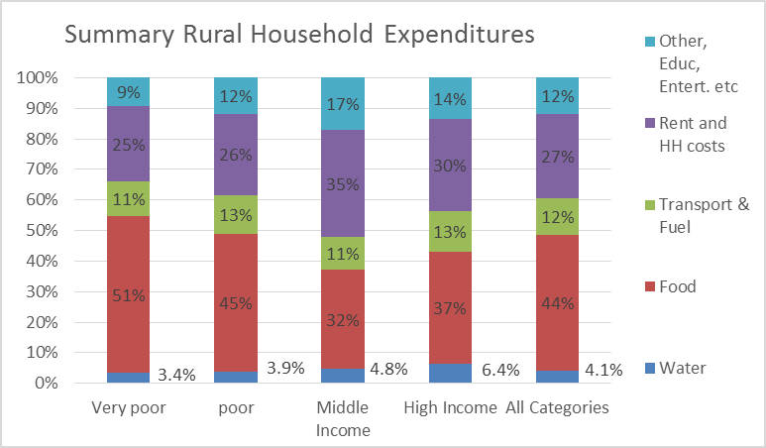The expenditure patterns in rural areas are similar as shown on Figure 3‑14. The differences in spending patterns between the ‘middle income’ and ‘high income’ are likely to be due to the small number of households in these categories in the sampled households in Western Rural.

Although the spending patterns in terms of the proportion of expenditures on different items is very similar in urban and rural areas, the actual expenditures are significantly lower in rural areas as shown on Figure 3‑15. The lower amounts spent on food in rural areas could indicate that rural households produce some of the food items through subsistence farming.

Figure 3‑15: Expenditures in Urban and Rural Areas [‘F-Income-Exp’ DE59:DN61]

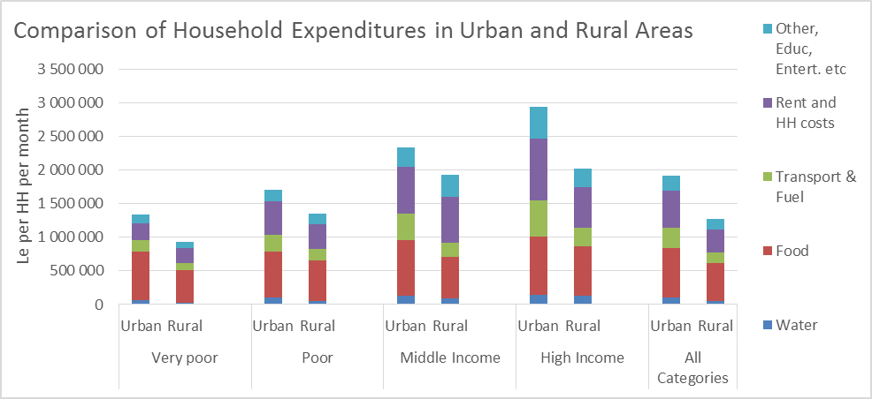

## Data on Commercial Enterprises

Figure 3‑16: Commercial Enterprises per City Section [‘A-Respondents’ D85:K98]

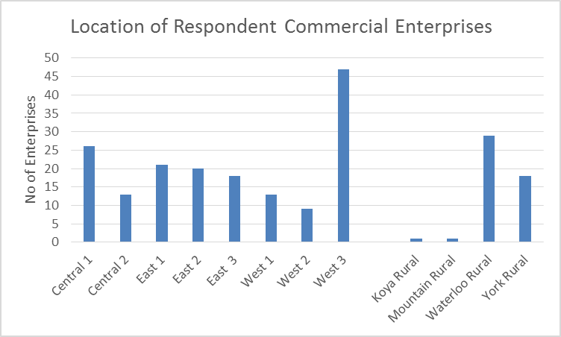Data was collected from 250 commercial enterprises in Western Urban and Rural. The distribution of the commercial consumers in the different city sections is shown in Figure 3‑16.

A greater proportion of the establishments are located in West 3 (about 22%), followed by Central 1 (12%). The East has a total of 27% of the establishments, distributed fairly uniformly over the 3 sections.

The enterprises included in rural areas are mainly located in Waterloo and in York Rural since there are not many enterprises in Koya and Mountain Rural.

Figure 3‑17: Type of Commercial Enterprises [‘A-Respondent’ L85:R98]

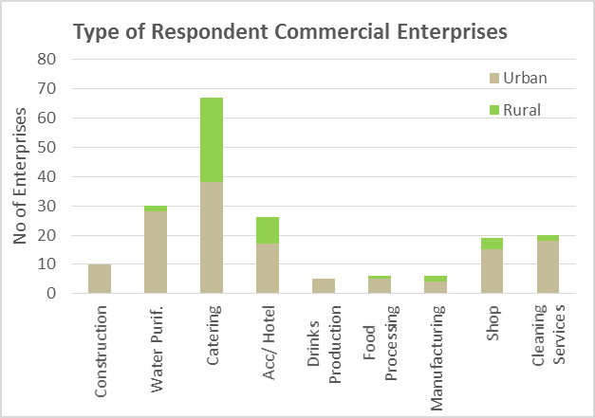The different types of commercial establishments in rural and urban areas are presented in the chart in Figure 3‑17. The majority of the enterprises included in the survey are in catering since this is the dominating type of enterprises, especially in rural areas.

Figure 3‑18: Gender of the Respondents from Commercial Enterprises [‘A-Respondent’ E100:L111]

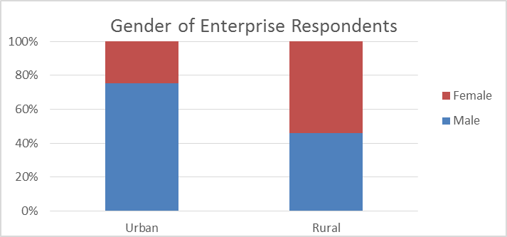The majority of the enterprises included in the data collection are managed by men in urban areas while 55% of the rural enterprises are managed by women, as illustrated on Figure 3‑18. The rural enterprises are mainly in the catering business.

Figure 3‑19: Size of Enterprises [‘F-Income-Exp’ N83:S99]

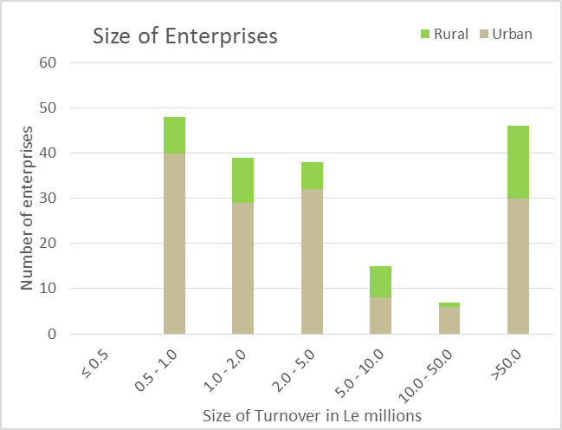Most of the enterprises included in the survey are small with annual turnover of less than Le5 million, with about 50 with a turnover above le 50 million as illustrated on Figure 3‑19.

The average turnover of the different types of enterprises are shown in Figure 3‑20.

Figure 3‑20: Average turnover of Enterprises [‘F-Income-Exp’ B85:G101]

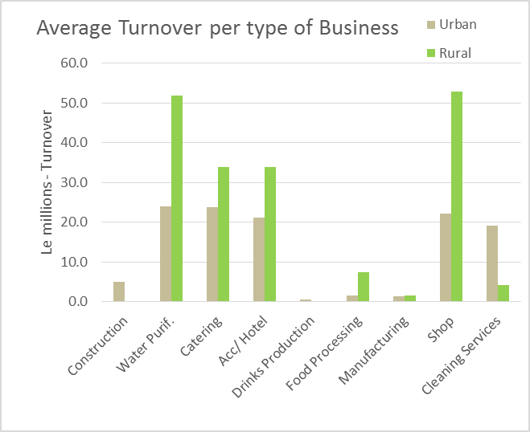

# Access to Water

## Water Sources

### Water Sources for Households

The study has identified fourteen typical sources of access to drinking water, not all them safe:

|  |  |  |
| --- | --- | --- |
| 1. Piped into dwelling 2. Piped into yard 3. Public stand pipe 4. Borehole 5. Protected well | 1. Un-protected well 2. Protected spring 3. Un-protected spring 4. Pushcart vendor 5. Tanker | 1. Packet water 2. Surface water 3. Rainwater 4. Neighbour pump |

With the exception of ‘packet water’ all sources are self-defined. Packet water is produced by private individuals using a packing machine and water from Guma. Each pack contains 20 bags of water of ½ a litre each. These bags are sold by stores and street vendors.

The information about sources has been collected from the different city sections. The information collected includes use of different sources by season and by income group, perceived quality of water by source, the volume of water used from each source per day and the daily cost and who is collecting the water. Information about the time spent fetching water was also gathered.

Figure 4‑1 shows the relative importance of the different water sources used in the dry season in the urban areas.

Figure 4‑1: Water Sources in the Dry Season in Urban Areas [‘B-Volume of Water by Source’ AR50:AZ68]

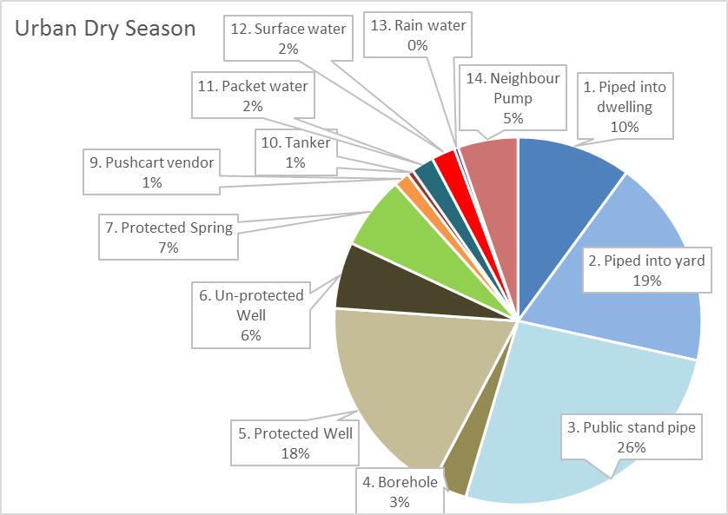The main observations are:

* Piped water is the main source of water – 55% of the water consumed in urban areas comes from piped systems, either through pipe connections to houses or yards or from public standpipes.
* The second most important source of water is groundwater. 27% of water used in urban areas is from either boreholes, protected or un-protected dug wells
* Packet water in terms of volume of water is a minor source – although very important as source of safe drinking water. In terms of volume, tankers and pushcart vendors supply only a minor part of the water used in town.
* Untreated surface water is used in some areas – 2% of the water used in Freetown is from untreated surface water sources.

Figure 4‑2 shows the relative importance of the different water sources used in the rainy season in the urban areas.

Figure 4‑2: Water Sources in the Rainy Season in Urban Areas [‘B-Volume of Water by Source’ BI50:BP68]

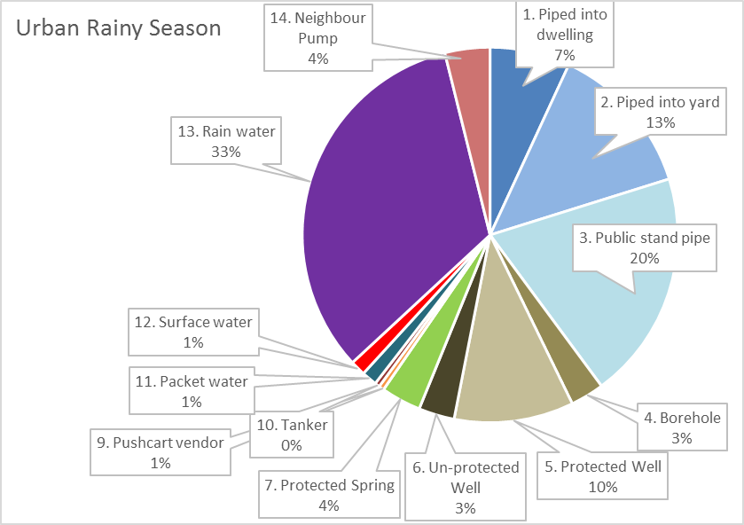It can be observed that rainwater play a major role in the rainy season and supplies 33% of the water consumed in urban areas.

The proportional importance of the other water sources in the rainy season is similar to the dry season water sources.

Figure 4‑3: Water Sources in the Dry Season in Rural Areas [‘B-Volume of Water by Source’ AZ50:BH68]

Figure 4‑3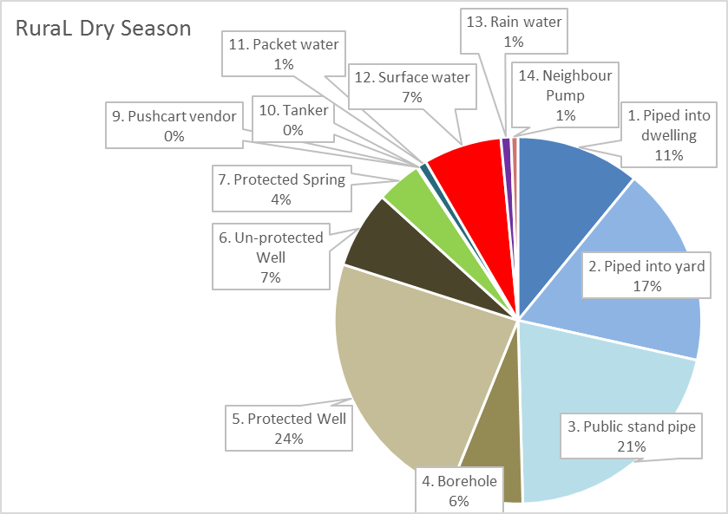 illustrates the relative importance of the different water sources in the dry season in rural areas. Piped systems serve about 50% of the water requirements through house or yard connections or public standpipes.

Like in urban areas, groundwater is the next important source of water supplying 37% of the volume of water used in rural areas from boreholes and protected or un-protected wells.

The proportion of water supplied by tankers and pushcart vendors is minimal and in terms of volume, packet water play a minor part. Surface water supplies is used by a significant proportion of the population as 7% of the water used in rural areas are from untreated surface water sources.

Figure 4‑4: Water Sources in the Rainy Season in Rural Areas [‘B-Volume of Water by Source’ BQ50:BY68]

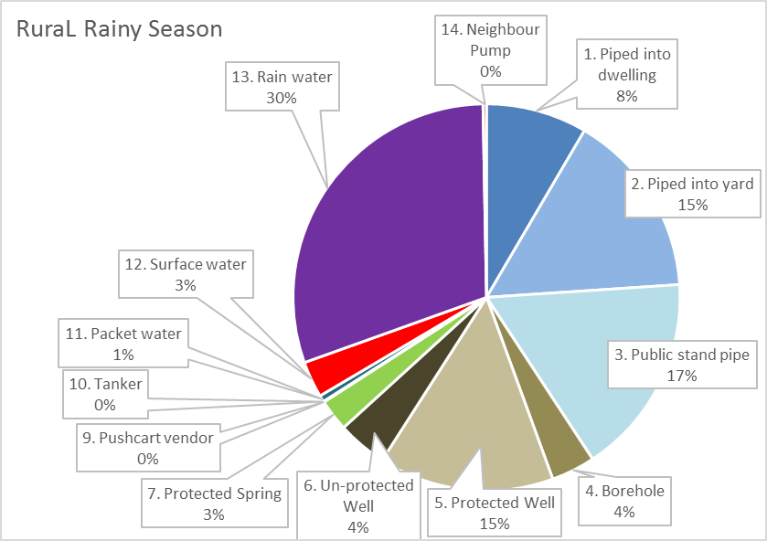Rainwater harvesting play a major role in the supply of water in rural areas during the rainy season with 30% of the water consumed in rural areas coming from rainwater sources.

The proportional importance of the other sources is similar to the dry season. The use of surface water sources is reduced to 3% in the rainy season – likely due to the easy access to rainwater sources.

**Water Sources in different geographical areas**

The water sources vary considerably between the different locations within Western Area. Figure 4‑5 illustrates the use of different water sources in different areas of town. Some areas such as Central 2 have almost 90% of the water use from piped water sources while other urban areas such as East 3 has less than 40% of the water supplied by the piped water systems.

In rural areas, Koya Rural is exceptional with no piped systems and almost 30% of the water use coming from surface water sources and the remaining 70% from groundwater sources.

Figure 4‑5: Sources of Water in the Dry Season [‘B-Volume of Water by Source’ B4:L19]

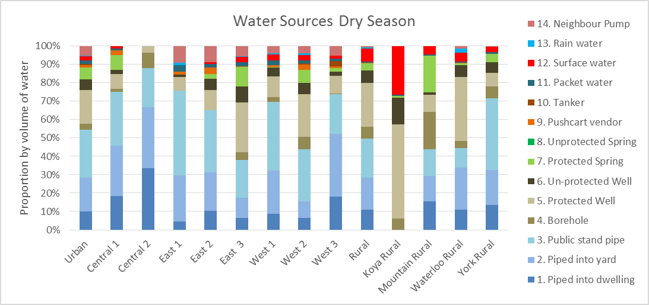

Figure 4‑6 illustrates the differences in water sources used in the rainy season in the various areas of town. The availability of rainwater changes the water use in most areas except where the coverage with piped water is very high such as in Central 2.

Figure 4‑6: Sources of Water in the Rainy Season [‘B-Volume of Water by Source’ O4:X19]

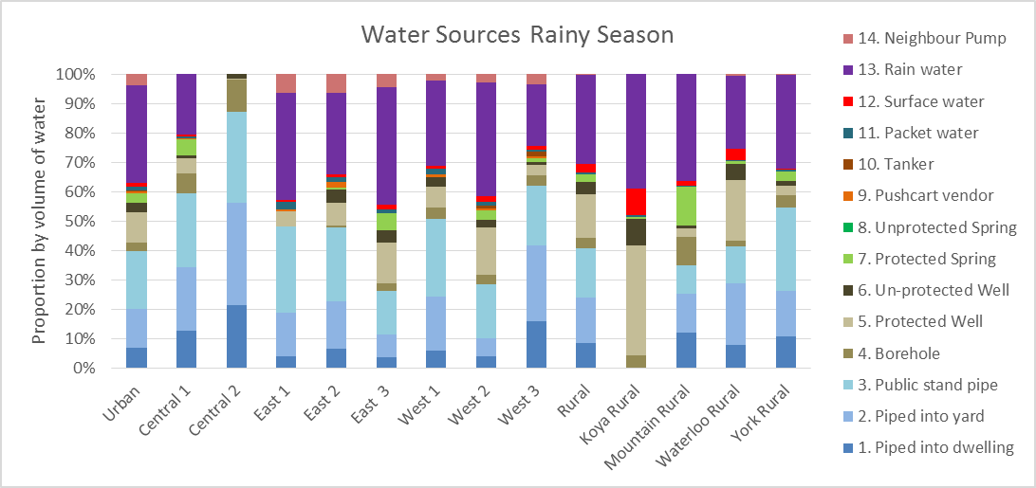

**Access to drinking water by income group and by source**

Figure 4‑7 shows the various water sources by income group. Main observations include:

* Piped water is more available for the higher income groups with only 40% of the very poor accessing piped water and more than 70% of the high income having access to piped water.
* Ground water from boreholes and wells play an important part for the lower income groups
* Almost 10% of the very poor use untreated surface water as their supply of water.

Figure 4‑7: Sources of Water by Income Groups in the Dry Season [‘B-Volume of Water by Source’ AR80:AZ96]

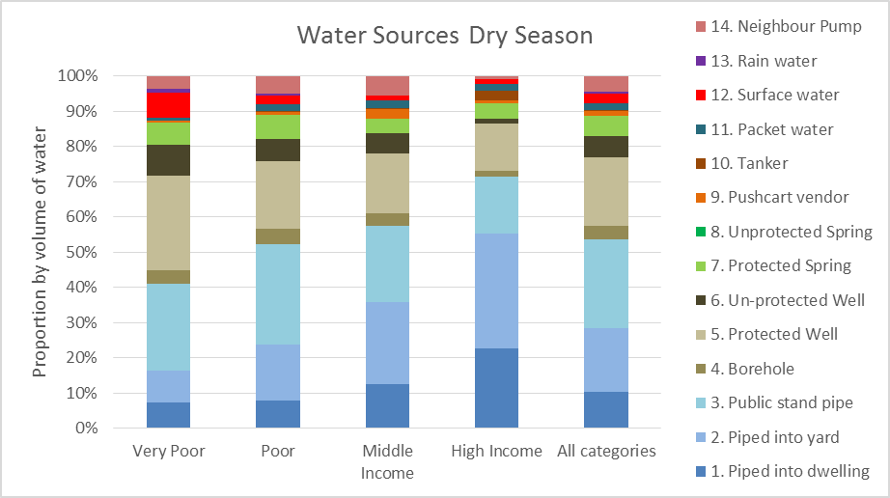

The water sources in the rainy season according to income groups are illustrated on Figure 4‑8. It is evident that rainwater is a major source of water for all income groups and in particular the poorer segments get more than 30% of their water use from rainwater in the rainy season.

Figure 4‑8: Sources of Water by Income Groups in the Rainy Season [‘B-Volume of Water by Source’ BI81:BQ96]

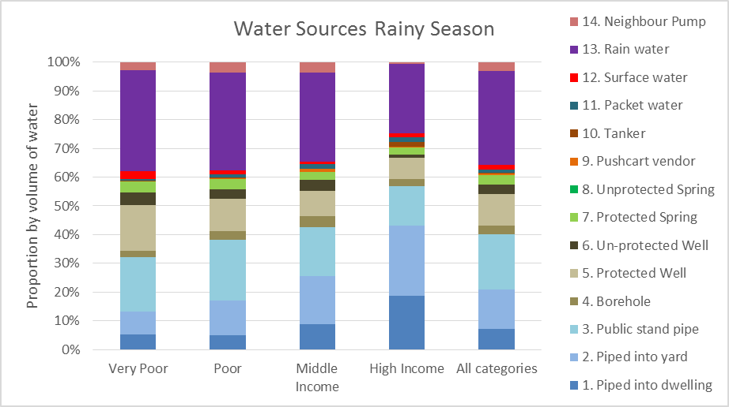

### Water Sources for Enterprises

The sources of water in the dry season for the commercial establishments are shown in Figure 4‑9.

Figure 4‑9: Sources of Water in Dry Season for Commercial Enterprises [‘B-Volume of Water by Source’ B20:L36]

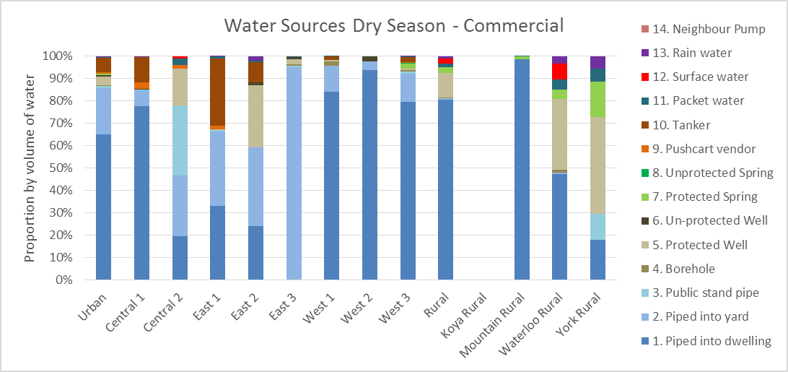

Piped systems in the form of yard or house connections provide almost 90% of the water use in commercial enterprises in the urban areas and 80% in rural areas. Groundwater is a main source of water in areas without reliable piped systems such as East 2, Waterloo Rural and York Rural. Tanker services also play a major role in some areas e.g. in East 1 30% of the consumption is from tankers. The sources of water in the rainy season for the commercial enterprises is illustrated in Figure 4‑10. Piped water connections are also the main source of water in the rainy season and rainwater is an important supplementary source of water in some areas such as Central 2, Waterloo Rural and York Rural.

Figure 4‑10: Sources of Water in the Rainy Season – Commercial [‘B-Volume of Water by Source’ O20:X36]

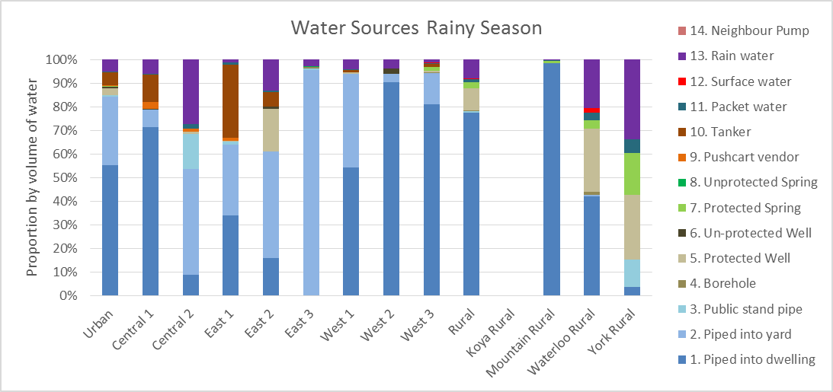

## Water Collection

### Time for Collection of Water

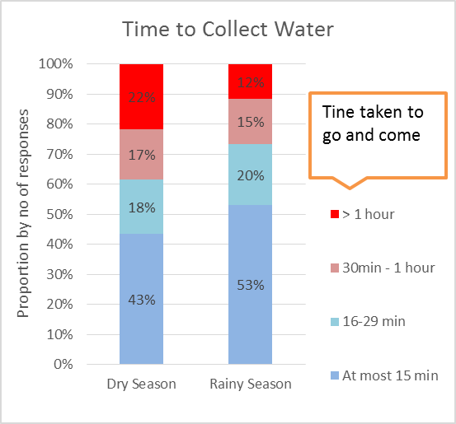Figure 4‑11: Time Spent Collecting Water [‘B-Water Source Dry Season’ AA78:AF94]

The time spent collecting water is shown in Figure 4‑11 combined for rural and urban households and for commercial enterprises in the dry and rainy seasons. It should be noted that:

* During dry season 21% of the population in Western Area spend more than 1 hour fetching water, compared with about 11% in the rainy season. This correspond to the wide use of rain water collection as an easy accessible source in the rainy season.
* 45% of the population use less than 15 minutes for collecting water in the dry season and this raises to about 55% in the rainy season.

The results show that providing access to water is a heavy burden for the households and commercial enterprises in terms of the time it takes – time that could more productively be used for other purposes. The data also provide information on who is using time to collect water as presented below.

### Who collects Water

Figure 4‑12: Who Collects Water in Households [‘B-Water Source Dry S’ BU79:BY97]

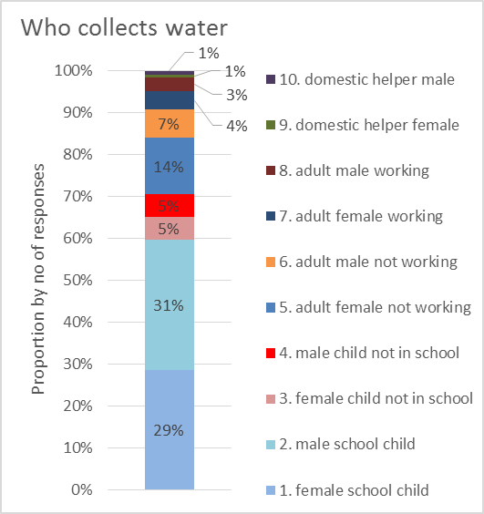The responsibility for collection of water is illustrated in Figure 4‑12. The detailed data show very little variance in who collects water in the dry and rainy season.

It is clear that the main burden for collection of water is on children – both boys and girls. 70% of the water is collected by children and this is likely to have adverse impact children schooling; i.e., in several focus group discussions water collection was stated as the reason for the children being late for school and for some social problems such as teenage pregnancies.

These problems are more pronounced in the eastern sections and in Western 2 where coverage with piped water seems much lower as illustrated in Figure 4‑5.

Figure 4‑13: Who Collects Water in Commercial Enterprises [‘B-Water Source Dry S’ BL99:BQ116]

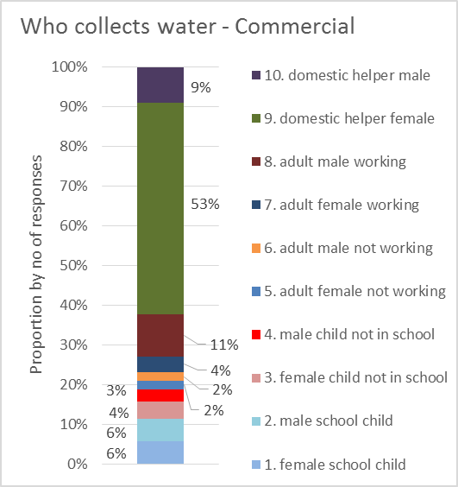The children also play a role in the collection of water in commercial enterprises although to a much lesser degree. Figure 4‑13 illustrates the responses from the commercial enterprises indicating that in about 20% of the enterprises the collection of water is done by children and 80% is collected by adults working or classified as domestic helpers. The majority of the adults collecting water are female.

## Practices in relation to Water

### Treatment of Drinking Water

Figure 4‑14: Treatment of Drinking Water [‘B-Water Treatment’ B54:E69]

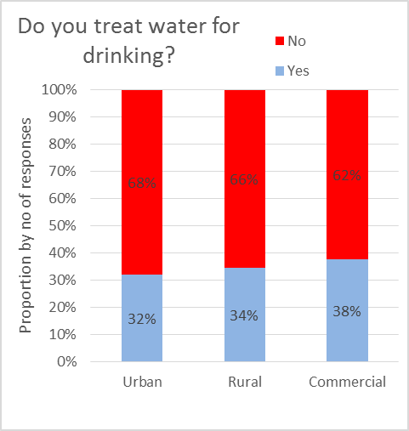The practises for treating drinking water are shown in Figure 4‑14.

32% of urban households and 34% of rural households treat water for drinking. The data show that in households where treatment of water is done, it is mainly water from un-protected sources that is treated, but it does include piped water also.

38% of the commercial enterprises are treating the water used for drinking purposes.

Figure 4‑15: Methods for Water Treatment [‘B-Water Treatment’ I54:O69]

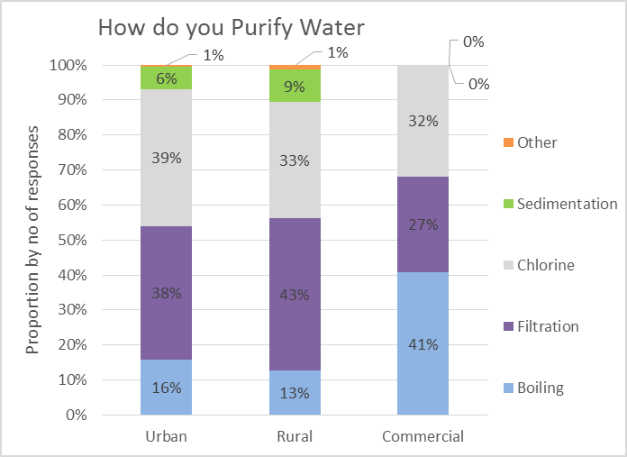Various methods are used for treatment as illustrated Figure 4‑15. Addition of chlorine or filtration is most commonly used in households in both urban and rural areas. The commercial enterprises are mostly treating the drinking water by boiling (41%) and to a lesser degree using filtration (27%) and addition of chlorine (32%).

### Water Storage

Most households and enterprises cope with the irregular supply of water by storing the water. 99% of the households in urban areas and 97% of households in rural areas reported that they store water and 96% of the commercial enterprises store water.

Figure 4‑16: Type of Water Storage [‘B-Water Treatment’ W54:AB69]

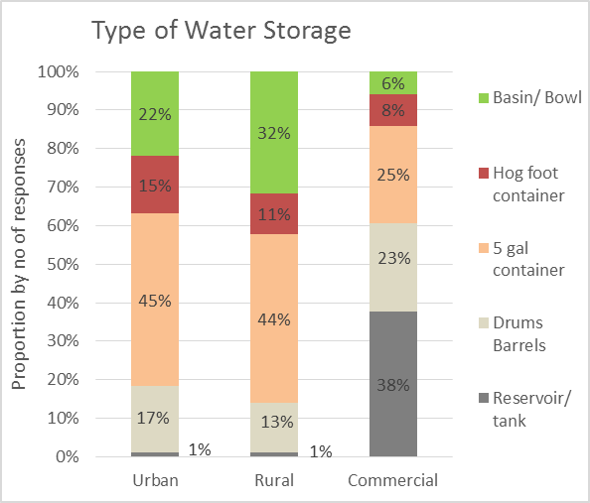The use of storage container in urban and rural households and in commercial enterprises is illustrated on Figure 4‑16.

The water for domestic consumption is mostly stored in drums or smaller containers and only the commercial enterprises use reservoirs and tanks to a larger degree.

It should be noted that the sampling method specifically targets the poorer households in Freetown and that a more uniform sampling might reveal a higher use of reservoirs and tanks since it would mainly be the higher income households that would afford the installation of tanks.

## Volume of water consumed

### Volume of Water – Households

The data on volume of water consumed per person for domestic purposes in the dry and wet season for the different areas is presented in Figure 4‑17. The data on per capita consumption reveals that the water consumption is restricted during the dry season since the rainy season consumption rates are about 30% higher than the dry season rates. The figures also indicate considerable variations across the different areas with urban areas generally having higher consumption rates.

Figure 4‑17: Average Consumption per Person in Dry and Rainy season [‘B-Volume of Water by Source’ CD5:CO17]

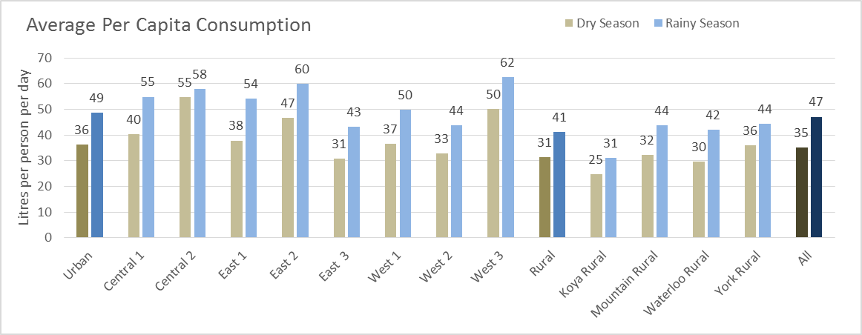

The average consumption in the rainy season of 48 litres per capita per day for the population of Freetown of about 1.3 million persons result in a consumption of approximately 63,000 m3 per day for domestic purposes. Approximately 45% of the water consumption comes from sources supplied by Guma such as the piped connections, public standpipes, tankers, packet water etc.; excluding the rainwater, groundwater and surface water sources. This indicates that Guma and to a small extent other water service providers would be supplying about 28,000 m3 per day for domestic purposes. Based on the responses on Guma and other service providers, Guma would supply 92% of the consumption or about 26,000 m3 per day.

Figure 4‑18: Volume of Water Supplied by Guma ‘Guma SIM ver0’ [‘Data’ G55:J79]

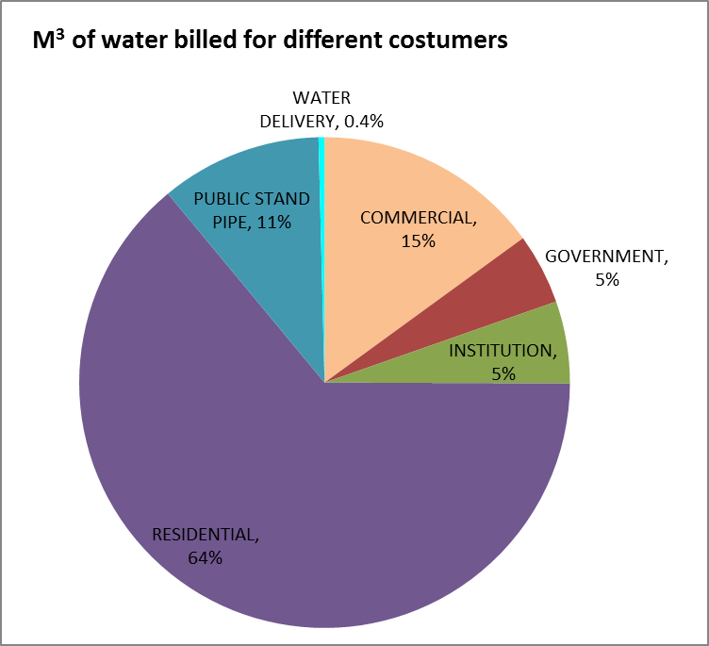The data on estimated delivery of water to the different type of customers in Freetown by Guma[2] indicate that the domestic consumption is approximately 75% of the total water supplied by Guma while the commercial, government and institutional consumption is about 25% as shown on Figure 4‑18. The total monthly delivery based on the billing data and average tariff rates is an estimated 1,000,000 m3/month or 750,000 m3/ month for domestic purposes.

The volume of water supplied for domestic purposes by Guma is therefore approximately 25,000 m3 per day according to the Guma records and this confirms that the average consumption data collected from the household surveys are of the correct magnitude.

### Volume of Water – Enterprises

The average volume of water used by the enterprises are illustrated on Figure 4‑19.

Figure 4‑19: Average Volume of Water used by Commercial Enterprises [‘B-Volume of Water by Source’ CH20:CS31]

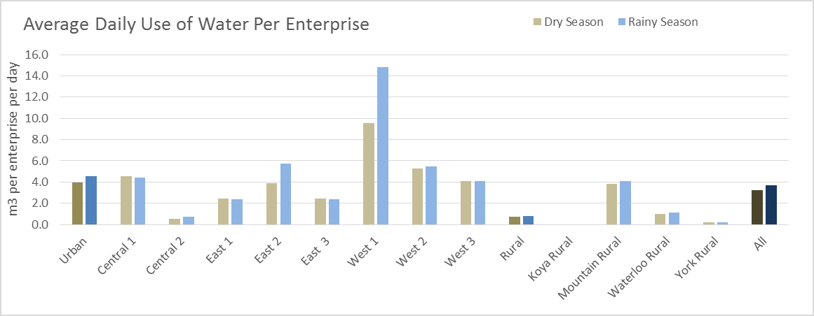

The water usage naturally depends on the type of enterprises and this is illustrated on Figure 4‑20. The Water Purification enterprises typically use more water than the other type of industries.

Figure 4‑20: Average Volume of Water used by Type of Enterprises [‘B-Volume of Water by Source’ DZ20:EK35]

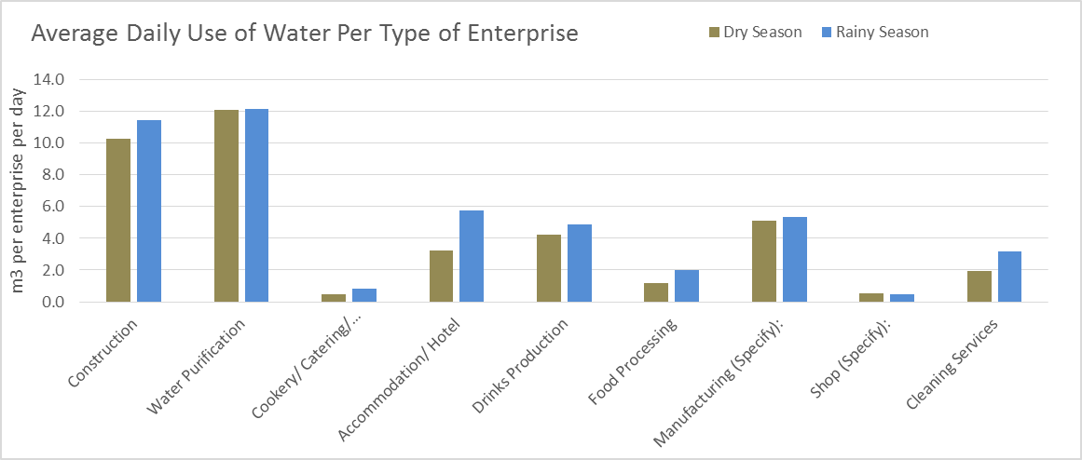

## Services from Water Providers

### Water Service Providers

Figure 4‑21: Water Service Providers [‘C-Reliability’ F36:I47]

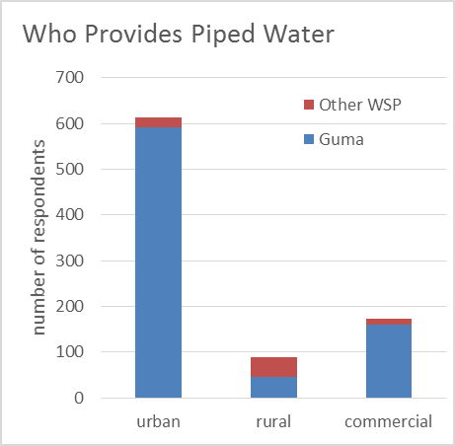The following data represents households that are supplied by a water service provider in the compound where they live or from the neighbours’ connections.

The main water service provider in the area covered by the survey is Guma serving more than 90% of the households in urban areas and the commercial customers.

In rural areas Guma serves about 50% of the customers that have access to piped water services. This is in the areas from the Treatment Plant to the western part of Freetown. ‘Other WSPs’ include Hastings Dam, Community Dam, Private pipelines, Piped Spring Water, and facilities provided by CRS, ADRA, and CARE.

Figure 4‑22: Type of Connection and Income Levels [‘C-Reliability’ C64:G77]

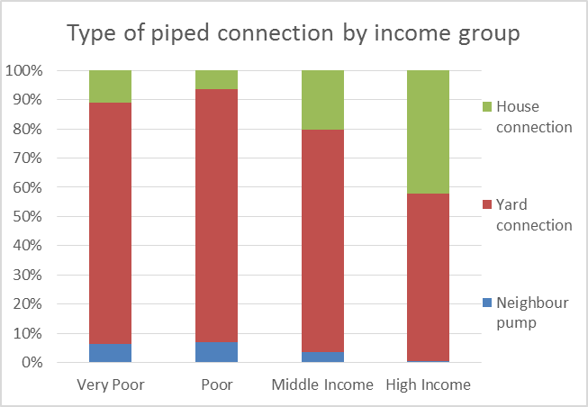The type of connections (in-house, yard tap, or collection from neighbour) used by the respective income categories is shown in Figure 4‑22.

The yard connection is the dominating type in all income categories. It is remarkable that only about 40% of the households in the high income group have access to house connections.

### Billing and Payment for Water – Households

**Billing**

Figure 4‑23: Payment for Water Services [‘D-Billing’ B102:F116]

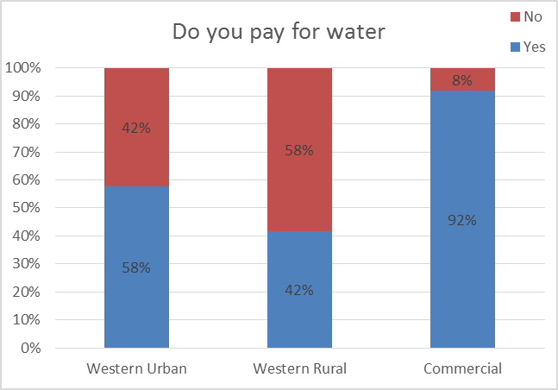A large proportion of the customers in Freetown receiving piped water services do not pay water bills.

42% of the customers in Western Urban and 58% of the customers in Western Rural do not pay for water. Only 8% of the Commercial customers do not pay for water services.

Only 3 of the household respondents who do not pay for water reported that they receive a water bill, so the main problem with payment for water seems to be that the customers do not receive bills from the water service providers. This indicates that the large majority of the households that do not pay for water do so because of inefficient billing and not due to un-willingness to pay the water bills.

Figure 4‑24: When was Last Water Bill Received [‘D-Billing’ O49:U62]

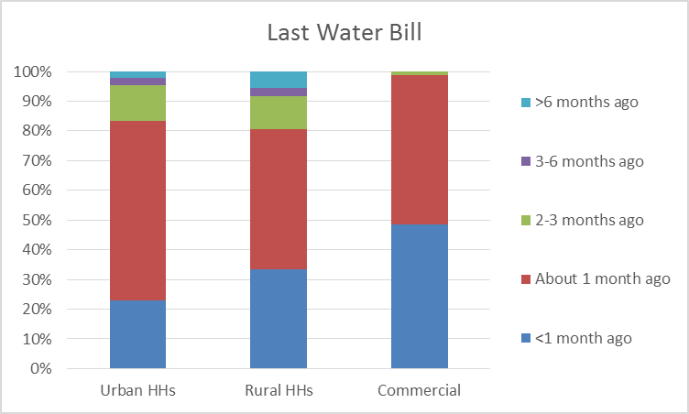The issue of billing is further illustrated on Figure 4‑24 showing that of the household customers who are billed for water, 80% received the last bill within the last month or about 1 month ago. The billing of commercial customers is more regular with 99% of the customers receiving bills within or about 1 month ago.

It appears that the water service providers focus on ensuring that the commercial customers are billed and pay less attention to the domestic customers.

**Type of Billing**

Figure 4‑25: Type of Billing System [‘D-Billing’ B128:F142]

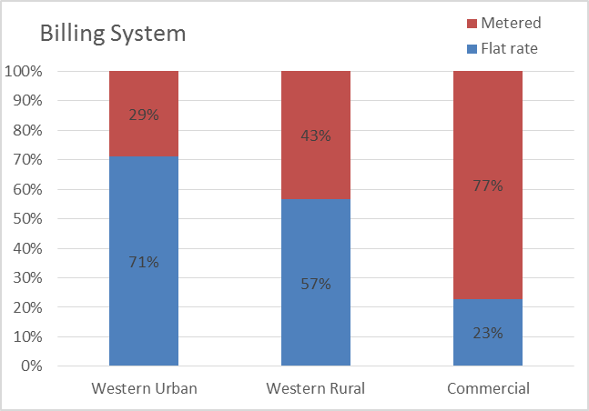The majority of the domestic customers in both rural and urban areas are billed according to a flat rate as shown in Figure 4‑25; while most of the commercial customers are metered with only 23% being billed a flat rate.

Figure 4‑26: Monthly Bills per Billing Method [‘D-Billing’ W70:Z84]

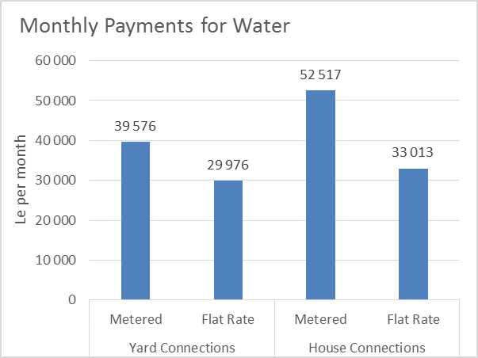The amounts paid for water according to the billing method and type of connection are shown in Figure 4‑26. Households with metered connections pay more for water than households that are billed a flat rate. Due to the higher consumption rates, households with house connections are in average paying more than households served by yard taps.

It is worth noting that the focus groups participants mentioned that typically the households that are paying flat rates are selling water to neighbours.

Figure 4‑27: Cost of Water from Different Types of Connections [‘D-Billing’ W92:Z106]

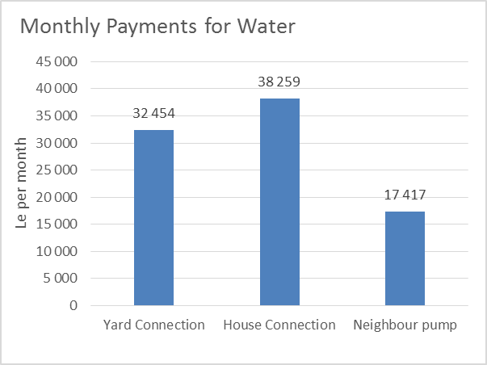The average bills for house connections are only marginally higher than the bills for yard connections. This might be explained by two issues: i) a large number of connections are billed on a flat rate and therefore the expected higher consumption from house connections are not reflected in the bills; and ii) the consumption from yard taps is similar to consumption from house connections since other households within a compound are served from the same connection.

The amounts paid by consumers who collect water from neighbours are less than for the households with their own connections. This seems logical since it is a shared water bill between several households. On the other hand, a yard tap shared between several households will generate a substantial income for the owner of the yard tap when each of the households collecting water from the tap pays about half of the flat rate charged by Guma for the connection.

Figure 4‑28: Payment of Water Bills [‘D-Billing’ AA48:AF62]

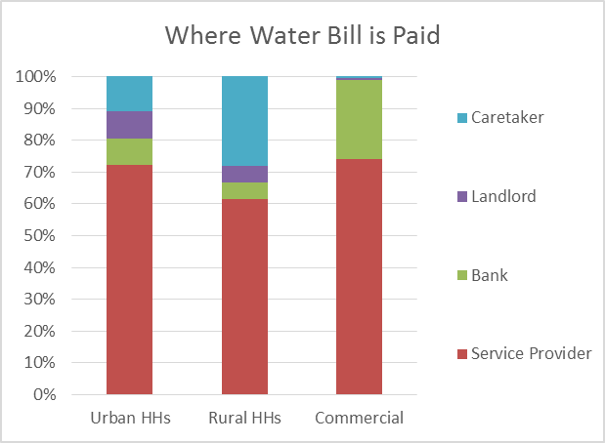**Where bills are paid:** The majority (70%) of the domestic consumers in urban areas pay water bills directly to the water utility and less than 10% pay through the banks. About 20% pay to landlords or caretakers, typically where the respondent household is renting accommodation in a compound with a yard connection. In rural areas the situation is similar with about 60% paying to the water utility and 35% paying to the landlords or caretakers.

A larger proportion of the commercial consumers take advantage of the banking facilities with about 25% paying the water bills to the banks and 75% paying directly to the water utility.

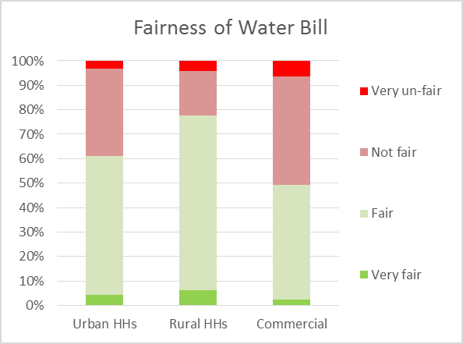Figure 4‑29: Rating of Fairness of Water Bills [‘D-Billing’ AG48:AK62]

**Rating of bills**: Information was collected on how fair the respondents regarded their water bills. The majority (60%) of the consumers in urban areas rate their bills as fair or very fair, while around 40% rate the bills as not fair or very un-fair.

The households in rural areas are more satisfied with almost 80% rating their bills as fair or very fair.

Amongst the commercial consumers, only 50% regard their water bills as fair.

The main complaint relates to the irregularity of the supply, while the satisfaction relates to the low price and the perception that the water is safe.

### Satisfaction with Service Provider

Figure 4‑30: Satisfaction with Water Service Provider [‘D-Billing’ AM49:AQ62]

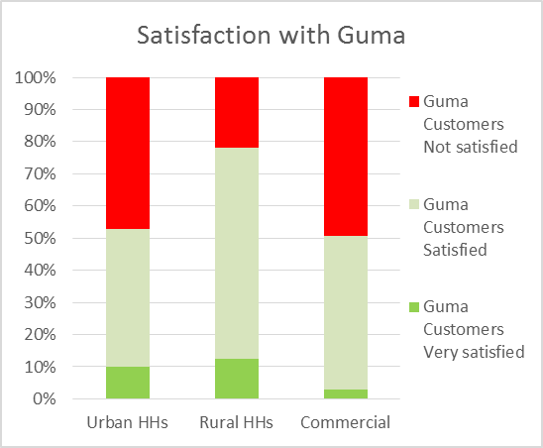The respondents were asked about their satisfaction with the water service provider.

About half of the respondents expressed either satisfied or very satisfied. This is a very surprising result and very different from the statements from the focus group discussions where the respondents expressed a high level of dissatisfaction with the water services.

The consumers in rural areas seem to be more satisfied with the Guma services than in urban areas. It should be recognised that the Guma customers in Western Rural are located along the main pipelines from the treatment plant to Freetown and are therefore more likely to receive regular service.

Amongst the commercial customers, 50% expressed that they are not satisfied with the services from Guma.

The satisfaction with other service providers is illustrated on Figure 4‑31.

Figure 4‑31: Satisfaction with Other WSPs [‘D-Billing’ AM63:AQ76]

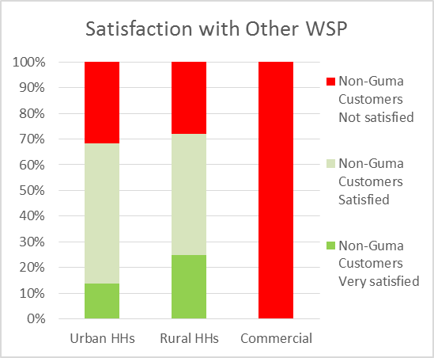The majority (70%) of the urban and rural consumers that are served by other WSPs expressed that they are satisfied with the services, while the commercial consumers are all not satisfied.

It should be noted that the commercial customers that are not served by Guma are only 15 and these are mainly located in rural areas.

### Reliability of Water Service

Service reliability is expressed through three criteria: i) frequency of service; ii) length of continuous time of service each time the service is available; and iii) time it takes the service provider to fix problems when reported by customers. The results presented below show the responses from both the households in urban and rural areas and the commercial customers.

***Frequency of service –*** the responses to frequency of services are illustrated on Figure 4‑32 for Guma customers. During dry season only about 15% of the household and commercial customers supplied by Guma have service daily, compared with about 20% during the rainy season. The commercial customers have better service than households with 22% in the dry season and 29% in the rainy season having daily services.

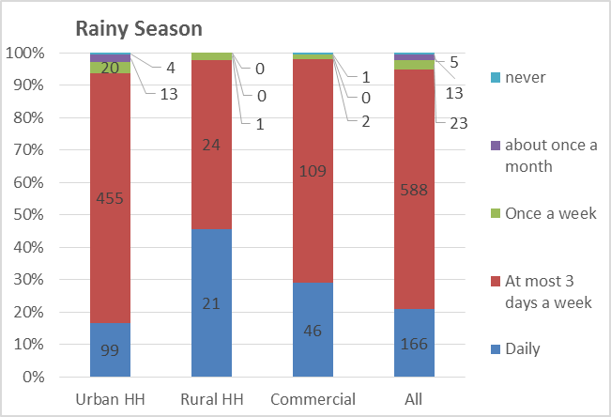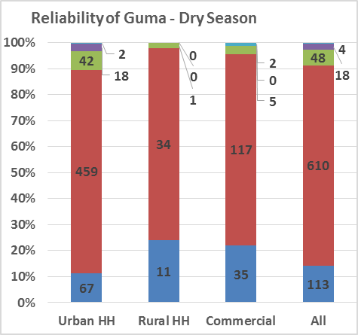Figure 4‑32: Frequency of Guma Water Service by Seasons [‘C-Reliability’ P49:R62 & BX49:CA62]

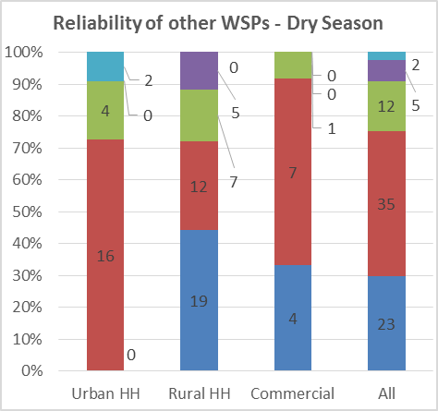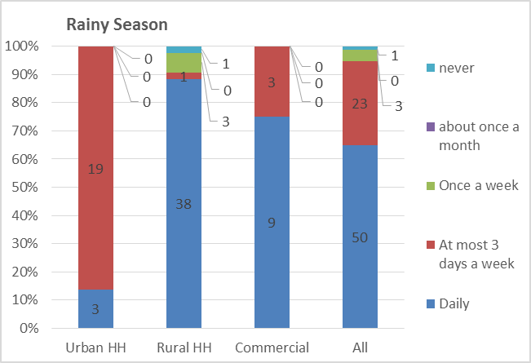Figure 4‑33: Frequency of Other WSPs Services by Seasons [‘C-Reliability’ AH49:AJ62 & CP49:CS62]

The frequency of supply from other WSPs is shown on Figure 4‑33. The trends are similar with more reliable supply in the rainy season and only a small proportion of the customers having daily services. The proportion of customers having daily services is 30% in the dry season and 65% in the rainy season, substantially better than the situation for the customers served by Guma. However, the number of customers served by other WSPs is smaller than the number served by Guma and this might affect to reliability of the data.

***Length of continuous water supply –*** About 10% of Guma customers in the dry season and 15% in the rainy season report that they normally receive the service for 24 hours. About 40% report that the water flows for at least 12 hours on the days where there is service and 50% in the dry season and 40% in the rainy season have water service for less than 12 hours.

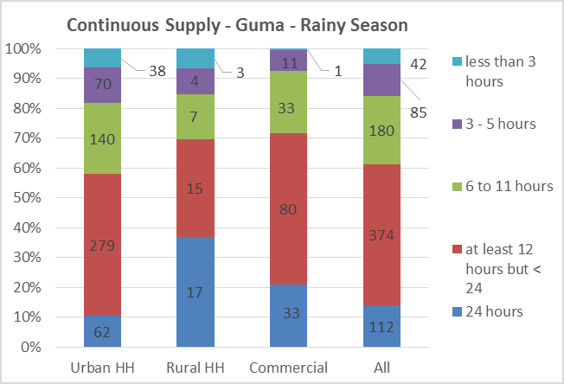Figure 4‑34: Continuity of Guma Service Provision by Season [‘C-Reliability’ P78:R92 & BX78:CA92]

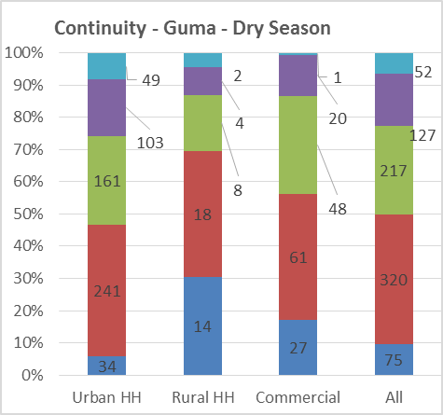

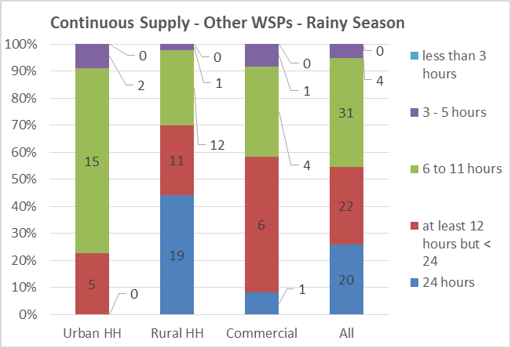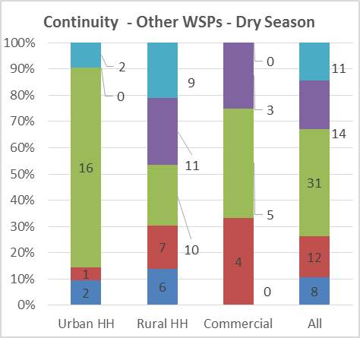Figure 4‑35: Continuity of Other WSPs’ Services by Season [‘C-Reliability’ AH78:AJ92 & CP78:CS92]

The variation in continuity of supply for the other WSPs is more between the dry and rainy season than for the Guma customers. The customers with 24 hour supply change from about 10% in the dry season to about 25% in the rainy season. The customers with less than 12 hour supply change from more than 70% in the dry season to about 45% in the rainy season.

Generally, the conclusion is that the customers in Western Area receive a very unreliable service with less than 10% receiving a daily 24hour supply from the piped systems.

***Time it takes Guma to repair reported problems –*** As per the survey information, presented in Figure 4‑36, Guma never attends requested repairs in 50% of the reported cases. However in about 24% of the cases it repairs within one week of the problem being reported, and in 9% of the cases the repairs are done within one month. In about 6% of the cases repairs are done the same day.

Figure 4‑36: Time to Attend Request for Repairs [‘C-Reliability’ DZ47:EC61]

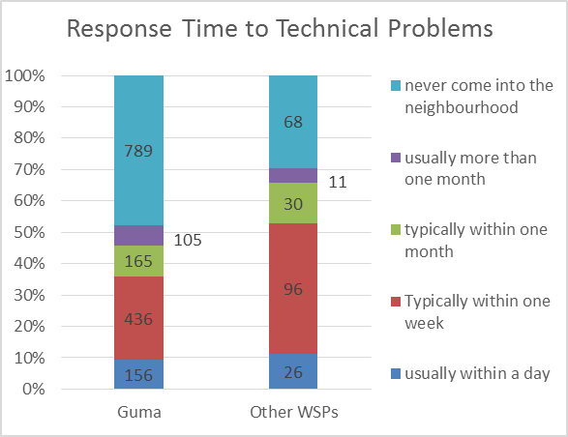The situation is similar for the other WSPs, however the respondent expressing that the WSP never attend to the repairs is reduced to 30% and about 45% of the cases are attended to within one week.

Overall service reliability is poor as measured by the three element criteria.

# Willingness and Ability to Pay

This section presents the results from the analysis of the data collected on willingness and ability to pay. The results are presented from the perspective of i) the willingness to pay for different levels of service as expressed by the respondents in the surveys; and ii) the cost of water services in the present situation in Freetown. The ability to pay for services is analysed from the data collected on the present household expenditures on water.

## Willingness to Pay for Water Services as expressed by Consumers

Willingness to pay are the schedules of various prices that consumers declare, when asked, are willing to pay in exchange for specific types of water services. Three types of water services were presented to Guma existing and potential customers: (i) Water services provided using standposts; (ii) Water services provided using yard tap connections; and (iii) Water services provided using household connections.

### Willingness to pay for Water Services by Quality of Service

**Willingness to pay for Standpost Water Services**

Households being served (or to be served) by standposts carry water services in 5 gallon containers (about 22.5 litres). Water is fetched from stand-post either directly by households members or bought from vendors who in turn have collected water from the standposts.

Figure 5‑1: Willingness to Pay for Standpipe Water Service [‘E-WTP’ B87:J101]

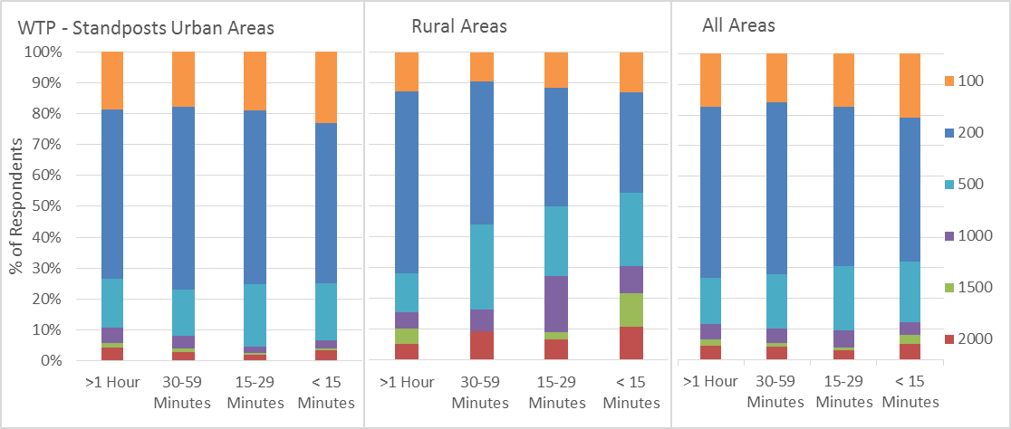

As illustrated in Figure 5‑1, the number of respondents that are willing to pay different costs for 5gal containers of water in urban areas seem not to depend significantly on the collection time, while there is a clear correlation in rural areas where more respondents are willing to pay higher costs for water when it is available within shorter distances. This is likely to be a reflection of the present situation in urban Freetown where access to water is very limited and the households who presently experience that the water is available with long collection times are willing to pay high costs for water.

These results are consistent with economic theory; i.e., the further away the household is located from the stand post the more time it has to spend walking to the stand post, the more it is willing to pay for each five gallon container full of water. If water is provided by vendors, this means that the longer the distance the vendor has to walk to fetch water the higher the price of each gallon full of water he has to charge to compensate for his time spent carrying water.

The average willingness to pay for water from public standpipes is illustrated on Figure 5‑2 for urban and rural areas separately and combined. The average willingness to pay is also compared to the present average cost of water per 5gal container according to the data collected on the cost of water from public standpipes. The present average costs are calculated according to the data on the responses on present collection time and therefore vary according to the collection time.

Figure 5‑2: Average Expressed WTP for Water from Public Standpipes [‘E-WTP’ C107:G125]

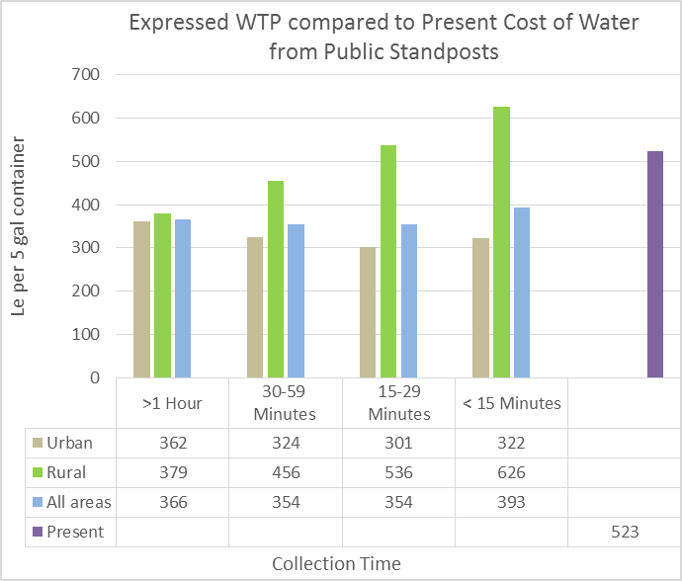The willingness to pay for water from public standpipes in rural areas is significantly higher than the willingness expressed in urban areas. This is likely to be a reflection of the present situation where few households in rural areas have access to piped water systems and the potential to have access to water from piped systems would be regarded as a significant improvement on the present situation with access to water from mainly improved or un-improved groundwater sources.

The expressed willingness to pay for water from public standposts within a short collection time of less than 15 minutes of about Le 400 per 5gal container is slightly lower than the cost presently paid by households of about Le 520 per 5gal container as shown on Figure 5‑2. The high cost of water from public standpipes is a reflection of the water scarcity situation in Freetown where households pay for collecting water from standpipes to the attendants and to people transporting the water. The government’s subsidy to Guma for water from public standpipes does thus not result in free water from public standpipes for the residents of Freetown.

From the above information, the average customers’ willingness to pay for water services provided through stand post is equivalent to Le 17,860 per m3 or 4.10 USD/m3. The present overall average cost of water from public standposts of Le 524 per 5 gal container is equivalent to 23,770 Le per m3 or 5.45 USD/m3.

**Willingness to pay for water services provided through Yard-tap Connections**

In this case, a yard-tap usually serve two or more households; i.e., the household that has the yard-tap connection pays the bill to Guma, but the payment of the bill is shared with neighbours who collect water from the yard tap.

The responses to how much the household is willing to pay for yard tap water service is illustrated in Figure 5‑3. The responses are reflecting the amount households are willing to pay for if water would be available at least 6 hours every: ‘Once per week’; ‘Every 3 days’; ‘Every day’ or on a ‘24 hours’ basis. In both rural and urban areas, households are willing to pay more for more reliable services – with households in urban area willing to pay substantially more compared to the rural areas: e.g. 30% of urban households are willing to pay Le 50,000 per month for 24 hour service while less than 20% of rural households are willing to pay Le 50,000 per month for that level of service. This is contrary to the results for the public standpipes where rural households are willing to pay more than urban households. This is likely to reflect that the yard connections would be the service level that would be preferred by most urban households while the rural households would find the public standpost level of service adequate.

Figure 5‑3: Willingness to Pay for Yard Tap Water Service [‘E-WTP’ Y103:AG117]

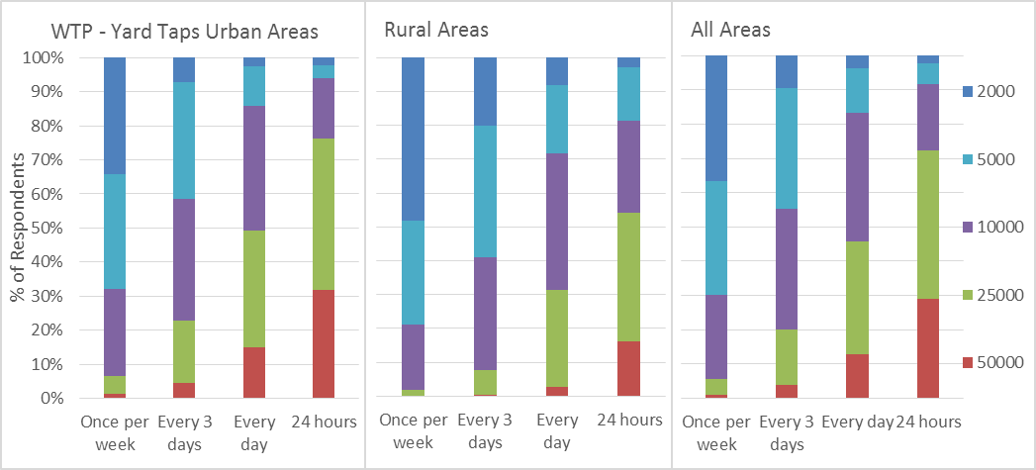

Figure 5‑4: Average Expressed WTP for water from Yard Taps

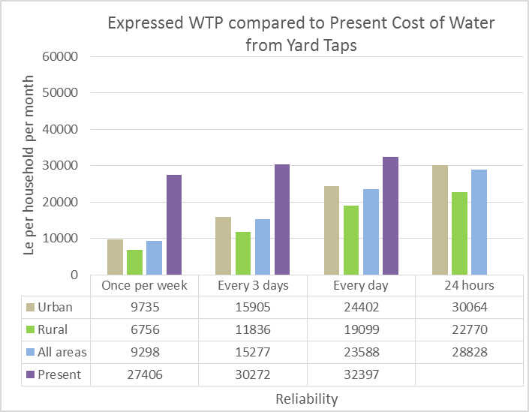The expressed willingness to pay for yard tap water service within the range from Le 2,000 to Le 50,000 per month translates into the average amounts in Le per household per month as illustrated on Figure 5‑4.

These expressed amounts are compared to the data on the actual cost of water for respondents with the respective reliability of service (per week/ 3 days/ every day). There is presently no 24 hour service in Freetown and therefore no data on the present cost of water for 24 hour service.

The information in Figure 5‑4 reveals that:

1. The willingness to pay increases 3-fold with the increase in reliability of service from ‘once per week’ to 24 hour service
2. Present cost of piped water is much higher than the expressed willingness to pay and at the same level as the expressed willingness to pay for 24 hour water service.

It should also be noted that the present total household expenses for water are much higher than the data presented in Figure 5‑4 since, due to unreliable utility water services and water scarcity, all households use multiple sources of water and not only the water utility piped water systems for which the present cost data is presented here. The total cost of water is presented in Figure 5‑18 for urban areas (average Le 110,000 per month) and Figure 5‑19 for rural areas (average Le 50,000).

The amounts the average customers are willing to pay for water services provided through yard-taps per month are presented above and translating this monthly amount to a rate per m3 must be based on some assumptions on amount of water used by the average household in a month. Table 5‑1 shows the average consumption data for the respondents that expressed that they would prefer a yard tap connection and provided the data on willingness to pay for the yard connection.

Table 5‑1: Average Consumption for HHs Opting for Yard Taps [‘E-WTP’ AN188:AQ191]

The rainy season consumption figures are higher than the dry season due to easier access to water. When using the rainy season figures for estimating the amounts the respondents would be willing to pay for water per m3, this would result in lower amounts. The higher amounts resulting from using the dry season consumption figures reflects the present situation in Freetown with water scarcity. Therefore the amounts the respondents would be willing to pay per m3 based on the rainy season figures might be a better reflection of the willingness to pay for water when the water supply has improved. The resulting willingness to pay per m3 is illustrated in Figure 5‑5.

Figure 5‑5: Willingness to Pay per m3 for Water from Yard Taps [‘E-WTP’ AL134:AP149]

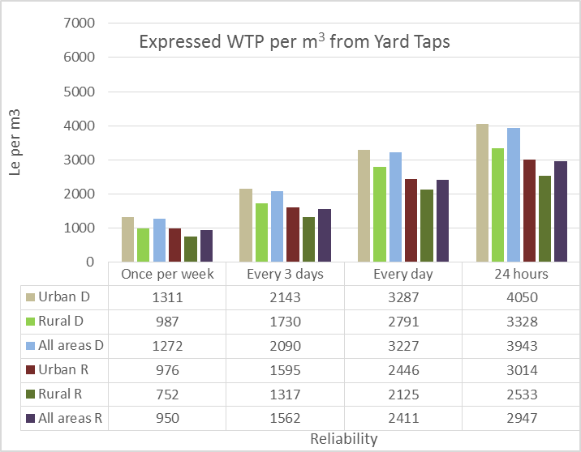The amounts range from less than Le 1000/m3 for ‘once per week’ service to close to Le 4000/m3 for 24 hour service using dry season consumption figures and close to Le 3000/m3 using rainy season consumption figures.

The resulting amounts in Le/m3 and USD/m3 are shown in Table 5‑2.

Table 5‑2: WTP for Water from Yard Taps per m3 [‘E-WTP’ AG119:AT124]



**Willingness to pay for water services provided through Household Connections**

In this case we have single family connections; i.e., a household has an in dwelling connection that supplies water to various facilities (toilets, sinks, kitchen, laundry room etc.) through a small pipe network. The water bill will be paid by the single family.

The responses to how much the household is willing to pay for the water services through house connections is illustrated in Figure 5‑6. Also in this case the responses are reflecting the amount households are willing to pay if water would be available at least 6 hours every: ‘Once per week’; ‘Every 3 days’; ‘Every day’ or on a ‘24 hours’ basis.

As for yard taps, In both rural and urban areas, households are willing to pay more for more reliable services – with households in urban area willing to pay more compared to the rural areas: e.g. 18% of urban households are willing to pay Le 100,000 per month for 24 hour service while very few rural households would pay this amount for water services. 75% of urban households would pay Le 50,000 or more while this is only the case for 25% of rural households.

Figure 5‑6: Willingness to Pay for House Connection Water Service [‘E-WTP’ AH103:AP117]

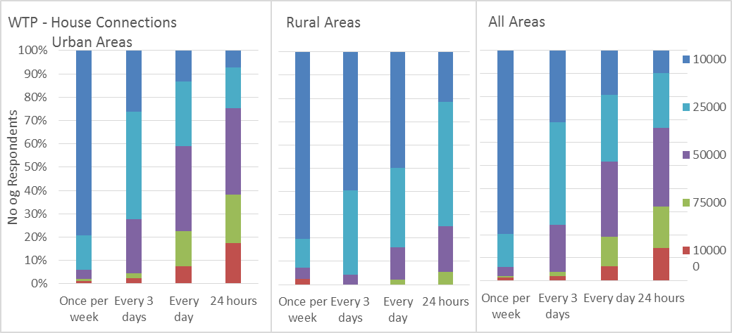

The expressed willingness to pay for house connections within the range from Le 10,000 to Le 100,000 per month translates into the average amounts in Le per household per month as illustrated on Figure 5‑7. These expressed amounts are compared to the data on the actual cost of water for respondents with the respective reliability of service (per week/ 3 days/ every day). There is presently no 24 hour service in Freetown and therefore no data on the present cost of water for 24 hour service.

Figure 5‑7: Average Expressed WTP for Water from House Connections [‘E-WTP’ AF134:AJ151]

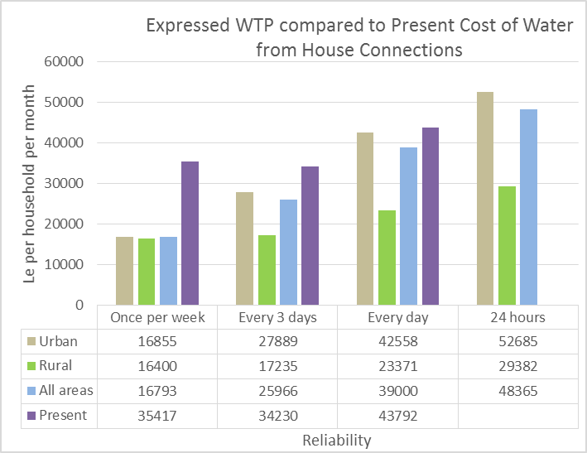The information in Figure 5‑7 reveals similar trends to the responses on yard taps, that the willingness to pay increases more than 3 fold with the increase in reliability of service from ‘once per week’ to 24 hour service.

The present cost of piped water is higher than the expressed willingness to pay however lower than the expressed willingness to pay for 24 hour water service.

In this case too, the results obtained are consistent with economic theory; i.e., customers who have 24/7 water services are in essence paying more for ready availability of water upon demand, without the inconvenience of having to store it. On the other extreme, customers who are receiving the water only once a week are willing to pay much less.

Figure 5‑8: Comparison of Responses for Households with Existing Reliable Service [‘E-WTP’ R112:X126]

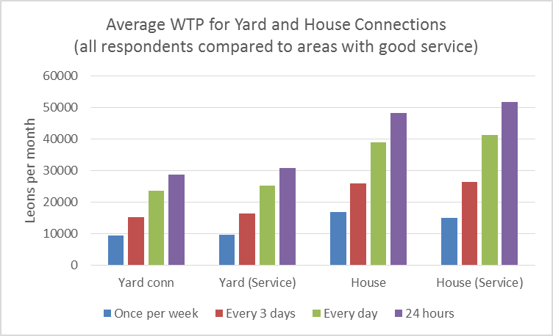The data on willingness to pay have been analysed for a comparison of the responses from all households with the responses from households that presently have a ‘reliable service’ defined as water available at least 3 days a week. The results are illustrated in Figure 5‑8.

Both households with yard taps and with house connections with reliable service are willing to pay slightly more for water services. This is consistent with that these households are familiar with the convenience of a reliable water service and are willing to pay more for this service.

Table 5‑3: Average Consumption for HHs opting for House Connections [‘E-WTP’ AN193:AQ196]

The conversion of the amounts the average customers are willing to pay for water services provided through house connections per month to the rate per m3 is in the description below based on the average household consumption rates per month as shown in Table 5‑3. The average consumption data is for the respondents that expressed that they would prefer a house connection and provided the data on willingness to pay for the house connections. The resulting willingness to pay per m3 is illustrated in Figure 5‑9.

Figure 5‑9: Willingness to pay per m3 for water from House Connections [‘E-WTP’ AQ134:AV151]

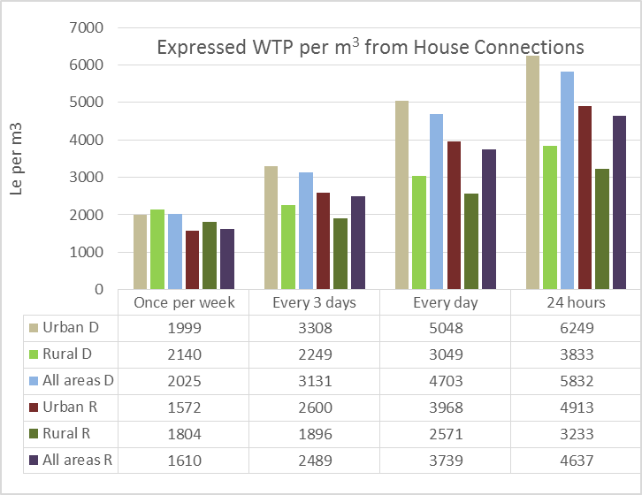The amounts range from less than Le 2000/m3 for ‘once per week’ service to more than Le 6000/m3 for 24 hour service using dry season consumption figures and close to Le 5000/m3 using rainy season consumption figures.

The resulting amounts in Le/m3 and USD/m3 are shown in Table 5‑4.

Table 5‑4: WTP for water from house connections per m3



### Willingness to pay for Water Services by Income Groups

**Willingness to pay for Standpipe Water Services**

Figure 5‑10: WTP for Public Standpipe Service per Income Category [‘E-WTP’ C199:G216]

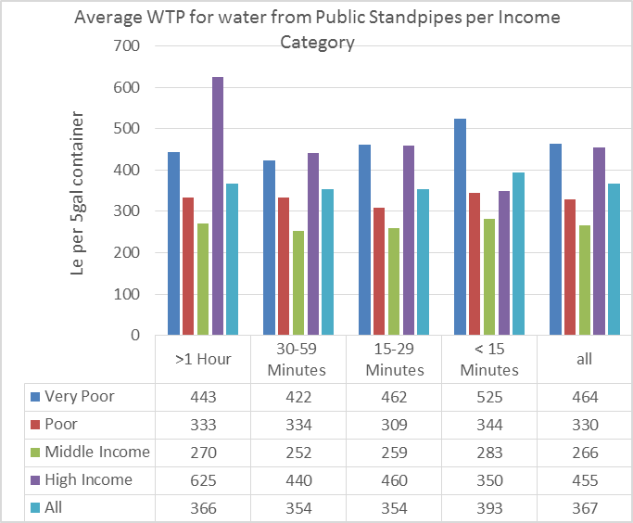The responses to willingness to pay for 5gal water containers from public standpipes analysed per income category is illustrated in Figure 5‑10.

The costs in the different income groups and for the different collection times average around Le 350 for 5gal of water.

The trend that ‘high income’ households are willing to pay high costs even for a ‘low service level’ with collection times more than 1 hour is likely to reflect the water scarcity situation in Freetown where the ‘high income’ households due to non-availability of yard or house connections would rely on water from public standpipes and be willing to pay a high price since it would be the only available water source.

The ‘very poor’ express willingness to pay more than the poor and middle income groups and this likely to reflect the present very difficult situation in relation to water supply for these households and therefore they would be willing to pay a high proportion of the available resources for this very necessary commodity.

**Willingness to pay for Yard Connection Services**

Figure 5‑11: WTP for Yard Tap Service per Income Category [‘E-Average WTP’ A39:D56]

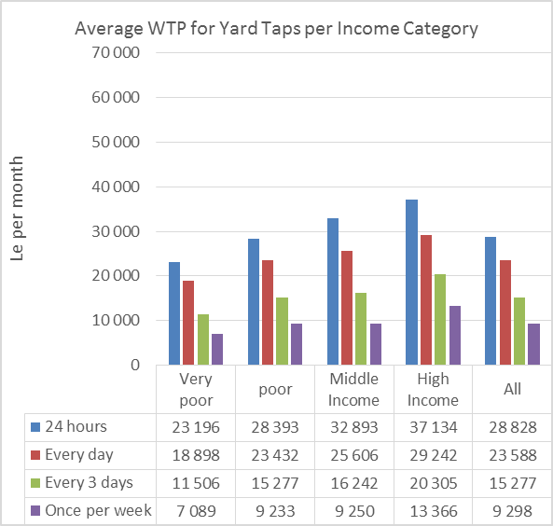The expressed willingness to pay for water services for yard tap service level per month is illustrated in Figure 5‑11 according to the income categories.

The willingness to pay for a 24 hour water supply service raise from Le 23,000 per month for the very poor to Le 37,000 per month for the high income group with an average of about Le 29,000 per month.

Translating the monthly figures to volumetric measures require estimates of the corresponding average consumption per household per month. The total consumption figures per income category in the rainy season has been used in the presentation below since the higher rainy season consumption figures would better simulate a situation without water scarcity in Freetown.

Figure 5‑12: Average Consumption per Household in Rainy Season [‘B-Water Quantity’ B171:F185]

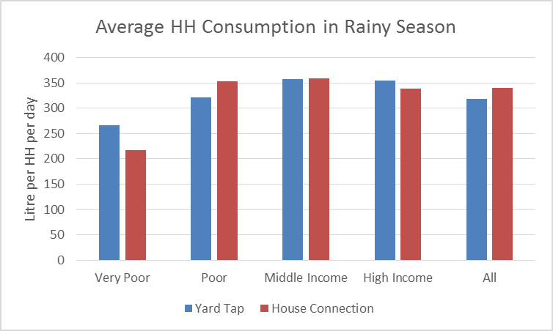The average household consumption figures in the rainy season for yard taps and house connections respectively are shown on Figure 5‑12. The consumption raises from about 250 litres per household per day for the very poor households to about 350 litres per household per day for the high income households with an average of about 320 litres per household per day.

The willingness to pay for water from yard taps per m3 is illustrated on Figure 5‑13.

Figure 5‑13: Average WTP per m3 for Yard Taps per Income Category [‘E-Average WTP’ E39:H56]

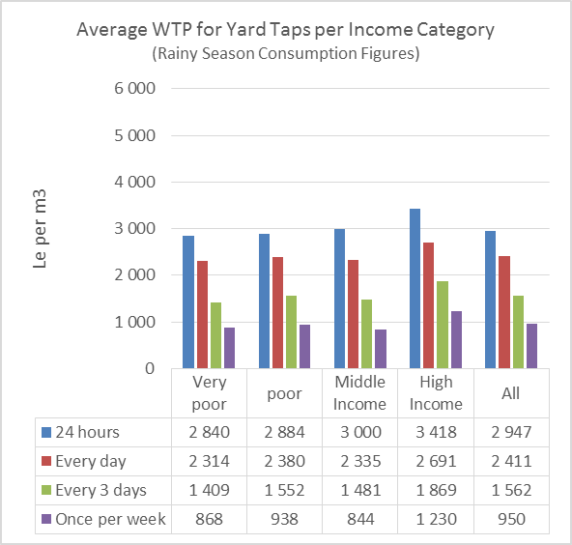The average willingness to pay for 24 hour water services from yard taps raises from about Le 2,800 per m3 for the very poor to about Le 3,400 for the high income category with an average of about Le 2,900.

The willingness to pay is markedly lower for poor service falling to below Le 1,000 per m3 for service that would only be available once per week.

The relatively small difference between the willingness to pay for the different income categories should be an indication of the in-elasticity of water services: water is a necessary commodity and the poor and very poor are willing to pay a considerable cost for having access to water.

**Willingness to pay for House Connection Services**

Figure 5‑14: WTP for House Connection Service per Income Category [‘E-Average WTP’ I39:L56]

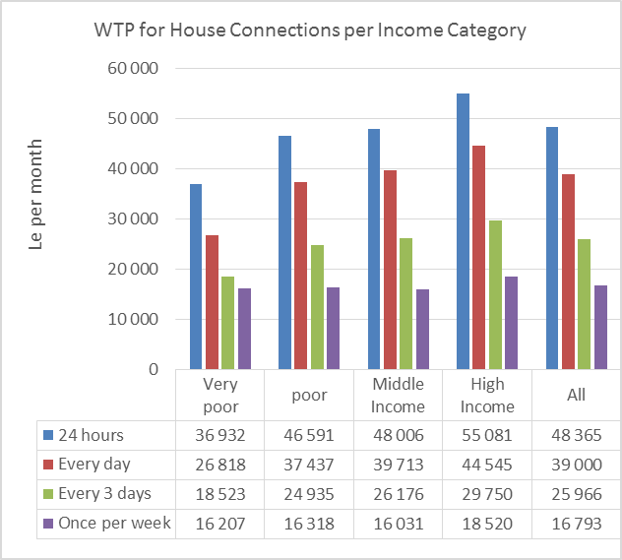The expressed willingness to pay for water services for house connection service level per month is illustrated in Figure 5‑14 according to the income categories.

The willingness to pay for a 24 hour water supply service raise from Le 37,000 per month for the very poor to Le 55,000 per month for the high income group with an average of about Le 49,000 per month.

Again we have used the rainy season consumption figures to translate the monthly figures to volumetric measures. The average household consumption figures in the rainy season for house connections are shown on Figure 5‑12. The consumption raises from about 200 litres per household per day for the very poor households to about 350 litres per household per day for the high income households with an average of about 350 litres per household per day.

The willingness to pay for water from house connections per m3 is illustrated on Figure 5‑15.

Figure 5‑15: Average WTP per m3 for House Connections per Income Category [‘E-Average WTP’ M39:R56]

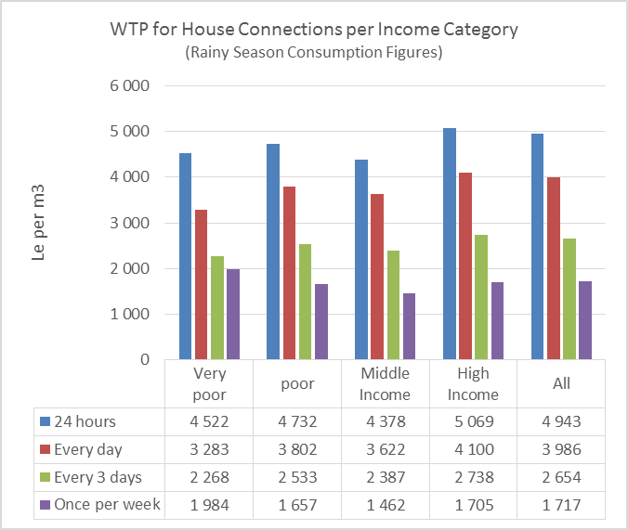The data indicate that the average willingness to pay for 24 hour water services from house connections do not vary consistently between the income categories but varies around an average of Le 4,900 per m3. Less than 10% of the respondents that expressed willingness to pay for services from house connections are in the ‘very poor’ income group and this might influence the statistical significance of the results for this income group.

However the average of Le 4,900 per m3 is an indication that households in Freetown are willing to pay a high cost for reliable water services. It is obvious that these statistics depend to a large extent on the estimated average household consumption. Using the present rainy season consumption figures from the survey as an estimate of a future situation with reliable water services might result in estimated willingness to pay per m3 that would be on the high side.

One remarkable outcome of the data analysis is the large difference between the amounts willing to pay for reliable 24 hour service (Le 4,900) and the much smaller amount the respondents are willing to pay for water services that would only be available once per week (Le 1,700).

## Willingness to Pay for Water Services for Commercial Enterprises

Figure 5‑16: Average WTP per month for Commercial Enterprises [‘E-WTP’ AM30:AS43]

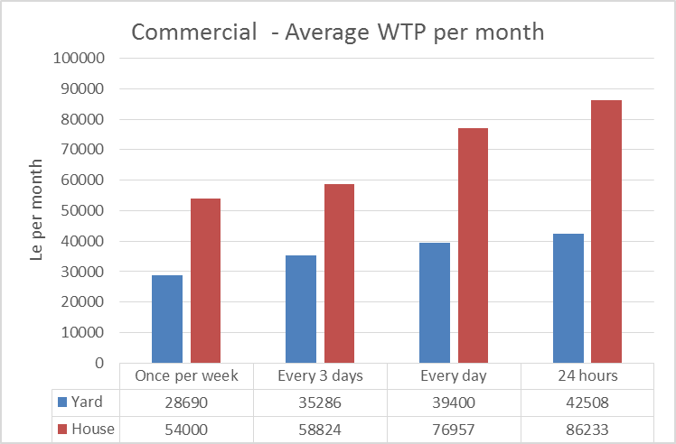Data were collected from commercial enterprises on the amounts the enterprises are willing to pay for water services at different levels of reliability: water available once per week; every 3days; every day; or continuous supply 24 hours.

The amounts per month vary according to the size and type of businesses e.g. water bottling companies with huge water consumption as compared to small catering businesses. The average amounts expressed by the enterprises that they are willing to pay per month are shown on Figure 5‑16.

Figure 5‑17: Average WTP per M3 for Commercial Enterprises[‘E-WTP’ AT30:AY43]

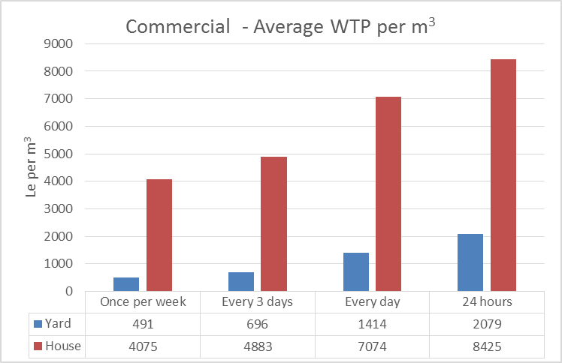The amounts the enterprises are willing to pay per volume of water are presented in Figure 5‑17. The results are based on the expressed willingness to pay per month divided with the present consumption of water in the respective enterprises.

The results show that businesses are willing to pay considerable more for more reliable service increasing to more than Le 8,000 per m3 for 24 hour service and with the amounts considerable higher for house connections compared to yard taps.

## Ability to pay for water services

The ability to pay for water services can be assessed by comparing the household expenditures on water to the total household expenditures or available incomes. As outlined in Chapter 3.1.5, the household incomes seems to be under-reported for various reasons and the data collected on household expenditures are regarded more reliable than the data collected on household incomes. The following analysis is therefore using the household expenditures data.

**Household Expenditures on Water**

Households in Western Area spend a considerable proportion of their financial resources on water. A threshold of 5%[3] combined for water and sanitation is often considered affordable. The proportion for water and sanitation depends on many factors such as technology and service levels, however for this assessment we propose to use a threshold of 3% of available resources for water. The households in Western Area spend considerably more than that as shown below.

**Urban Households**

The data on household expenditures on water are summarised on Figure 5‑18 for urban households. The monthly expenditures on water increases from about Le 70,000 per month or 5.2% of total household expenditures for the very poor households to about Le 150,000 per month for the high income households representing about 5% of total household expenditures. This trend could indicate that the poorer households are assessing water from less expensive and unprotected sources while the high income households are more likely to use water from safer and more convenient sources such as piped systems and tankers as well as using more water per capita.

Figure 5‑18: Water expenditures in Urban Areas [‘F-Income-Exp’ BQ43:BW56]

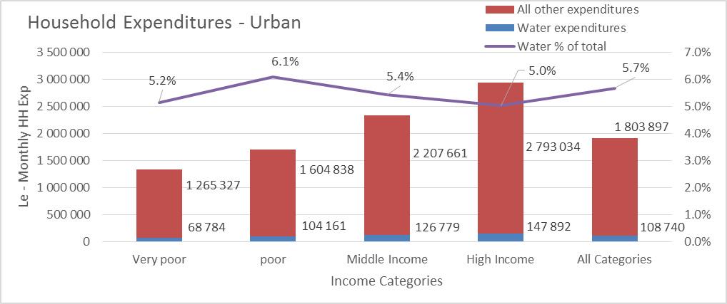

It should be noted that the total expenditures on water is reported to be considerably more than the flat rate charged by Guma for domestic consumers of approximately Le 30,000 per month. This is likely to be an effect of in-frequent piped water services that will necessitate households to seek water from other sources than their yard or house connections.

**Rural Households**

The expenditures for rural households are illustrated on Figure 5‑19. The expenditures for rural households show a similar trend to the urban households, however the expenditures on water are significantly less in rural areas, in particular for the poorer households – this is likely to be due to easier access to natural water sources. The middle and high income households in rural areas pay considerably more for water and this is likely to be due to the absence of reliable piped systems and therefore the households are using more expensive sources such as water vendors. The access to the different sources of water is further addressed in Chapter 4 above.

Figure 5‑19: Water expenditures in Rural Areas [‘F-Income-Exp’ BY43:CF56]

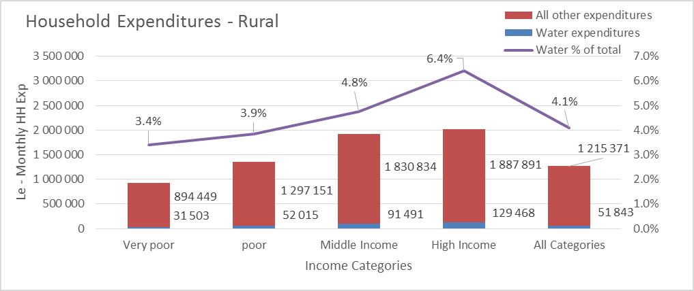

The affordability of water services for the average households in Western Area and for the households categorised as ‘very poor’ is presented in Table 2‑1 below using a threshold of 3% of household income as the limit for affordable water services.

Table 5‑5: Affordability of water services

|  |  |  |  |
| --- | --- | --- | --- |
| **Affordability of water services** | **All** | **Very Poor** | **units** |
| Threshold for water | 3% | | |
| Monthly expenditures | 1 782 930 | 1 149 079 | Le/ month |
| Threshold amount per month | 53 488 | 34 472 | Le/ month |
| Average consumption | 12 | 9 | m3/ month |
| Threshold affordability | 4 553 | 3 983 | Le/ m3 |

With this assessment, a cost of Le 4,000 per m3 could be considered affordable for most households. It should be noted that a cost of Le 4,000 per m3 is equivalent to a cost of only Le 90 per 5gal container, considerably less than the cost of Le 400 – 500 presently paid for water from standpipes.

## Conclusion on Willingness and Ability to Pay for Water Services

The detailed assessment of willingness to pay for water services can be summarised as:

**Public Standpipes**

Households relying on water from public standpipes express that they are willing to pay in average about Le 400 per 5gal container of water. This is below the present average cost of about Le 500 per 5gal container and much more than the cost that can be considered affordable for the poorer households using the water expenditure threshold of 3% of total household expenditures (of Le 90 per 5gal container). It should be noted that despite the Government subsidy for public standpipes operated by Guma, households are paying considerable prices for water to tap attendants and for transport of water.

**Yard Taps and House Connections**

The willingness to pay for water from yard taps and house connections depends on the reliability of the water service. In average households are willing to pay Le 28,000 per month for yard taps equivalent to about Le 3,000 per m3 for 24 hour water services. This reduces to less than Le 1,000 per m3 for water services only available once per week.

Households are willing to pay about Le 50,000 for house connections with 24 hour service corresponding to Le 4,600 per m3. This reduces to less than Le 2,000 per m3 for water services only available once per week. The per m3 amounts are calculated based on the data on the total household water consumption in the rainy season, however with improved reliability of water service the water consumption is likely to increase and therefore the expressed willingness to pay per month would result in a lower rate per m3. The willingness to pay for commercial enterprises for reliable services increase to above Le 8,000/m3 for 24 hour service from house connections.

According to the assessment of household expenditures on water compared to total expenditures using a threshold of 3% for affordable water services, a cost of Le 4,000 per m3 could be considered affordable for most households. The willingness and ability to pay for water services is summarised in Table 5‑6.

Table 5‑6: Average household WATP for 24 hour water services

| **Service Level (24h)** | **WTP/month** | **WTP/ volume** | **Affordable threshold** |
| --- | --- | --- | --- |
| Public Stand Posts |  | Le 400 per 5gal container | Le 90 per 5 gal container |
| Yard taps | Le 28,000 per month | Le 3,000 per m3 | Le 4,000 per m3 |
| House Connections | Le 52,000 per month | Le 6,400 per m3 | Le 4,000 per m3 |

# Tariff Setting

Given that official tariffs for Guma have not changed since 2006 it seems to be time to adjust them. When adjusting the tariffs we will need to consider the Willingness and Ability to Pay (WATP) by the served population, but at the same time we will also need to consider what it will take to improve reliability and accessibility of the water service provided by Guma. In addition we will also need to take into account the changes in prices which affect the purchasing capacity of the tariff in place at any point in time.

## Willingness and Ability to Pay

Based on the willingness to pay survey information presented in Chapter 5, we prepared the following graphs that summarizes willingness to pay.

According to Figure 6‑1, for the case of household connections, if the price of water would be about Le 9,000/m3, interviewed people manifested they could consume about 888 m3 per month. And as the price went down, they manifested they could consume 2,184 m3 per month if the price were about Le 7,000/m3; 5,885 m3 per month if the price were about Le 4,600/m3; 11,521 m3 per month if the price were about Le 2,300/m3, and 16,638 m3 per month if the price were about Le 1,000/m3.

Figure 6‑1: Willingness to Pay for Household Piped Connections

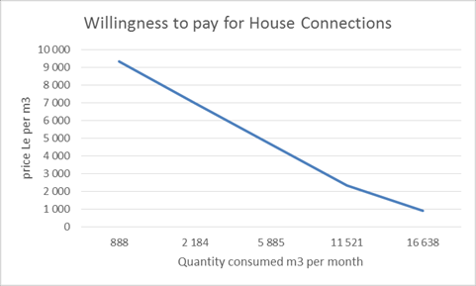

Based on the same survey information, we estimated that the average willingness to pay for water was about Le 3,156 per m3 (or US$ 0.73/m3). This average tariff is consistent with ability to pay by the well-off people in Freetown, who command higher income as has been documented in section 5.

According to Figure 6‑2, for the case of Yard Tap connections, if the price of water were about Le 5,000/m3, interviewed people manifested they could consume about 7,970 m3 per month. And as the price went down, they manifested they could consume 25,884 m3 per month if the price were about Le 2,500/m3, 37,385 m3 per month if the price were about Le 1,000/m3, 43,430 m3 per month if the price were about Le 500/m3, and 47,898 m3 per month if the price were about Le 200/m3.

Figure 6‑2: Willingness to Pay for Yard Tap Piped Connections

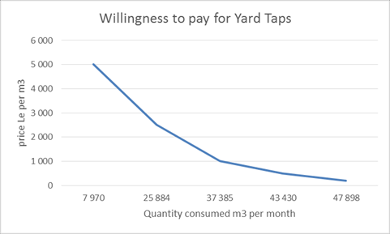

Based on the same survey information, we estimated that the average willingness to pay for water was about Le 2,094 per m3 (or US$ 0.49/ m3). This average tariff also seems consistent with ability to pay by the middle income people in Freetown, who command income just below of richest segment of the population as has been documented in section 5.

Note here that the prices the people are willing to pay presented in Figure 6‑1 and Figure 6‑2, and the related volumes of water demanded at each price correspond to that of the survey populations. Based on this survey information, we can conclude here that in average pipe water connection in Freetown might be willing to pay between Le 2,094 (US$ 0.49) and Le 3,156 (US$0.73) per m3. Bearing this in mind we go on to propose a framework for the proposing tariff adjustment for GUMA.

## General Framework for Tariff Fixing

Figure 6‑3: Willingness to Pay and Guma Efficient Unit Costs

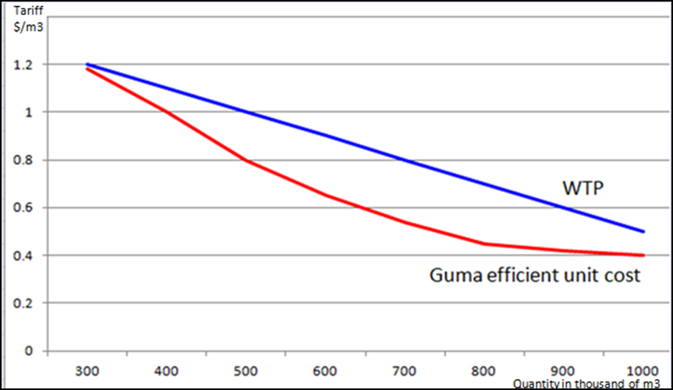From the survey results on willingness to pay (WTP) presented in section 6.1, and from economic theory we know that the less the quantity of water supplied by Guma the higher the willingness to pay will be. This idea is presented in Figure 6‑3, according to which if Guma would supply only 300,000 m3 per month then residents in Freetown might be willing to pay Le 5,160 (US$1.2) per m3. At 700,000 m3, the average connection might be willing to pay about Le 3,440 (US$0.8) per m3. This means willingness to pay is inversely related to quantity (blue line in Figure 6‑3). At the same time, Figure 6‑3 also shows Guma’s schedule of efficient unit cost (red line) which declines faster than WTP; this is so because water systems usually exhibit economies of scale.

By the economies of scale assumption we trust Guma will be able to improve and achieve a unit cost that allows it to maximize revenue, provided tariffs are in line with the willingness to pay. However, this assumption can easily be spoiled by the reality of system losses. If system losses get out of control, then tariffs needed to breakeven can easily be above the willingness to pay. In the case of Guma, non-revenue water is at present about 50% and non-collected billing is about 25% which makes about 75% losses; these financial losses are too high and must have a tremendous adverse impact on the financial performance of Guma.

To illustrate the impact of various levels of system losses on the tariff needed to break-even, we present information of a hypothetical water company whose unit cost is US$ 1/m3 (see Table 6‑1). If this water company had 10% losses then it would need a Tariff of US$1.11 to cover its costs; if the system losses is 25% then it would need a tariff of US$1.33/m3; and if it had a 50% system losses with would need a tariff of US$ 2/m3 just to cover costs (i.e., to break-even). In this last case it is easy to verify that the two dollar per m3 tariff will be used as follows: one dollar to pay for the water billed and the other dollar to pay for the water lost in the system.

Table 6‑1: Unit Costs, System Losses, and Tariff needed to Break-even

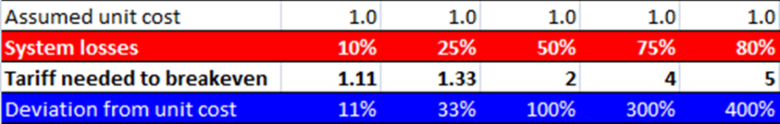As one might expect, having 75% losses is untenable, as the tariff needed to break-even will be four times the unit costs; i.e., if the unit cost is one dollar, the tariff needed to break-even will be four dollar. This four dollar tariff will be used as follows: one dollar to pay for the one cubic meter of water billed, and the remaining three dollar to cover the three cubic meter water lost in the system.

This analysis means that when fixing tariffs we need to take into account the strategic objective of investing in programs to reduce system losses. Also, with water that is not lost anymore, Guma can increase the number of connections to be supplied with the water that is not lost. But expanding the number of connections will require investments in expansions of network. In all, tariff making then need to take into account investments in reductions of systems losses and investments to expand service provision.

## Principles for Tariff Setting and Main Methodological Approaches

### Principles for Tariff Making

***The average tariff, willingness to pay, and the tariff structure –*** First we need to find an average tariff that makes Guma financially viable, which should be compared with willingness and ability to pay findings. Once average tariff is found, then tariff structure can be worked out taking into account Guma policy objectives including achievement of financial viability and to accommodate the government of Sierra Leone social and health policy objectives.

**Estimation of an average tariff –** Estimation of average tariff to make Guma financially viable should include provisions to cover:

* ***Full efficient O&M costs –*** Estimate Operation and Maintenance (O&M) costs taking into account the results of the 100 days program and any new company turn-around program. The word efficient is key here taking into account the room for economies of scale.
* ***Investments on reduction of systems losses –*** Investments on fixing/ rehabilitating distribution network, elimination of illegal spaghetti connections and other illegal connection, investments on metering systems.
* ***Investments on expansion of the system –*** Investment in network expansions, investments in capacity additions.

***Cost recovery –*** As a principle all O&M will be recovered through tariffs. Regarding investment it can be full cost recovery if all investments will be paid out of tariff revenues; partial cost recovery if not all investments costs are financed out of tariff revenue.

### Methodological Approaches

We present here two main methodological approaches which are used in tariff studies to estimate average tariffs.

***Revenue requirement methodology -*** As a general rule, the revenue required by a utility in a defined period is determined by two essential cost components: O&M expenses and the capital component. The formula is expressed as follows:

$$T_{t}=\frac{Revenue required to undertake operations at year t}{Volume of water delivered to all customers at year t}$$

***Long run Marginal Cost Methodology (LRMC) –*** In this methodology incremental operating costs are assumed plus investment programs for undertaking the water services up to completing full coverage is assumed. The formula is as follows:

$$LRMC=\frac{\sum_{t=1}^{n}{\frac{(C_{t}-C_{0})}{{\left(1+r\right)}^{t}}}+ \sum_{t=1}^{n}{\frac{I_{t}}{{\left(1+r\right)}^{t}}+}\frac{SV}{{\left(1+r\right)}^{n}}}{\sum_{t=1}^{n}{\frac{(Q_{t}-Q_{0})}{{\left(1+r\right)}^{t}}}}$$

Where,

LRMC: Long Rung Marginal Cost average tariff

$C_{t}$: Operating costs at year t (do not include depreciation)

$C_{0}$: Operating costs at year zero. Note that $C_{t}-C_{o}$ is the incremental operating cost at each year.

$I_{t}$: Investment to be implemented at year t

SV: Savage (residual) value of infrastructure investments at the end of year n.

$Q_{t}$: Volume of water service delivered to customers at year t

$Q_{0}$: Volume of water services delivered to customers at year zero.

r: Cost of capital (rate of discount)

We will use here the revenue requirement methodology. LRMC methodology can be used later to estimate tariffs conducive to the achievement of full coverage of service in Freetown.

## Preliminary estimate of the average tariff for Guma

The following estimates of tariffs for Guma are included in this report to illustrate the principles of tariff estimation and how to justify the level of tariffs. Any specific proposal for adjusting the Guma tariffs would require a more thorough analysis of the operational and financial data.

We will use the revenue requirement methodology that can be re-written as follows:

$$T_{t}=\frac{O\&M_{t}}{Q_{t}}+\frac{I_{RSL}}{Q_{t}}+\frac{I_{exp,t}}{Q_{t}}$$

Where:

$T_{t}$: is the average tariff at year t.

$O\&M_{t}$: is the efficient O&M cost at year t

$I_{exp,t}$: is the investment in expansion at year t

$I_{RSL,t}$: is the investment in reduction of system losses at year t.

$Q_{t}$: is the water billed at year t

Procedure to estimate

* To estimate $\frac{O\&M_{t}}{Q_{t}}$, we took information from Guma, month of April 2013. Specifically, Guma billed during that month Le 1,827 million for 771,000 m3 of water delivered to all classes of customers. Assuming that by April 2013 Guma was break even (or close to it) as a result of the 100 Days Transformation Program we obtain a break-even tariff equal to Le 2,369/m3 (US$0.55/m3). In addition, we assumed that in April 2013 systems losses were 50%[4]. Using this information we estimate a preliminary efficient unit O&M cost for Guma is[5] Le 1,575 (US$0.37/m3), which includes a provision for 25% system losses.
* To estimate the unit cost component related to reduction of system losses we take proposed budget for investment in reduction of system losses for 2013 included in the 100 Days Transformation Programme which is US$5,700,000 and calculate a depreciation allowance (10%, assuming 10 years depreciation) to be reflected in the tariff. Doing this calculation, we get Le 352/m3 (US$0.08/m3) to reflect in the preliminary tariff estimate the unit cost for investments in reduction of system losses.
* To estimate unit cost component related to expansion, we used PEM’s Financial Model preliminary estimates for investments in expansion which amounts US$30,300,000, excluding investments in reduction of system losses. In this case we calculate a depreciation allowance (5%, assuming 20 years depreciation) to be reflected in the tariff. Doing this calculation we get Le 936/m3 (us$0.22/m3) to be reflected in the tariff to cover for expansion.

Our estimated tariff for the year 2013 is:

/m3 (or US$0.67/m3)

This tariff estimated, using the revenue requirement methodology is consistent with the average willingness to pay presented in section 6.1; i.e., our conclusion in section 6.1 was that the average willingness to pay was between Le 2,094 (US$0.49) and Le 3,156 (US$0.73).

Consequently, this analysis points to that an average tariff of Le 2,900/m3 (US$0.67/m3) would be an appropriate tariff that will allow Guma to start contributing to investments out of internally generated funds and at the same time within the range that consumers are willing and able to pay.

Consequently, this analysis points to that an average tariff of Le 2,900/m3 (US$0.67/m3) would be an appropriate tariff that will allow Guma to start contributing to investments out of internally generated funds and at the same time within the range that consumers are willing and able to pay.

## Review of Guma Tariff Structure and Tariff Schedules

***Current Tariff structure -*** Current Estimated Tariff Structure is shown in Table 6‑2; where one can see that average per customer class go from Le 729/m3 (for stand pipes and Government) to Le 29,772/m3 (Bowser service). From these tariffs per class one can get the general average using the metered demand per customer class; however such information is not available. To overcome this issue we made and educated assumption presented in the last column of Table 6-2.

Table 6‑2: Current Estimated Tariff Structure[6]

|  |  |  |  |
| --- | --- | --- | --- |
|  | US$/m3 | Le/m3 | Assumed demand per customer class |
| Standpipes (paid by government) | 0.17 | 729 | 10% |
| Residential tariff | 0.17 | 729 | 62% |
| Institutions | 0.06 | 237 | 5% |
| Government | 1.00 | 4,308 | 5% |
| Commercial | 0.99 | 4,257 | 15% |
| Bowser service | 6.92 | 29,772 | 3% |

**New proposed tariff structure -** Assuming demand per customer class as in the last column of Table 6‑2, we estimate that the current average tariff is about Le 2,285/m3 (US$0.53), which is below of our estimated average tariff in Section 6.4, Le 2,864. Hence we propose, for discussion, the new following tariff structure:

Table 6‑3: Proposed Tariff Structure

|  |  |  |  |
| --- | --- | --- | --- |
|  | US$/m3 | Le/m3 | Assumed demand per customer class |
| Standpipes (paid by government) | 0.2 | 860 | 10% |
| Residential tariff | 0.46 | 1,955 | 62% |
| Government/institutions | 0.46 | 1,955 | 10% |
| Commercial | 0.7 | 3,010 | 15% |
| Bowser service | 6.9 | 29,670 | 3% |

Applying the structure in Table 6‑3, the general average tariff that will give Guma financial viability will be Le 2,835/m3. This tariff is close enough to the tariff estimated by the Revenuer Requirement Methodology.

***Fairness and simplicity principles –*** Fairness in the application of the above proposed tariff will be achieved through the implementation of universal metering, which is budgeted as part of the current investment program.

Simplicity will be achieved by having as much as possible flat tariff for each customer class; as per this principle, it is proposed here that all customer classes except residential are at uniform tariff. In the case of residential tariffs, it is proposed a lifeline segment for customers that consume less than 5 m3 per month at a cost of Le 860 per m3, and consumption above that threshold be charge at a tariff of Le 2,481/m3. Under the principle of simplicity, the following average tariff per customer class and tariff schedules are as in Table 6‑4.

A fair implementation of the ‘lifeline tariff’ for consumption less than 5 m3 with many yard taps serve multiple households within a compound, will necessitate that Guma establishes a comprehensive customer data base that will include information on the number of households served by each yard tap. Guma is presently planning a survey for GIS mapping of all connections and it would be important to include this type of data in these surveys.

Table 6‑4: Proposed Tariff Structure and tariff schedules

|  |  |  |  |
| --- | --- | --- | --- |
|  | Average per customer class | | Tariff schedule |
| US$/m3 | Le/m3 |
| Standpipes | 0.2 | 860 | Le 860/m3, uniform |
| Residential tariff | 0.46 | 1,995 | - Le 860/m3; less or equal than5m3/month  - Le 2,481/m3; more than 5m3/month |
| Government/institutions | 0.46 | 1,995 | Le 1,995, uniform |
| Commercial | 0.7 | 3,010 | Le 3,010, uniform |
| Bowser service | 6.95 | 29,885 | Le 29,885, uniform |

***Other costs not included in the above structure –*** Connection costs and capacity costs are not included in the above tariffs. It is recommended here that connection and capacity are included as a single connection cost which therefore will vary by the capacity (measure by diameter of valve) the customers want to have.

## Tariff Adjustment formula to compensate for inflation

Once the above tariff structure is adopted, use the following formula to adjust tariff to compensate for inflation.

$$T_{i,t}=T_{i,t-1}*(1+CPI_{t})$$

Where,

$T_{i,t}$: level of tariff of customer class “*i*” at time period *t*.

$CPI_{t}$: Commulative Increase in Consumer Price Index between periods “*t-1*” and “*t*”

The rule to apply this formula will be that each time cumulative $CPI_{t}$ is greater or equal 10% then increase tariff. Minimum time to increase tariff will be on month.

## Subsidies and Affordability

The above tariff does not imply use of subsidies, except for the customer class standpipes for which Guma receives a transfer from the government equal to the amount of water billed for the consumption in standpipes.

As documented in Chapter 5 above, despite the government subsidy for standpipes, the consumers still pay considerable amounts for water collected from standpipes due to different practices of charging for water by standpipe attendants and payment for transport of water. Ensuring that poor households have access to affordable water services, assessed in Chapter 5 to be a cost of about Le 4,000 per m3 or Le 90 for a 5gal container of water, a regulated, metered and easily accessible system of public standpipe services would need to be established.

Due to the cost of operating and maintaining a public standpipe system, this is unlikely to be profitable for Guma and therefore it might be considered for Government to specifically subsidise the volume of water supplied thorough the public standpipes.

Investments are assumed to be funded by donors and the government of Sierra Leone, but as outlined above, depreciation allowance should enable Guma to pay for it based on instalments properly calculated. If applied properly the above tariff schedule, and specially, if system losses are reduced accordingly, Guma should be able to generate cash to contribute to investments in both reduction of system losses and expansion of service provision.

# Modelling the Guma Business

A basic strategic financial planning model has been established for Guma. The model estimates the investment requirements needed to reach certain coverage targets, the operations and maintenance costs and the revenues.

The calculations are based on a number of assumptions on growth in population, commercial and institutional demand, adjustment of tariffs and improvements in operating efficiencies etc.

Based on the present weak data foundation, the results of the calculations should not be regarded as accurate; however the model can be used to illustrate the relations between the service level and coverage targets, the investment needs and level of tariffs to sustain the water services.

The forecast presented in Figure 2‑1 is based on:

* Increase in coverage for domestic services from a present estimate of 35% of the population in Freetown to 85% in 2023 and 100% in 2033
* Annual increases in commercial and institutional demands of 10%
* Reduction of non-revenue water from presently 60% to 30% in 2023 and 20% in 2033
* Annual increase in tariffs above inflation of 10% until 2023 and thereafter 7%
* Financing of investments assuming a mix of grant and loans using a general 5% of the accumulated investment as the cost to be recovered by tariffs

The results are based on the demand and capacity development as shown in Figure 7‑2. The capacity development result in the investments in replacement and expansion of the different water system components as illustrated on Figure 7‑3.

Although the calculations are not accurate, one can conclude that considerable investments are needed in water services in Freetown and if Guma is to finance these capacity expansion and replacement investments from tariffs, then considerable tariff increases will be required over the next 20 years to reach a level where the revenues can cover the investment costs.

It is recommended that Guma continue to work on the data foundation for this type of analysis and further develop planning tools that can assist in documenting and justifying tariff levels and overall planning of investments.

Figure 7‑1: Forecast of Guma Revenue and Costs [‘Guma SIM ver0 Jan2014’ sheet ’Graphs WATP Report’ C9:P35]



Figure 7‑2: Demand and Capacity forecast [‘Guma SIM ver0 Jan2014’ sheet ’Guma’ H17:O40]



Figure 7‑3: Investment Requirements [‘Guma SIM ver0 Jan2014’ sheet ’Guma’ P17:AD40]



# Cost Recovery Recommendations

The following conclusions regarding payment for water services and the viability of the Guma Valley Water Company are emerging from the WATP study and the tariff considerations and modelling of the Guma services:

1. Households in Freetown get water from various sources and are generally paying for water depending on the time of the year and the quality required e.g. many households use packet water for purely drinking purposes. Although Government pays Guma for public standpipe services, many households are also paying for this water to standpipe attendants and water vendors.
2. People and commercial enterprises are generally willing to pay for water services at levels even above the present tariff rates provided the reliability of the services improve.
3. The approximately 16,500 residential connections are serving about 350,000 persons; how-ever 40% of the households reported that they are not paying for water, mainly because they are not billed. Most residential connections are not metered.
4. The technical non-revenue water (leaks) are wasting water while the administrative non-revenue water (illegal connections and billing inefficiencies) is actually providing people with water – only that Guma is not collecting revenue. The 75,000 m3/day (2.25 million m3/month) capacity of the Guma system can provide a large proportion of Freetown’s water needs – provided technical losses are brought to a minimum. Actually the estimated 1.3 million people presently residing in Freetown can all be supplied with an average of 40l/person/day allowing for 25% of the water for commercial and institutional use.
5. Commercial customers are generally paying for water and are the most important revenue source for Guma providing 50% of the revenue. Most commercial and institutional connections are metered. There are still arrears in Government payment of water bills.
6. The efforts over the last 9 months (100 days programme etc.) has proven that it is possible to improve the viability of the water company.

To improve the water services in Freetown and improve the financial viability of Guma, the following 10-point road map is recommended:

1. To improve the short-term financial viability of the water company, Guma continues to focus on the improvements in billing and revenue collection, especially targeting residential customers
2. To improve the reliability of water services, Guma implements a programme to reduce water losses by carrying out network and customer mapping in connection with i) metering of all connections; ii) renovating the distribution system; and iii) zoning and installation of area meters
3. To ensure long term water services to the greater Freetown area, Guma prepares an investment programme focussing as a first priority on investments in the transmission and distribution network, and secondly on longer term plans for capacity expansion and new water sources.
4. To improve the longer financial viability of the water company, Guma prepares a proposal for tariff increases to Government using the guidelines and methodologies outlined in Chapter 6. This should include seeking approval of the mechanism for automatic tariff increases to compensate for inflation as outlined in Chapter 6.6.
5. To ensure immediate improvements in access to water services for poorer households, Guma expands the network of public standpipes and implements a programme of water kiosks with metered supply, local water storage and priority supply from the network. To supplement this action it is noted that the WATP survey revealed that the majority of households are interested in and willing to pay for yard connections and therefore a programme of making metered yard connections available should be implemented.
6. To achieve economic efficiency, Guma improves the data management and develop planning tools to provide the baseline and planning data needed to base longer term tariff increases on the long run marginal cost methodology.
7. To ensure an integrated programme and culture of performance improvement, Guma improves the response to complaints, communications and public relations. This will in particular be needed if substantial tariff increases are to be accepted to finance the replacement and expansion programmes.

To improve governance in the sector and improved performance management in the sector institutions, the Ministry of Water could consider the following steps:

1. Arrange for performance contract to be signed between Guma and the Ministry of Water with clear milestones. Such performance contract can include:
   * Commitment to timely payment of water bills from Government departments
   * Schedule of payment of subsidies for investments in network improvements based on achievement of billing and revenue collection targets
   * Schedule of tariff increases based on documented, metered reduction of systems losses and milestones for improvements in reliability of supply.
2. Arrange for update of investment plans and planning studies to ensure long term sustainability of water services to Western Area as an integrated part of the municipal and physical development plans. Assist Guma in seeking financing for the implementation of the longer term plans
3. Consider the subsidies paid for water from public standpipes in Freetown in the national context and prepare a national pro-poor subsidy strategy for water and sanitation services.

# Annex A: Terms of Reference

Enclosed in Pdf version of report

# Annex B: Survey Questionnaires

## Annex B.1: Household Questionnaire

|  |  |  |  |
| --- | --- | --- | --- |
| **Enumerator Name:** | .................................................................................... | **Enumerator Serial #:**  ………………………….. | **Interview Date:**  ..................... |

|  |  |  |  |  |  |  |  |  |
| --- | --- | --- | --- | --- | --- | --- | --- | --- |
| **SECTION A:** | | **GENERAL INFORMATION** | | | | | | |
| ***Instructions*** | | Please **circle** response(s) to questions in this section, as appropriate. Enter the required details of interview location before proceeding to the other sections. | | | | | | |
| **Section A-1:** | | **Interview Location** | | | | | | |
| **A1** | Province: | East 1 | | West 2 | North 3 | | | South 4 |
| **A2** | District: | …………………………………………………………………………………………………………………. | | | | | | |
| **A3** | Chiefdom: | .................................................................. | | | Ward | ................................................... | | |
| **A4** | Town/Village/City Section: | | ............................................................................................................... | | | | | |
| **A5** | Street: | ............................................................................. | | | | House # | …................................. | |
| **A6** | EA Code: | ........................................................................................................................................... | | | | | | |
| **PLEASE READ INSTRUCTIONS BEFORE PROCEEDING TO THE SECTIONS BELOW:**  Up to two respondents may be required to complete the questionnaire for household consumers, depending on two separate scenarios.  **Scenario A**: This scenario is most likely to be applicable to female headed households, where the female makes expenditure decisions in the home and at the same time manages water consumption. In this case, complete all sections in the questionnaire with this respondent.  **Scenario B**: You will be required to elicit data on respondent characteristics for two separate respondents in households where the head of the household does not have very detailed knowledge about water consumption in the home. In this case, you will have to complete Sections A7-A12b, and Sections D and E with the head of the household and complete sections A13-A17b, and Sections B, C and F with the more informed respondent on water usage in the home.  **ENUMERATOR DECLARATION:** | | | | | | | | |
| I declare that I have asked this entire questionnaire as it is laid out and as I have been briefed. I declare that all the responses and answers recorded by me in this questionnaire were given to me by the correct respondent. This Questionnaire has been fully checked by me. | | | | | | | | |
| ***Signature of Enumerator:*** | | | | | | | | |

|  |  |  |  |  |
| --- | --- | --- | --- | --- |
| **Section A-2: Respondent Information- Please read instructions below**  ***A.*** This questionnaire was completed by interviewing the most informed person only  ***B.*** This questionnaire was completed by interviewing the household head and the most informed person on water usage | | | | |
| ***A-2-1*** | | ***Household Head (If the most informed respondent is also household head, fill in Section A7-A12 Only)*** | | |
| **A7** | Respondent ID #: ………………………. 1 | | | Respondent Name: ……………………………………. 2 |
| **A8** | Gender | | Male 1 | Female 2 |
| **A9** | Age | | ……………………… Years | Don’t Know 99 |
| **A10** | Tenancy | | Owner 1 | |
| Tenant 2 | |
| Caretaker 3 | |
| Others (*specify)* 4 | |
| **A11** | Highest Educational level attained: | | No formal schooling 1 | |
| Some primary schooling 2 | |
| Completed primary schooling 3 | |
| Some secondary schooling 4 | |
| Completed secondary schooling 5 | |
| Some tertiary education 6 | |
| University/College degree 7 | |
| Post-Graduate degree 8 | |
| Other (*Specify) 9* | |
| **A12** | Employment Status | | Paid employee 1 (also select appropriate kind of work in ***A12-b***) | |
| Self-employed 2 | |
| Unpaid family worker 3 | |
| Looking for work 4 | |
| Not working & not looking for work 5 | |
| Household work 6 | |
| Full time student 7 | |
| Retired/pensioner 8 | |
| Other (specify) 9 | |
| **A12b** | Profession for paid employment | | Legislators, Senior Officials & Managers 1 | |
| Professionals 2 | |
| Technicians & Associate Professionals 3 | |
| Clerks 4 | |
| Service Workers, Shop and Market Sales Workers 5 | |
| Skilled Agricultural and Fishery Worker 6 | |
| Craft and Related Trade Workers 7 | |
| Plant & Machine Operators & Assemblers 8 | |
| Elementary Occupations 9 | |

|  |  |  |  |  |
| --- | --- | --- | --- | --- |
| ***A-2-2*** | | ***Most Informed Respondent on Water Usage in the Home (if not HH Head)*** | |  |
| **A13** | Respondent ID #: ………………………. 1 | | Respondent Name: ……………………………………. 2 | |
| **A14** | Gender | Male 1 | Female 2 | |
| **A15** | Age | ………………………… Year | Don’t Know 99 | |
| **A16** | Tenancy | Owner 1 | | |
| Renting 2 | | |
| Caretaker 3 | | |
| Others (*specify)* 4 | | |
| **A17** | Highest Educational level attained: | No formal schooling 1 | | |
| Some primary schooling 2 | | |
| Completed primary schooling 3 | | |
| Some secondary schooling 4 | | |
| Completed secondary schooling 5 | | |
| Some tertiary education 6 | | |
| University/College degree 7 | | |
| Post-Graduate degree 8 | | |
| Other (*Specify) 9* | | |
| **A18** | Employment Status | Paid employee 1 (also select appropriate kind of work in ***A12-b***) | | |
| Self employed 2 | | |
| Unpaid family worker 3 | | |
| Looking for work 4 | | |
| Not working & not looking for work 5 | | |
| Household work 6 | | |
| Full time student 7 | | |
| Retired/pensioner 8 | | |
| Other (specify) 9 | | |
| **A18b** | Profession for paid employment | Legislators, Senior Officials & Managers 1 | | |
| Professionals 2 | | |
| Technicians & Associate Professionals 3 | | |
| Clerks 4 | | |
| Service Workers, Shop and Market Sales Workers 5 | | |
| Skilled Agricultural and Fishery Worker 6 | | |
| Craft and Related Trade Workers 7 | | |
| Plant & Machine Operators & Assemblers 8 | | |
| Elementary Occupations 9 | | |

|  |  |  |  |  |  |  |  |  |  |
| --- | --- | --- | --- | --- | --- | --- | --- | --- | --- |
| **A19** | Households living in dwelling unit/ compound and household size: | **HH Size** | **Households (*Please circle for respondents' HH*)** | | | | | | |
| HH1 | HH2 | HH3 | HH4 | HH5 | HH6 | HH7 |
|  |  |  |  |  |  |  |

**SECTION B: WATER SOURCE, CONSUMPTION, COST AND QUALITY**

**Instructions:** Please administer this section to the ***most informed respondent*** on water usage in the home. The possible response(s) to each question is/are found in the shaded cells in the lower end of the table while the questions are at the top end of the table. Please record appropriate response(s) by writing code or circling appropriate codes to the response boxes

|  |  |  |  |  |  |  |  |  |  |  |  |  |  |  |  |  |  |  |  |  |  |  |  |  |
| --- | --- | --- | --- | --- | --- | --- | --- | --- | --- | --- | --- | --- | --- | --- | --- | --- | --- | --- | --- | --- | --- | --- | --- | --- |
| **B-1: In the dry season (November - April) (please complete table):** | | | | | | | | | | | | | | | | | | | | | | | | |
| B1. What are the sources of water for this household?  **(*Use one cell for each water source)*** | B2. What do you use the water for? (***Multiple response allowed)*** | | | | | | | B3. What can you say about the quality of water from each source in terms of | | | | B4. How much time does one trip to fetch water take, for each source? (go and come back) | B5. How many '5 gallon rubber' containers does your household use per day from each source? | B6. How much do you pay for one '5 gallon rubber' container? | B7. Who collects water  (***Multiple response allowed)*** | | | | | | | | | |
| See codes below | See codes below | | | | | | | B3.1  Dirty | | B3.2 Bad taste | B3.3 Bad smell | See codes below | Number | Amount Leones | See codes below | | | | | | | | | |
| i. | 1 | 2 | 3 | 4 | 5 | 6 | 7 | |  |  |  |  |  |  | 1 | 2 | 3 | 4 | 5 | 6 | 7 | 8 | 9 | 10 |
| ii. | 1 | 2 | 3 | 4 | 5 | 6 | 7 | |  |  |  |  |  |  | 1 | 2 | 3 | 4 | 5 | 6 | 7 | 8 | 9 | 10 |
| iii. | 1 | 2 | 3 | 4 | 5 | 6 | 7 | |  |  |  |  |  |  | 1 | 2 | 3 | 4 | 5 | 6 | 7 | 8 | 9 | 10 |
| iv. | 1 | 2 | 3 | 4 | 5 | 6 | 7 | |  |  |  |  |  |  | 1 | 2 | 3 | 4 | 5 | 6 | 7 | 8 | 9 | 10 |
| v. | 1 | 2 | 3 | 4 | 5 | 6 | 7 | |  |  |  |  |  |  | 1 | 2 | 3 | 4 | 5 | 6 | 7 | 8 | 9 | 10 |
| vi. | 1 | 2 | 3 | 4 | 5 | 6 | 7 | |  |  |  |  |  |  | 1 | 2 | 3 | 4 | 5 | 6 | 7 | 8 | 9 | 10 |
| 1. Piped into dwelling | 1. Drinking | | | | | | | 1. Never | | | | 1. At most15 minutes |  |  | 1. female school child | | | | | | | | | |
| 2. Piped into yard | 2. Bathing | | | | | | | 2. Once-in-a while | | | | 2. 16-29 min. walk |  |  | 2. male school child | | | | | | | | | |
| 3. Public stand pipe | 3. Laundry | | | | | | | 3. Sometimes | | | | 3. 30 min- 1hr walk |  |  | 3. female child not in school | | | | | | | | | |
| 4. Borehole | 4. Cooking | | | | | | | 4. Always | | | | 4. More than 1 hour |  |  | 4. male child not in school | | | | | | | | | |
| 5. Protected Well | 5. Flush toilet | | | | | | | 5. Not sure | | | | 5. Not applicable |  |  | 5. adult female not working | | | | | | | | | |
| 6. Un-protected Well | 6. For cleaning | | | | | | |  | | | |  |  |  | 6. adult male not working | | | | | | | | | |
| 7. Protected Spring | 7. for productive/ business uses (Specify): | | | | | | |  | | | |  |  |  | 7. adult female working | | | | | | | | | |
| 8. Unprotected Spring |  | | | |  |  |  | 8. adult male working | | | | | | | | | |
| 9. Pushcart vendor |  | | | | | | |  | | | |  |  |  | 9. domestic helper female | | | | | | | | | |
| 10. Tanker |  | | | |  |  |  | 10. domestic helper male | | | | | | | | | |
| 11. Packet water |  | | | |  |  |  |  | | | | | | | | | |
| 12. Surface water |  | | | |  |  |  |  | | | | | | | | | |

|  |  |  |  |  |  |  |  |  |  |  |  |  |  |  |  |  |  |  |  |  |  |  |  |  |
| --- | --- | --- | --- | --- | --- | --- | --- | --- | --- | --- | --- | --- | --- | --- | --- | --- | --- | --- | --- | --- | --- | --- | --- | --- |
| **B-2: In the rainy season (May - October), (please complete table):** | | | | | | | | | | | | | | | | | | | | | | | | |
| B8. What are the sources of water for this household?  **(*Use one cell for each water source)*** | B9. What do you use the water for? (***Multiple response allowed)*** | | | | | | | B10. What can you say about the quality of water from each source in terms of | | | | B11. How much time does one trip to fetch water take, for each source? (go and come back) | B12. How many '5 gallon rubber' containers does your household use per day from each source? | B13. How much do you pay for one '5 gallon rubber' container? | B14. Who collects water  (***Multiple response allowed)*** | | | | | | | | | |
| See codes below | See codes below | | | | | | | B10.1  Dirty | | B10.2 Bad taste | B10.3 Bad smell | See codes below | Number | Amount Leones | See codes below | | | | | | | | | |
| i. | 1 | 2 | 3 | 4 | 5 | 6 | 7 | |  |  |  |  |  |  | 1 | 2 | 3 | 4 | 5 | 6 | 7 | 8 | 9 | 10 |
| ii. | 1 | 2 | 3 | 4 | 5 | 6 | 7 | |  |  |  |  |  |  | 1 | 2 | 3 | 4 | 5 | 6 | 7 | 8 | 9 | 10 |
| iii. | 1 | 2 | 3 | 4 | 5 | 6 | 7 | |  |  |  |  |  |  | 1 | 2 | 3 | 4 | 5 | 6 | 7 | 8 | 9 | 10 |
| iv. | 1 | 2 | 3 | 4 | 5 | 6 | 7 | |  |  |  |  |  |  | 1 | 2 | 3 | 4 | 5 | 6 | 7 | 8 | 9 | 10 |
| v. | 1 | 2 | 3 | 4 | 5 | 6 | 7 | |  |  |  |  |  |  | 1 | 2 | 3 | 4 | 5 | 6 | 7 | 8 | 9 | 10 |
| vi. | 1 | 2 | 3 | 4 | 5 | 6 | 7 | |  |  |  |  |  |  | 1 | 2 | 3 | 4 | 5 | 6 | 7 | 8 | 9 | 10 |
| 1. Piped into dwelling | 1. Drinking | | | | | | | 1. Never | | | | 1. At most15 minutes |  |  | 1. female school child | | | | | | | | | |
| 2. Piped into yard | 2. Bathing | | | | | | | 2. Once-in-a while | | | | 2. 16-29 min. walk |  |  | 2. male school child | | | | | | | | | |
| 3. Public stand pipe | 3. Laundry | | | | | | | 3. Sometimes | | | | 3. 30 min- 1hr walk |  |  | 3. female child not in school | | | | | | | | | |
| 4. Borehole | 4. Cooking | | | | | | | 4. Always | | | | 4. More than 1 hour |  |  | 4. male child not in school | | | | | | | | | |
| 5. Protected Well | 5. Flush toilet | | | | | | | 5. Not sure | | | | 5. Not applicable |  |  | 5. adult female not working | | | | | | | | | |
| 6. Un-protected Well | 6. For cleaning | | | | | | |  | | | |  |  |  | 6. adult male not working | | | | | | | | | |
| 7. Protected Spring | 7. for productive/ business uses (Specify): | | | | | | |  | | | |  |  |  | 7. adult female working | | | | | | | | | |
| 8. Unprotected Spring |  | | | |  |  |  | 8. adult male working | | | | | | | | | |
| 9. Pushcart vendor |  | | | | | | |  | | | |  |  |  | 9. domestic helper female | | | | | | | | | |
| 10. Tanker |  | | | |  |  |  | 10. domestic helper male | | | | | | | | | |
| 11. Packet water |  | | | |  |  |  |  | | | | | | | | | |
| 12. Surface water |  | | | |  |  |  |  | | | | | | | | | |

|  |  |  |  |  |  |  |  |  |  |  |  |  |  |
| --- | --- | --- | --- | --- | --- | --- | --- | --- | --- | --- | --- | --- | --- |
| **B 15** | Do you treat any of the water for drinking? | | | | | Yes 1 | | | No 2 | | | ***If No skip to B18)*** | |
| **B16** | Water from which source(s) do you treat for drinking?  (***Multiple response allowed)*** | | Piped-Borne Sources 1 | | | | | | | | | | |
| Spring 2 | | | | | | | | | | |
| Well 3 | | | | | | | | | | |
| Bowser/Push cart vendor 4 | | | | | | | | | | |
| Surface water 5 | | | | | | | | | | |
| **B17** | How do you purify the water | | Boiling 1 | | | | | | | | | | |
| Filtration (cotton wool/foam/plain cloth 2 | | | | | | | | | | |
| Using chlorine/ camphor/ alum 3 | | | | | | | | | | |
| Sedimentation 4 | | | | | | | | | | |
| Other, (specify) 5 | | | | | | | | | | |
| **B18** | Do you store water in your home? | | Yes 1 | | | | No 2 | | | | ***If No skip to B20)*** | | |
| **B19** | How is water stored in this house?  ***(Multiple response allowed)*** | | Reservoir/Tank 1 | | | | | | | | | | |
| Drums/Barrels 2 | | | | | | | | | | |
| 5 gallon container 3 | | | | | | | | | | |
| Hog foot container 4 | | | | | | | | | | |
| Basin/Bowl 5 | | | | | | | | | | |
| Others (specify) 6 | | | | | | | | | | |
| **B20** | Did any member of this household suffer from the following diseases? | | | | | | | | | | | | |
| ***(Enumerator- Please proceed to table and read diseases and the time/period range one by one)*** | | | | | | | | | | | | |
| **Disease** | **Last Two weeks** | | | **Last one month** | | | | | **Last one year** | | | |
| **Yes** | | **No** | **Yes** | | | **No** | | **Yes** | | | **No** |
| Diarrhoea |  | |  |  | | |  | |  | | |  |
| Cholera |  | |  |  | | |  | |  | | |  |
| Tyohoid Fever |  | |  |  | | |  | |  | | |  |
| Malaria |  | |  |  | | |  | |  | | |  |
| River Blindness |  | |  |  | | |  | |  | | |  |
| Bilharzia |  | |  |  | | |  | |  | | |  |

|  |  |  |  |  |  |  |  |  |  |  |  |
| --- | --- | --- | --- | --- | --- | --- | --- | --- | --- | --- | --- |
| **SECTION C:** | | | **RELIABILITY & RESPONSIVENESS OF WATER SERVICE PROVIDER** | | | | | | | | |
| **Instructions:** | | | Please administer this section to the ***most Informed respondent on water usage in households with access to piped source of water supply*** | | | | | | | | |
| **C1** | | If, you access some /all of your water from a piped source, who provides this connection to you? | | | | | | | | | |
| Guma Valley 1 | | | SALWACO 2 | | Others (*Specify):3.* | | | | Don't Know 99 |
| **C2** | | How often do you access water from this piped source in the dry season? | | | | | | | | | |
| Daily: 1 | | | At most 3 Days a Week: 2 | | Once a week: 3 | About once a month: 4 | | Never in the dry season: 5 | |
| **C3** | | When the tap is flowing in the dry season, how long does it usually stay open? | | | | | | | | | |
| 24 hours: 1 | | | At least 12 hours but not up to 24 hours: 2 | | 6-11 hours: 3 | 3-5 hours: 4 | | Less than 3 hours: 5 | |
| **C4** | | How often do you access water from this piped source in the rainy season? | | | | | | | | | |
| Daily: 1 | | | | At most 3 Days a Week: 2 | Once a week: 3 | About once a month: 4 | | Never in the dry season: 5 | |
| **C5** | | When the tap is flowing in the rainy season, how long does it usually stay open? | | | | | | | | | |
| 24 hours: 1 | | At least 12 hours but not up to 24 hours: 2 | | | 6-11 hours: 3 | | 3-5 hours: 4 | Less than 3 hours: 5 | |
| **C6** | How long does it take the water service provider to fix technical problems, such as leakages and faulty standpipes, in your neighborhood? | | | | | | | | | | |
| Usually within a day 1 | | | | | | | | | | |
| Typically within one week after the problem occurs 2 | | | | | | | | | | |
| Typically within one month after the problem occurs 3 | | | | | | | | | | |
| Usually more than one month after the problem occurs 4 | | | | | | | | | | |
| Never come into the neighborhood to fix problems 5 | | | | | | | | | | |

|  |  |  |  |  |  |  |  |  |  |  |  |  |  |  |  |  |  |
| --- | --- | --- | --- | --- | --- | --- | --- | --- | --- | --- | --- | --- | --- | --- | --- | --- | --- |
| **SECTION D:** | | | | **BILLING** | | | | | | | | | | | | | |
| **Instructions:** | | | ***Administer questions in this section to household heads in households with yard or house connection*** | | | | | | | | | | | | | | |
| **D1** | | Where do you collect water from? | | | | | | | House Connection 1 | | | Yard Connection 2 | | | | | |
| **D2** | | Do you usually pay bills for collecting water from the piped connection? | | | | | | | Yes 1 | | | No 2 | | | | | ***(If No skip to Section E)*** |
| **D3** | | How are you billed for the water? | | | | | | | Metered: 1 | | | Flat rate: 2 | | | | | Don't Know 99 |
| **D4** | | How many people get water from your connection? | | | | | | | | | | | | | | | |
| **Households** | | | | | | **No of Households** | | | | | | **No of People in total** | | | |
| Own Household | | | | | |  | | | | | |  | | | |
| Other Households in Yard  (zero for single family dwelling) | | | | | |  | | | | | |  | | | |
| Neighboring Households | | | | | |  | | | | | |  | | | |
| **D5** | | When last did you receive bill from the provider? | | | | | | | | | | | | | | | |
| Less than a month ago 1 | | | | | | | | | | | | | | | |
| About one month ago 2 | | | | | | | | | | | | | | | |
| 2-3 months ago 3 | | | | | | | | | | | | | | | |
| 3- 6 months ago 4 | | | | | | | | | | | | | | | |
| More than 6 months ago 5 | | | | | | | | | | | | | | | |
| Can't remember 6 | | | | | | | | | | | | | | | |
| **D6** | | How much do you usually pay for water per month? ................................ Leones | | | | | | | | | | | | | | | |
| **D7** | | Where do you usually pay your bills | | | | | | | | | | | | | | | |
| At the service provider's office: 1 | | | At a Bank: 2 | | | | | | To the Landlord: 3 | | | | | | To a Caretaker 4 |
| **D8** | | What do you think about the rate charged to your home, for collecting water from the piped connection? | | | | | | | | | | | | | | | |
| Very fair: 1 | | | Fair: 2 | | | | | Not fair: 3 | | | | | Very unfair: 4 | | |
| **D9** | | Please give reasons to response in (D8) above: | | | | | | | | | | | | | | | |
|  | | | | | | | | | | | | | | | |
| **D10** | | Overall, how satisfied are you with the performance of the water service provider in your neighbourhood/community? | | | | | | | | | | | | | | | |
| Very satisfied 1 | | | | Satisfied 2 | | | | | | | Not satisfied 3 | | | | |
| **D11** | | Please give reason(s) to response in (D10) above? | | | | | | | | | | | | | | | |
| . | | | | | | | | | | | | | | | |
| **D12** | Do you buy water from bowsers? | | | | | | Yes ...... 1 | | | | No ....... 2 | | | | | ***(If no, skip to Section E)*** | | |
| **D13** | Name of (Company/ Agency) You Buy from | | | | | | Cost/Bowser | | | | Volume/Bowser (gallons) | | | | | # of Bowsers in the last three months | | |
|  | | | | | |  | | | |  | | | | |  | | |
|  | | | | | |  | | | |  | | | | |  | | |
|  | | | | | |  | | | |  | | | | |  | | |
|  | | | | | |  | | | |  | | | | |  | | |

|  |  |  |  |  |  |  |  |  |  |  |  |  |
| --- | --- | --- | --- | --- | --- | --- | --- | --- | --- | --- | --- | --- |
| **SECTION E:** | | **WILLINGNESS TO PAY** | | | | | | | | | | |
| **Instructions:** | | ***Administer questions in this section to household heads ONLY*** | | | | | | | | | | |
| The water service provider for this town/village would like to improve/extend services to this locality at some point in the future. It involves cost in purifying and distributing water. Hence, the service provider will rely on bills from customers like you to supply water now and improve its services in the future. I would therefore like to ask you what you will be willing to pay for providing the services. | | | | | | | | | | | | |
| **E1** | What type of connection(s) would you prefer to be provided with? | | | | | | | | | | | ***(Multiple response allowed)*** |
| In-House Connection: 1 | | Yard/Plot Connection: 2 | | | | | Bowser 3 | | | Public Standpipe/Tap: 4 | |
| **E2** | You have already said you pay ……. (*Please refer to a price for source in Section B) f*or water from …….. (*Please refer to source in Section B).* Based on your preference in (E1) above, what are you willing to pay for improved water supply on the following schedules:  ***(note- bidding game is only applicable to selected connection(s) in E1 above)*** | | | | | | | | | | | |
| **E2.1** | **Public Standpipe/Tap** | | | | | | | | | | | |
| ***If the time to collect water (go, queue, collect, return) takes:*** | | | ***What price are you willing to pay per 5 Gallons of water*** | | | | | | | ***Remarks*** | |
| >1 Hour | | | 2,000 | 1,500 | | 1,000 | | 500 | 200 |  | | |
| 30-59 Minutes | | | 2,000 | 1,500 | | 1,000 | | 500 | 200 |  | | |
| 15-29 Minutes | | | 2,000 | 1,500 | | 1,000 | | 500 | 200 |  | | |
| < 15 Minutes | | | 2,000 | 1,500 | | 1,000 | | 500 | 200 |  | | |
| **E2.1a** | ***How would you prefer to pay:*** | | | | | | | | Yes | No |  | | |
| Pay as you fetch | | | | | | | |  |  |  | | |
| Flat rate per household per week | | | | | | | |  |  |  | | |
| Flat rate per household per month | | | | | | | |  |  |  | | |
| **E2.2** | **Yard Connection** | | | | | | | | | | | | |
| ***If water available at least 6 hours every supply schedule*** | | | ***What price are you willing to pay Per Month*** | | | | | | | ***Remarks*** | | |
| Once per week | | | 50,000 | 25,000 | 10,000 | | | 5,000 | 2,000 |  | | |
| Every 3 days | | | 50,000 | 25,000 | 10,000 | | | 5,000 | 2,000 |  | | |
| Every day | | | 50,000 | 25,000 | 10,000 | | | 5,000 | 2,000 |  | | |
| 24 hours | | | 50,000 | 25,000 | 10,000 | | | 5,000 | 2,000 |  | | |

|  |  |  |  |  |  |  |  |
| --- | --- | --- | --- | --- | --- | --- | --- |
| **E2.3** | **House Connection** | | | | | | |
| ***If water available at least 6 hours every supply schedule*** | ***What price are you willing to pay Per Month*** | | | | | ***Remarks*** |
| Once per week | 100,000 | 75,000 | 50,000 | 25,000 | 10,000 |  |
| Every 3 days | 100,000 | 75,000 | 50,000 | 25,000 | 10,000 |  |
| Every day | 100,000 | 75,000 | 50,000 | 25,000 | 10,000 |  |
| 24 hours | 100,000 | 75,000 | 50,000 | 25,000 | 10,000 |  |
| **E2.4** | **Bowser Delivery** | | | | | | |
| ***If water available within these delivery times*** | ***What price are you willing to pay Per Delivery of 1300 gal (6,000 liters)*** | | | | | ***Remarks*** |
| Same day as ordered | 500,000 | 400,000 | 300,000 | 200,000 | 100,000 |  |
| Before end of next day | 500,000 | 400,000 | 300,000 | 200,000 | 100,000 |  |
| Within a week | 500,000 | 400,000 | 300,000 | 200,000 | 100,000 |  |

**Section F: ABILITY TO PAY FOR WATER**

***Instructions: Administer questions in this section to household heads ONLY***

|  |  |  |  |  |  |  |  |  |  |  |  |  |
| --- | --- | --- | --- | --- | --- | --- | --- | --- | --- | --- | --- | --- |
| **F1** | How many people in your home earn income? ***(Enumerator, please ask for estimates of household members who earn income from informal employment) –Monthly Income in Leones*** | | | | | | | | | | | |
| Household Members | Profession/  Employment | ≤ 100,000 | | > 100,000  ≤ 300,000 | | > 300,000  ≤ 500,00 | | | >500,000  ≤ 1,000,000 | | >1,000,000 |
|  |  |  | |  | |  | | |  | |  |
|  |  |  | |  | |  | | |  | |  |
|  |  |  | |  | |  | | |  | |  |
|  |  |  | |  | |  | | |  | |  |
|  |  |  | |  | |  | | |  | |  |
| **F2** | What percentage of the monthly household income do you think is spent on accessing water? | | | | | | | | % | | | |
| **F3** | How much does the household spend on the following items?  ***(Record amount based on the expenditure period reported by respondent)*** | | | | | | | | | | | |
|  | **Items** | | | **Expenditure Schedule** | | | | | | | | |
|  | **Daily** | | **Weekly** | | **Monthly** | | | **Quarterly** | |
|  | Food | | |  | |  | |  | | |  | |
|  | Drinking water | | |  | |  | |  | | |  | |
|  | Drinks and Tobacco | | |  | |  | |  | | |  | |
|  | Transport | | |  | |  | |  | | |  | |
|  | Fuel for car/ vehicle | | |  | |  | |  | | |  | |
|  | Fuel for generator | | |  | |  | |  | | |  | |
|  | Fuel for cooking-kerosine/ gas | | |  | |  | |  | | |  | |
|  | Education | | |  | |  | |  | | |  | |
|  | Communication- mobile phone | | |  | |  | |  | | |  | |
|  | Water | | |  | |  | |  | | |  | |
|  | Electricity bills | | |  | |  | |  | | |  | |
|  | House Rent | | |  | |  | |  | | |  | |
|  | Support to Family or relatives | | |  | |  | |  | | |  | |
|  | Entertainment | | |  | |  | |  | | |  | |
|  | Health | | |  | |  | |  | | |  | |
|  | Clothing | | |  | |  | |  | | |  | |
|  | Contributions to church/ mosque | | |  | |  | |  | | |  | |
|  | Others (specify) | | |  | |  | |  | | |  | |
|  | Others (specify) | | |  | |  | |  | | |  | |
|  | Others (specify) | | |  | |  | |  | | |  | |
|  | Others (specify) | | |  | |  | |  | | |  | |

|  |  |  |  |  |  |  |  |
| --- | --- | --- | --- | --- | --- | --- | --- |
| **HOUSEHOLD AMENITIES/ASSETS** | | | | | | | |
| **Instructions:** | | Please complete the Tables F4- by circling the appropriate response | | | | | |
| **F4** | **Does this household or any of its members have?** | | | |  | **F5: What type of fuel does your household mainly use for cooking?**  ***(Multiple response allowed)*** | |
|  | ***Amenities/Assets*** | | ***Yes*** | ***No*** |  | ***FUEL*** | ***CODES*** |
|  | Electricity from national grid? | | 1 | 2 |  | ELECTRICITY | 1 |
|  | A generator? | | 1 | 2 |  | LPG/NATURAL GAS | 2 |
|  | Solar panels? | | 1 | 2 |  | BIOGAS | 3 |
|  | A radio? | | 1 | 2 |  | KEROSENE | 4 |
|  | A television? | | 1 | 2 |  | COAL/LIGNITE | 5 |
|  | A cassette player? | | 1 | 2 |  | CHARCOAL | 6 |
|  | A mobile telephone? | | 1 | 2 |  | FIREWOOD/STRAW | 7 |
|  | A fixed land line telephone? | | 1 | 2 |  | DUNG | 8 |
|  | A refrigerator? | | 1 | 2 |  | OTHER (Specify) | 9 |
|  | An electric iron? | | 1 | 2 |  | OTHER (Specify) | 10 |
|  | A bicycle? | | 1 | 2 |  | OTHER (Specify) | 11 |
|  | A motorcycle or scooter? | | 1 | 2 |  | OTHER (Specify) | 12 |
|  | A cow, goat, or sheep? | | 1 | 2 |  |  | |
|  | A canoe or boat? | | 1 | 2 |  |  | |
|  | An electric fan? | | 1 | 2 |  |  | |
|  | A domestic worker (unrelated to household head)? | | 1 | 2 |  |  | |
|  | A plough? | | 1 | 2 |  |  | |
|  | A vehicle (car or truck)? | | 1 | 2 |  |  | |
|  | Other (Specify) | | 1 | 2 |  |  | |
|  | Other (Specify) | | 1 | 2 |  |  | |

**F6: What material is the dwelling unit constructed of?**

|  |  |  |
| --- | --- | --- |
| **Major Materials used for Housing Construction** *(Circle appropriate option under each material category)* | | |
| **ROOF** | **WALL** | **FLOOR** |
| Thatch 1 | Stone 1 | Stones 1 |
| Zink 2 | cement blocks 2 | Tiles 2 |
| Tarpuline 3 | clay blocks 3 | Cement 3 |
| Concrete 4 | Zinc 4 | Wood 4 |
| Asbestos 5 | Timber 5 | Mud 5 |
| Others 6 | Tarpaulin 6 | Others 6 |
|  | Tiles 7 |  |
|  | Sandcrete 8 |  |
|  | poles/reds 9 |  |
|  | mud/wattle 10 |  |
|  | Others 11 |  |

**F7:** Kind of toilet facility in the dwelling unit

|  |  |
| --- | --- |
| Flush | Flush with functioning piped connection 1 |
| Flush used as pour flush 2 |
| Pit Latrine | Ventilated pit latrine 3 |
| Open pit 4 |
| Pit latrine with covered wall and roof 5 |
| No latrine facility/Bush 6 | |
| Other (specify) 7 | |

|  |
| --- |
| **General remarks by the respondents:** |
| **General observations and remarks by the enumerator:** |

## Annex B.2: Commercial Questionnaire

|  |  |  |  |
| --- | --- | --- | --- |
| **Enumerator Name:** | .................................................................................... | **Enumerator Serial #:**  ………………………….. | **Interview Date:**  ..................... |

|  |  |  |  |  |  |  |  |  |
| --- | --- | --- | --- | --- | --- | --- | --- | --- |
| **SECTION A:** | | **GENERAL INFORMATION** | | | | | | |
| ***Instructions*** | | Please administer this questionnaire to owner/manager of commercial, industrial or manufacturing enterprise | | | | | | |
| **Section A-1:** | | **Interview Location** | | | | | | |
| **A1** | Province: | East 1 | | West 2 | North 3 | | | South 4 |
| **A2** | District: | …………………………………………………………………………………………………………………. | | | | | | |
| **A3** | Chiefdom: | .................................................................. | | | Ward | ................................................... | | |
| **A4** | Town/Village/City Section: | | ............................................................................................................... | | | | | |
| **A5** | Street: | ............................................................................. | | | | House # | …................................. | |
| **A6** | EA Code: | ........................................................................................................................................... | | | | | | |
| **ENUMERATOR DECLARATION:** | | | | | | | | |
| I declare that I have asked this entire questionnaire as it is laid out and as I have been briefed. I declare that all the responses and answers recorded by me in this questionnaire were given to me by the correct respondent. This Questionnaire has been fully checked by me. | | | | | | | | |
| ***Signature of Enumerator:*** | | | | | | | | |

|  |  |  |  |
| --- | --- | --- | --- |
| **Section A-2: Background Information- Information on Business/ Industry** | | | |
| **A7** | Respondent ID #: ………………………. 1 | | Respondent Name: ……………………………………….………. 2 |
|  | Respondent Designation: ……………………………………………………………………………………………..…………….. 3 | | |
| **A8** | Gender | Male 1 | Female 2 |
| **A9** | Age | ……………………… Years | Don’t Know 99 |
| **A10** | Type of Activity | Construction 1 | |
| Water Purification 2 | |
| Cookery/ Catering/ Restaurant 3 | |
| Accommodation/ Hotel 4 | |
| Drinks Production 5 | |
| Food Processing 6 | |
| Cleaning Services 9 | |
| Manufacturing (Specify): 7 | |
| Shop (Specify): 8 | |
| Others (*specify) 10* | |
| **A11** | No of permanent and paid employees: | Less than 5 Employees 1 | |
| 5 – 10 Employees 2 | |
| 11 – 50 Employees 3 | |
| 51 or more Employees 4 | |

**SECTION B: WATER SOURCE, CONSUMPTION, COST AND QUALITY**

**Instructions:** Please administer this section to the ***most informed respondent*** on water usage in the enterprise. The possible response(s) to each question is/are found in the shaded cells in the lower end of the table while the questions are at the top end of the table. Please record appropriate response(s) by writing code or circling appropriate codes to the response boxes

|  |  |  |  |  |  |  |  |  |  |  |  |  |  |  |  |  |  |  |  |  |  |  |  |  |
| --- | --- | --- | --- | --- | --- | --- | --- | --- | --- | --- | --- | --- | --- | --- | --- | --- | --- | --- | --- | --- | --- | --- | --- | --- |
| **B-1In the dry season (November - April), (please complete table):** | | | | | | | | | | | | | | | | | | | | | | | | |
| B1. What are the sources of water for this household?  **(*Use one cell for each water source)*** | B2. What do you use the water for? (***Multiple response allowed)*** | | | | | | | B3. What can you say about the quality of water from each source in terms of | | | | B4. How much time does one trip to fetch water take, for each source? (go and come back) | B5. How many '5 gallon rubber' containers does your household use per day from each source? | B6. How much do you pay for one '5 gallon rubber' container? | B7. Who collects water  (***Multiple response allowed)*** | | | | | | | | | |
| See codes below | See codes below | | | | | | | B3.1  Dirty | | B3.2 Bad taste | B3.3 Bad smell | See codes below | Number | Amount Leones | See codes below | | | | | | | | | |
| i. | 1 | 2 | 3 | 4 | 5 | 6 | 7 | |  |  |  |  |  |  | 1 | 2 | 3 | 4 | 5 | 6 | 7 | 8 | 9 | 10 |
| ii. | 1 | 2 | 3 | 4 | 5 | 6 | 7 | |  |  |  |  |  |  | 1 | 2 | 3 | 4 | 5 | 6 | 7 | 8 | 9 | 10 |
| iii. | 1 | 2 | 3 | 4 | 5 | 6 | 7 | |  |  |  |  |  |  | 1 | 2 | 3 | 4 | 5 | 6 | 7 | 8 | 9 | 10 |
| iv. | 1 | 2 | 3 | 4 | 5 | 6 | 7 | |  |  |  |  |  |  | 1 | 2 | 3 | 4 | 5 | 6 | 7 | 8 | 9 | 10 |
| v. | 1 | 2 | 3 | 4 | 5 | 6 | 7 | |  |  |  |  |  |  | 1 | 2 | 3 | 4 | 5 | 6 | 7 | 8 | 9 | 10 |
| vi. | 1 | 2 | 3 | 4 | 5 | 6 | 7 | |  |  |  |  |  |  | 1 | 2 | 3 | 4 | 5 | 6 | 7 | 8 | 9 | 10 |
| 1. Piped into dwelling | 1. Drinking | | | | | | | 1. Never | | | | 1. At most15 minutes |  |  | 1. female school child | | | | | | | | | |
| 2. Piped into yard | 2. Bathing | | | | | | | 2. Once-in-a while | | | | 2. 16-29 min. walk |  |  | 2. male school child | | | | | | | | | |
| 3. Public stand pipe | 3. Laundry | | | | | | | 3. Sometimes | | | | 3. 30 min- 1hr walk |  |  | 3. female child not in school | | | | | | | | | |
| 4. Borehole | 4. Cooking | | | | | | | 4. Always | | | | 4. More than 1 hour |  |  | 4. male child not in school | | | | | | | | | |
| 5. Protected Well | 5. Flush toilet | | | | | | | 5. Not sure | | | | 5. Not applicable |  |  | 5. adult female not working | | | | | | | | | |
| 6. Un-protected Well | 6. For cleaning | | | | | | |  | | | |  |  |  | 6. adult male not working | | | | | | | | | |
| 7. Protected Spring | 7. for productive/ business uses (Specify): | | | | | | |  | | | |  |  |  | 7. adult female working | | | | | | | | | |
| 8. Unprotected Spring |  | | | |  |  |  | 8. adult male working | | | | | | | | | |
| 9. Pushcart vendor |  | | | | | | |  | | | |  |  |  | 9. domestic helper female | | | | | | | | | |
| 10. Tanker |  | | | |  |  |  | 10. domestic helper male | | | | | | | | | |
| 11. Packet water |  | | | |  |  |  |  | | | | | | | | | |
| 12. Surface water |  | | | |  |  |  |  | | | | | | | | | |

|  |  |  |  |  |  |  |  |  |  |  |  |  |  |  |  |  |  |  |  |  |  |  |  |  |
| --- | --- | --- | --- | --- | --- | --- | --- | --- | --- | --- | --- | --- | --- | --- | --- | --- | --- | --- | --- | --- | --- | --- | --- | --- |
| **B-2: In the rainy season (May - October), (please complete table):** | | | | | | | | | | | | | | | | | | | | | | | | |
| B8. What are the sources of water for this household?  **(*Use one cell for each water source)*** | B9. What do you use the water for? (***Multiple response allowed)*** | | | | | | | B10. What can you say about the quality of water from each source in terms of | | | | B11. How much time does one trip to fetch water take, for each source? (go and come back) | B12. How many '5 gallon rubber' containers does your household use per day from each source? | B13. How much do you pay for one '5 gallon rubber' container? | B14. Who collects water  (***Multiple response allowed)*** | | | | | | | | | |
| See codes below | See codes below | | | | | | | B10.1  Dirty | | B10.2 Bad taste | B10.3 Bad smell | See codes below | Number | Amount Leones | See codes below | | | | | | | | | |
| i. | 1 | 2 | 3 | 4 | 5 | 6 | 7 | |  |  |  |  |  |  | 1 | 2 | 3 | 4 | 5 | 6 | 7 | 8 | 9 | 10 |
| ii. | 1 | 2 | 3 | 4 | 5 | 6 | 7 | |  |  |  |  |  |  | 1 | 2 | 3 | 4 | 5 | 6 | 7 | 8 | 9 | 10 |
| iii. | 1 | 2 | 3 | 4 | 5 | 6 | 7 | |  |  |  |  |  |  | 1 | 2 | 3 | 4 | 5 | 6 | 7 | 8 | 9 | 10 |
| iv. | 1 | 2 | 3 | 4 | 5 | 6 | 7 | |  |  |  |  |  |  | 1 | 2 | 3 | 4 | 5 | 6 | 7 | 8 | 9 | 10 |
| v. | 1 | 2 | 3 | 4 | 5 | 6 | 7 | |  |  |  |  |  |  | 1 | 2 | 3 | 4 | 5 | 6 | 7 | 8 | 9 | 10 |
| vi. | 1 | 2 | 3 | 4 | 5 | 6 | 7 | |  |  |  |  |  |  | 1 | 2 | 3 | 4 | 5 | 6 | 7 | 8 | 9 | 10 |
| 1. Piped into dwelling | 1. Drinking | | | | | | | 1. Never | | | | 1. At most15 minutes |  |  | 1. female school child | | | | | | | | | |
| 2. Piped into yard | 2. Bathing | | | | | | | 2. Once-in-a while | | | | 2. 16-29 min. walk |  |  | 2. male school child | | | | | | | | | |
| 3. Public stand pipe | 3. Laundry | | | | | | | 3. Sometimes | | | | 3. 30 min- 1hr walk |  |  | 3. female child not in school | | | | | | | | | |
| 4. Borehole | 4. Cooking | | | | | | | 4. Always | | | | 4. More than 1 hour |  |  | 4. male child not in school | | | | | | | | | |
| 5. Protected Well | 5. Flush toilet | | | | | | | 5. Not sure | | | | 5. Not applicable |  |  | 5. adult female not working | | | | | | | | | |
| 6. Un-protected Well | 6. For cleaning | | | | | | |  | | | |  |  |  | 6. adult male not working | | | | | | | | | |
| 7. Protected Spring | 7. for productive/ business uses (Specify): | | | | | | |  | | | |  |  |  | 7. adult female working | | | | | | | | | |
| 8. Unprotected Spring |  | | | |  |  |  | 8. adult male working | | | | | | | | | |
| 9. Pushcart vendor |  | | | | | | |  | | | |  |  |  | 9. domestic helper female | | | | | | | | | |
| 10. Tanker |  | | | |  |  |  | 10. domestic helper male | | | | | | | | | |
| 11. Packet water |  | | | |  |  |  |  | | | | | | | | | |
| 12. Surface water |  | | | |  |  |  |  | | | | | | | | | |

|  |  |  |  |  |  |  |  |
| --- | --- | --- | --- | --- | --- | --- | --- |
| **B 15** | Do you treat any of the water for drinking/ the production in your business? | | Yes 1 | | No 2 | ***If No skip to B18)*** | |
| **B16** | Water from which source(s) do you treat for drinking?  (***Multiple response allowed)*** | Piped-Borne Sources 1 | | | | | |
| Spring 2 | | | | | |
| Well 3 | | | | | |
| Bowser/Push cart vendor 4 | | | | | |
| Surface water 5 | | | | | |
| **B17** | How do you purify the water | Boiling 1 | | | | | |
| Filtration (cotton wool/foam/plain cloth 2 | | | | | |
| Using chlorine/ camphor/ alum 3 | | | | | |
| Sedimentation 4 | | | | | |
| Other, specify 5 | | | | | |
| **B18** | Do you store water for your operations? | Yes 1 | | No 2 | | | ***If No skip to B20)*** |
| **B19** | How is water stored in this house?  ***(Multiple response allowed)*** | Reservoir/Tank 1 | | | | | |
| Drums/Barrels 2 | | | | | |
| 5 gallon container 3 | | | | | |
| Hog foot container 4 | | | | | |
| Basin/Bowl 5 | | | | | |
| Others (specify 6 | | | | | |

|  |  |  |  |  |  |  |  |  |  |  |  |  |  |  |  |
| --- | --- | --- | --- | --- | --- | --- | --- | --- | --- | --- | --- | --- | --- | --- | --- |
| **SECTION C:** | | | **RELIABILITY & RESPONSIVENESS OF WATER SERVICE PROVIDER** | | | | | | | | | | | | |
| **Instructions:** | | | Please administer this section to the ***most Informed respondent on water usage in the enterprise with access to piped source of water supply*** | | | | | | | | | | | | |
| **C1** | | If, you access some /all of your water from a piped source, who provides this connection to you? | | | | | | | | | | | | | |
| Guma Valley 1 | | | | SALWACO 2 | | | Others (*Specify):3.* | | | | Don't Know 99 | | |
| **C2** | | How often do you access water from this piped source in the dry season? | | | | | | | | | | | | | |
| Daily: 1 | | | | At most 3 Days a Week: 2 | | | Once a week: 3 | | About once a month: 4 | | | | Never in the dry season: 5 |
| **C3** | | When the tap is flowing in the dry season, how long does it usually stay open? | | | | | | | | | | | | | |
| 24 hours: 1 | | At least 12 hours but not up to 24 hours: 2 | | | | 6-11 hours: 3 | | 3-5 hours: 4 | | | | Less than 3 hours: 5 | |
| **C4** | | How often do you access water from this piped source in the rainy season? | | | | | | | | | | | | | |
| Daily: 1 | | | | | At most 3 Days a Week: 2 | | Once a week: 3 | | About once a month: 4 | | | Never in the dry season: 5 | |
| **C5** | | When the tap is flowing in the rainy season, how long does it usually stay open? | | | | | | | | | | | | | |
| 24 hours: 1 | | | At least 12 hours but not up to 24 hours: 2 | | | | 6-11 hours: 3 | | | 3-5 hours: 4 | | Less than 3 hours: 5 | |
| **C6** | How long does it take the water service provider to fix technical problems, such as leakages and faulty standpipes, in your neighborhood? | | | | | | | | | | | | | | |
| Usually within a day 1 | | | | | | | | | | | | | | |
| Typically within one week after the problem occurs 2 | | | | | | | | | | | | | | |
| Typically within one month after the problem occurs 3 | | | | | | | | | | | | | | |
| Usually more than one month after the problem occurs 4 | | | | | | | | | | | | | | |
| Never come into the neighbourhood to fix problems 5 | | | | | | | | | | | | | | |

|  |  |  |  |  |  |  |  |  |  |  |  |  |  |  |  |  |
| --- | --- | --- | --- | --- | --- | --- | --- | --- | --- | --- | --- | --- | --- | --- | --- | --- |
| **SECTION D:** | | | **BILLING** | | | | | | | | | | | | | |
| **Instructions:** | | ***Administer questions in this section to business/ industry owner/ appropriate manager with yard or house connection*** | | | | | | | | | | | | | | |
| **D1** | Where do you collect water from? | | | | House Connection 1 | | | | | Yard Connection 2 | | | | | | |
| **D2** | Do you usually pay bills for collecting water from the piped connection? | | | | Yes 1 | | | | | No 2 | | | | | ***(If No skip to Section E)*** | |
| **D3** | How are you billed for the water? | | | | Metered: 1 | | | | | Flat rate: 2 | | | | | Don't Know 99 | |
| **D4** | How many people get water from your connection for domestic purposes? (only for commercial/ institutional connections/ customers serving both business and residential areas) | | | | | | | | | | | | | | | |
| **Households** | | | | | | | **No of Households** | | | | | **No of People in total** | | | |
| Own Household | | | | | | |  | | | | |  | | | |
| Other Households in Yard  (zero for single family dwelling) | | | | | | |  | | | | |  | | | |
| Neighboring Households | | | | | | |  | | | | |  | | | |
| **D5** | When last did you receive bill from the provider? | | | | | | | | | | | | | | | |
| Less than a month ago 1 | | | | | | | | | | | | | | | |
| About one month ago 2 | | | | | | | | | | | | | | | |
| 2-3 months ago 3 | | | | | | | | | | | | | | | |
| 3- 6 months ago 4 | | | | | | | | | | | | | | | |
| More than 6 months ago 5 | | | | | | | | | | | | | | | |
| Can't remember 6 | | | | | | | | | | | | | | | |
| **D6** | How much do you usually pay for water per month? ................................ Leones | | | | | | | | | | | | | | | |
| **D7** | Where do you usually pay your bills | | | | | | | | | | | | | | | |
| At the service provider's office: 1 | | | At a Bank: 2 | | | | | To the Landlord: 3 | | | | | To a Caretaker 4 | | |
| **D8** | What do you think about the rate charged to your business, for collecting water from the piped connection? | | | | | | | | | | | | | | | |
| Very fair: 1 | | | Fair: 2 | | | | | Not fair: 3 | | | | | Very unfair: 4 | | |
| **D9** | Please give reasons to response in (D8) above: | | | | | | | | | | | | | | | |
|  | | | | | | | | | | | | | | | |
| **D10** | Overall, how satisfied are you with the performance of the water service provider in your neighbourhood/community? | | | | | | | | | | | | | | | |
| Very satisfied 1 | | | | | Satisfied 2 | | | | | | Not satisfied 3 | | | | |
| **D11** | Please give reason(s) to response in (D10) above? | | | | | | | | | | | | | | | |
| . | | | | | | | | | | | | | | | |
| **D12** | Do you buy water from bowsers? | | | Yes ...... 1 | | | | | No ....... 2 | | | | | ***(If no, skip to Section E)*** | | |
| **D13** | Name of (Company/ Agency) You Buy from | | | | | | Cost/Bowser | | | | Volume/Bowser (gallons) | | | | | # of Bowsers in the last three months |
|  | | | | | |  | | | |  | | | | |  |
|  | | | | | |  | | | |  | | | | |  |
|  | | | | | |  | | | |  | | | | |  |
|  | | | | | |  | | | |  | | | | |  |

|  |  |  |  |  |  |  |  |  |  |  |  |  |
| --- | --- | --- | --- | --- | --- | --- | --- | --- | --- | --- | --- | --- |
| **SECTION E:** | | **WILLINGNESS TO PAY** | | | | | | | | | | |
| **Instructions:** | | ***Administer questions in this section to business owner/ manager*** | | | | | | | | | | |
| The water service provider for this town/village would like to improve/extend services to this locality at some point in the future. It involves cost in purifying and distributing water. Hence, the service provider will rely on bills from customers like you to supply water now and improve its services in the future. I would therefore like to ask you what you will be willing to pay for providing the services. | | | | | | | | | | | | |
| **E1** | What type of connection(s) would you prefer to be provided with? | | | | | | | | | | | ***(Multiple response allowed)*** |
| In-House Connection: 1 | | Yard/Plot Connection: 2 | | | | | Bowser 3 | | | Public Standpipe/Tap: 4 | |
| **E2** | You have already said you pay ……. (*Please refer to a price for source in Section B) f*or water from …….. (*Please refer to source in Section B).* Based on your preference in (E1) above, what are you willing to pay for improved water supply on the following schedules:  ***(note- bidding game is only applicable to selected connection(s) in E1 above)*** | | | | | | | | | | | |
| **E2.1** | **Public Standpipe/Tap** | | | | | | | | | | | |
| ***If the time to collect water (go, queue, collect, return) takes:*** | | | ***What price are you willing to pay per 5 Gallons of water*** | | | | | | | ***Remarks*** | |
| >1 Hour | | | 2,000 | 1,500 | | 1,000 | | 500 | 200 |  | |
| 30-59 Minutes | | | 2,000 | 1,500 | | 1,000 | | 500 | 200 |  | |
| 15-29 Minutes | | | 2,000 | 1,500 | | 1,000 | | 500 | 200 |  | |
| < 15 Minutes | | | 2,000 | 1,500 | | 1,000 | | 500 | 200 |  | |
| **E2.1a** | ***How would you prefer to pay:*** | | | | | | | | Yes | No |  | |
| Pay as you fetch | | | | | | | |  |  |  | |
| Flat rate per household per week | | | | | | | |  |  |  | |
| Flat rate per household per month | | | | | | | |  |  |  | |
| **E2.2** | **Yard Connection** | | | | | | | | | | | |
| ***If water available at least 6 hours every supply schedule*** | | | ***What price are you willing to pay Per Month*** | | | | | | | ***Remarks*** | |
| Once per week | | | 50,000 | 25,000 | 10,000 | | | 5,000 | 2,000 |  | |
| Every 3 days | | | 50,000 | 25,000 | 10,000 | | | 5,000 | 2,000 |  | |
| Every day | | | 50,000 | 25,000 | 10,000 | | | 5,000 | 2,000 |  | |
| 24 hours | | | 50,000 | 25,000 | 10,000 | | | 5,000 | 2,000 |  | |

|  |  |  |  |  |  |  |  |  |  |  |  |
| --- | --- | --- | --- | --- | --- | --- | --- | --- | --- | --- | --- |
| **E2.3** | **House Connection** | | | | | | | | | | |
| ***If water available at least 6 hours every supply schedule*** | ***What price are you willing to pay Per Month*** | | | | | | | | | ***Remarks*** |
| Once per week | 100,000 | | 75,000 | | 50,000 | | 25,000 | 10,000 | |  |
| Every 3 days | 100,000 | | 75,000 | | 50,000 | | 25,000 | 10,000 | |  |
| Every day | 100,000 | | 75,000 | | 50,000 | | 25,000 | 10,000 | |  |
| 24 hours | 100,000 | | 75,000 | | 50,000 | | 25,000 | 10,000 | |  |
| **E2.4** | **Bowser Delivery** | | | | | | | | | | |
| ***If water available within these delivery times*** | ***What price are you willing to pay Per Delivery of 1300 gal (6,000 liters)*** | | | | | | | | | ***Remarks*** |
| Same day as ordered | 500,000 | 400,000 | | 300,000 | | 200,000 | | | 100,000 |  |
| Before end of next day | 500,000 | 400,000 | | 300,000 | | 200,000 | | | 100,000 |  |
| Within a week | 500,000 | 400,000 | | 300,000 | | 200,000 | | | 100,000 |  |

|  |  |  |  |  |  |  |  |
| --- | --- | --- | --- | --- | --- | --- | --- |
| ***Section F: ABILITY TO PAY FOR WATER*** | | | | | | | |
| ***Instructions: Administer questions in this section to business owner/ manager*** | | | | | | | |
| **F1** | What is the average monhly turnover of you enterprise? (Enumerator, please ask for estimates for informal enterprises that do not usually keep financial records) | | | | | | |
| ≤ 500,000 | >500,000 ≤ 1,000,000 | >1,000,000 ≤ 2,000,000 | > 2,000,000 ≤ 5,000,000 | >5,000,000 ≤ 10,000,000 | > 10,000,000 ≤ 50,000,000 | >50,000,000 |
|  |  |  |  |  |  |  |

**F2:** Kind of toilet facility in the business premises

|  |  |
| --- | --- |
| Flush | Flush with functioning piped connection 1 |
| Flush used as pour flush 2 |
| Pit Latrine | Ventilated pit latrine 3 |
| Open pit 4 |
| Pit latrine with covered wall and roof 5 |
| No latrine facility/Bush 6 | |
| Other (specify) 7 | |

|  |
| --- |
| **General remarks by the respondents:** |
| **General observations and remarks by the enumerator:** |

1. Meaning most/all of the households in this EA had direct access to Guma piped network
2. Based on Guma billing data base records from May 2012 to April 2013 and average tariffs.
3. The 5 % threshold has been used by the World Health Organisation and is generally adopted as the basic affordability criterion for water supply and sanitation projects.
4. GVWC management reported system losses 60% for Dec 2012 and at present (August 2013) 40%; so assumption of 50% is just fair.
5. To find efficient Unit cost, we used the following formula: $T_{be}=\frac{Eff_U_Cost}{(1-\%system-losses)}$, where *Eff_U_Costs stands for efficient unit cost, and $T_{be}$ is the break-even tariff.*
6. Average tariff figures based on Guma Performance Report June 2013